**Linux Project**

Index

**Introduction** 4

**Questions** 5

**1. Install Virtual Box on your machine and create a virtual machine running Rocky Linux.** 5

**1.1 Set up the virtual machine.** 5

**1.1.1 Install Rocky server** 5

**1.1.2 Install Ubuntu Client** 22

**1.2 Obstacles encountered, obstacles overcome** 32

**2. Install and configure a DNS server using BIND on the virtual machine. Ensure that the DNS server can resolve local and external domain names.** 33

**2.1 Setting DNS server** 33

**2.2 Obstacles encountered, obstacles overcome** 47

**3. Install and configure a DHCP server using DHCPd on the virtual machine. Configure the DHCP server to assign IP addresses to clients on the local network.** 48

**3.1 Setting DHCP server** 48

**3.2 Obstacles encountered, obstacles overcome** 56

**4. Install and configure an email server using Postfix and Dovecot on the virtual machine. Configure the email server to allow local users to send and receive emails.** 57

**4.1 Setting email server** 57

**4.1.2 Setting Postfix** 57

**4.1.2 Setting Dovecot** 62

**4.2 Obstacles encountered, obstacles overcome** 71

**5. Install and configure a web server using Apache on the virtual machine. Configure the web server to host a basic website that can be accessed by clients on the local network.** 72

**5.1 Setting web server** 72

**5.2 Obstacles encountered, obstacles overcome** 78

**6 . Implement SSL/TLS encryption for email and web services on the virtual machine. Generate and install SSL certificates for the email and web servers.** 79

**6.1 setting up SSL/TLS encryption** 79

**6.1.1 Setting up SSL/TLS encryption for email** 79

**6.1.2 Setting up SSL/TLS encryption for web server** 85

**6.2 Obstacles encountered, obstacles overcome/ Any Outstanding/Unresolved Issues** 90

**7. Test the system to ensure that all services are working correctly on the virtual machine. Verify that clients can access the website, send, and receive email.** 91

**7.1 Testing** 91

**7.2 Obstacles encountered, obstacles overcome** 93

**8. Document the system configuration** 94

**8.1 documenting** 94

# **Introduction**

In the vast landscape of operating systems, Linux stands as a testament to the power of community-driven innovation, open collaboration, and technological excellence. Born out of the visionary efforts of Linus Torvalds in the early 1990s, Linux has evolved from a humble project into a global phenomenon, powering everything from personal computers to enterprise servers, mobile devices, and embedded systems.

Linux's rich history is a narrative of resilience, adaptability, and democratization of technology. Built on the principles of open-source development, Linux fosters a culture of transparency, inclusivity, and shared ownership, where contributions from developers around the world shape its evolution. This collaborative ethos has not only propelled Linux to the forefront of computing but also fueled its relentless growth and innovation over the years.

Accomplishing the task of integrating essential services on Rocky Linux offers a gateway to mastering a versatile and widely adopted operating system. Through hands-on experience with Linux, I will develop proficiency in system administration, network management, security, and more, equipping themselves with valuable skills sought after in the tech industry.

# **Questions**

# **1. Install Virtual Box on your machine and create a virtual machine running Rocky Linux.**

## **1.1 Set up the virtual machine.**

### **1.1.1 Install Rocky server**

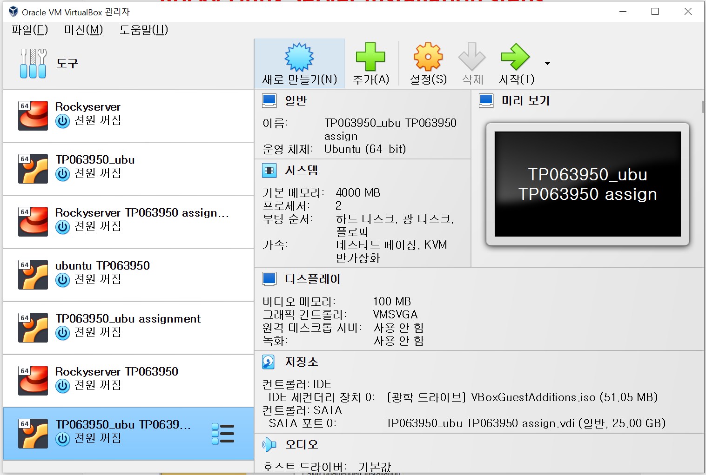

The intallation of Rocky Linux will start from installation of Virtulal box. Even though the language is Korean, due to previous attempts where changing of lanugaes brought unknown errors to existing virtual servers and clients, installation of Rocky Linux and Ubuntu was done in this condition.

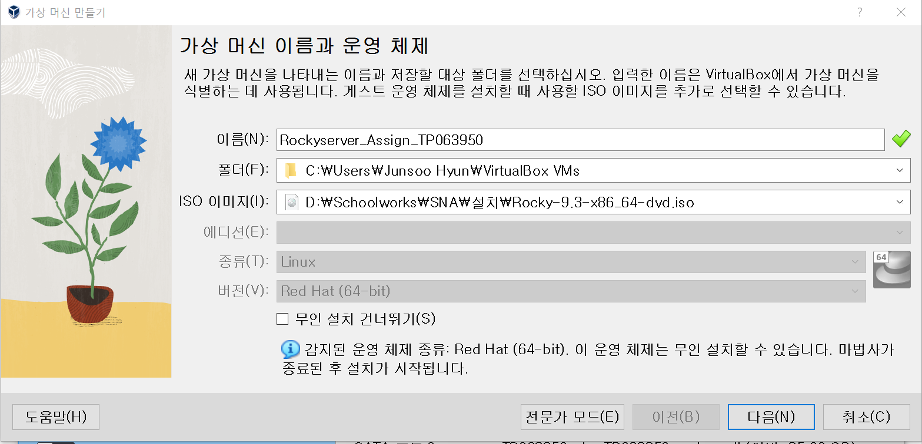

Rocky Linux will be installed first. As shown, name of the server will be **Rockyserver_Assign_TP063950**. Using ISO image of rocky dvd, installation will be done.

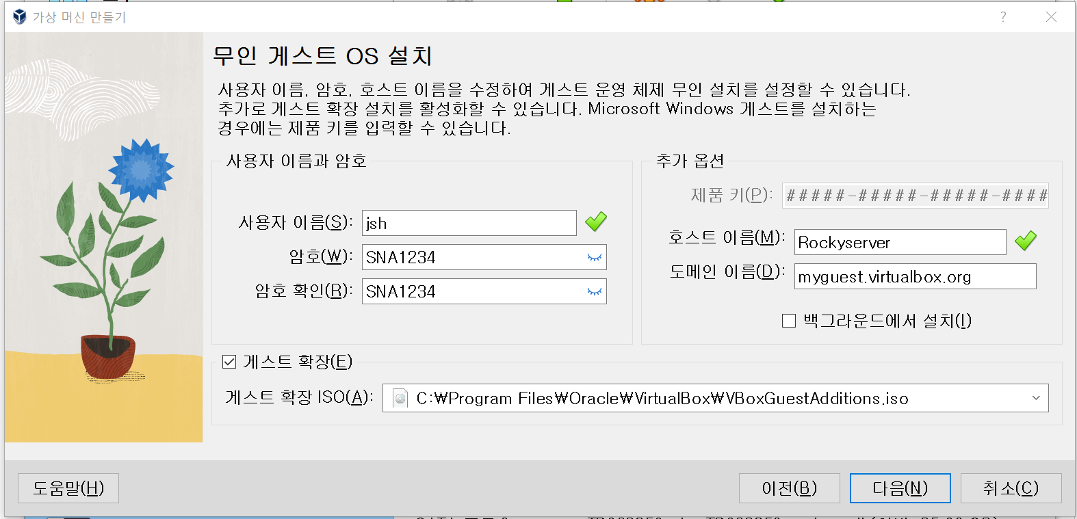

The name and the password of the first user anf hostname is set here. Change in domain is not applied, as I will chnge them after installation.

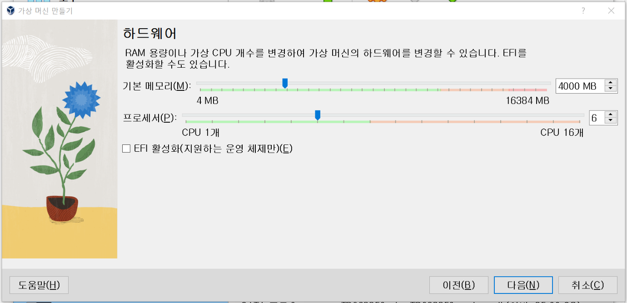

The hardware of the server is set as basic memory of 4000MB and processor of 6 CPUs.

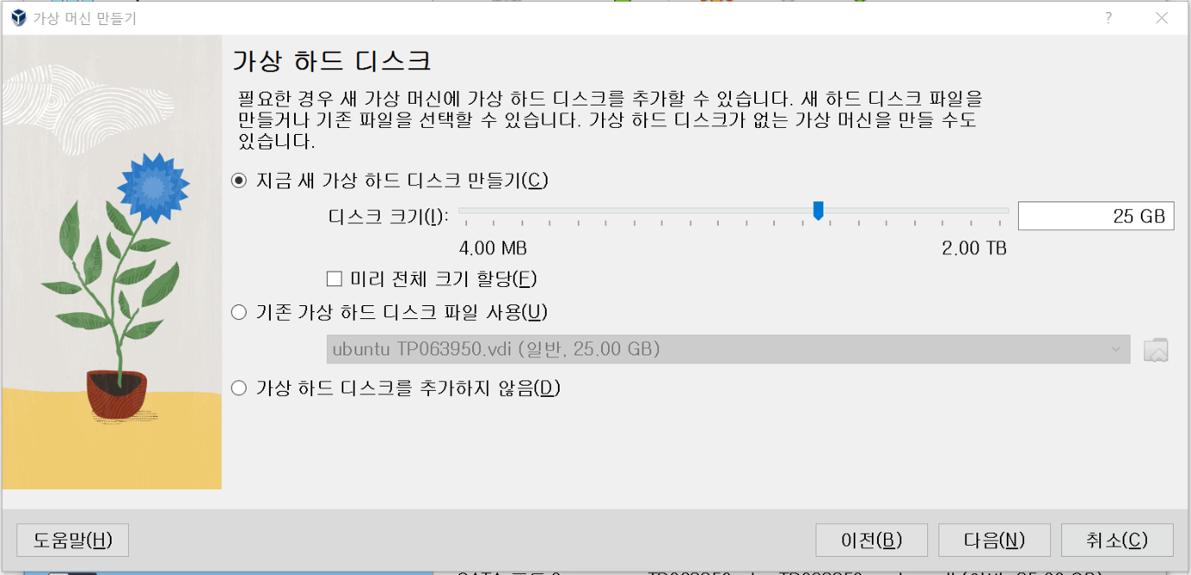

Virtual harddisk’s size has been set as 25GB, creating new virtual harddisk.

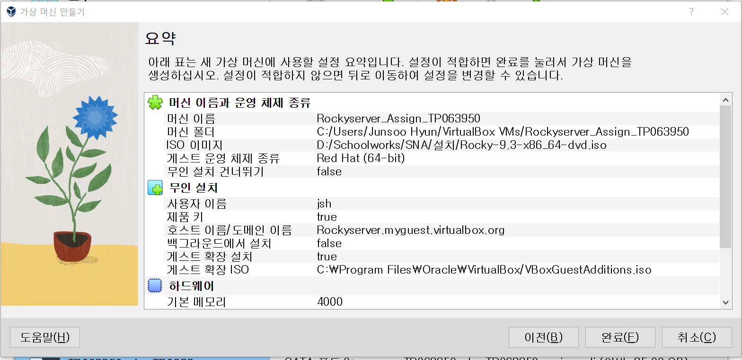

This will be the summerisation for the machine:

Virtual Machine Creation Settings

Name: Rockyserver_Assign_TP063950

Path: C:/Users/Junsoo Hyun/VirtualBox VMs/Rockyserver_Assign_TP063950

ISO Image: D:/Schoolworks/SNA/Practical/Rocky-9.3-x86_64-dvd.iso

Guest OS Vendor: Red Hat (64-bit)

Unattended Installation Available: false

Common Settings:

Username: jsh

Provider: true

Host Name/Domain Name: Rockyserver.myguest.virtualbox.org

Run in Background: false

Install Guest Additions: true

Guest Additions ISO: C:/Program Files/Oracle/VirtualBox/VBoxGuestAdditions.iso

Hardware:

Base Memory: 4000

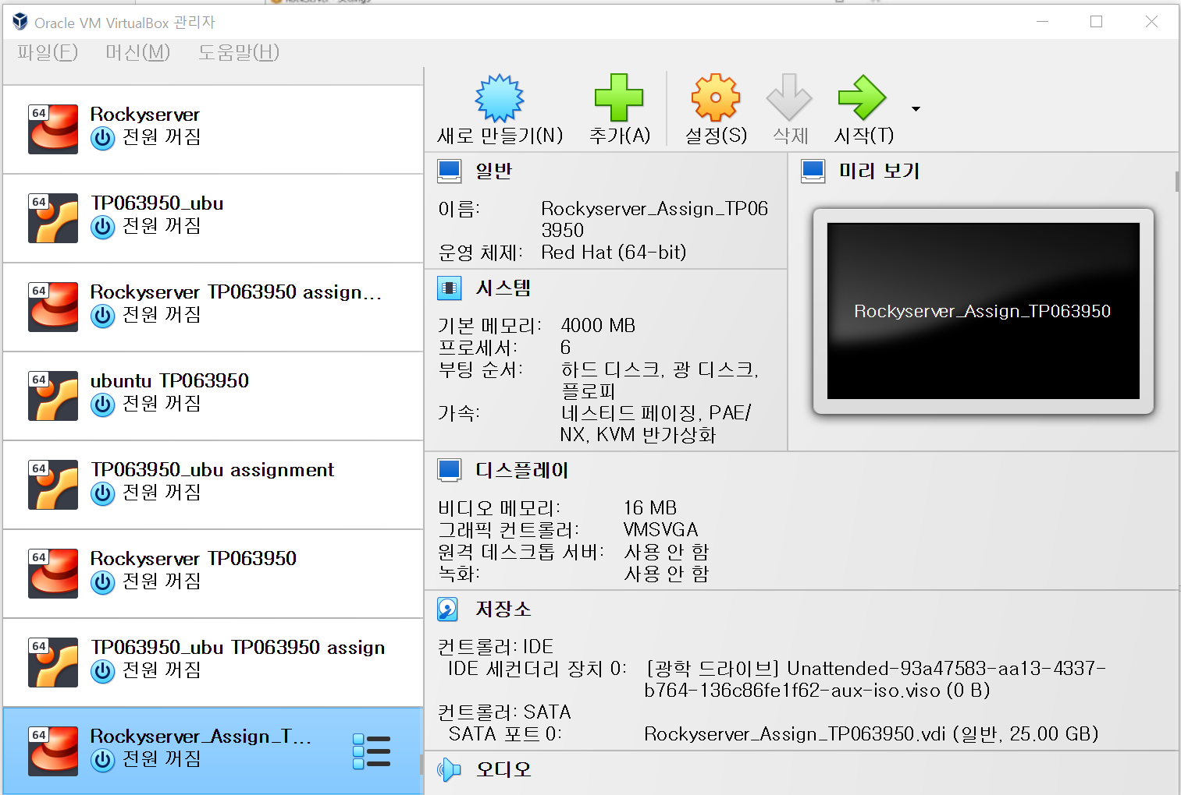

Now **Rockyserver_Assign_TP063950** rockyserver is created.

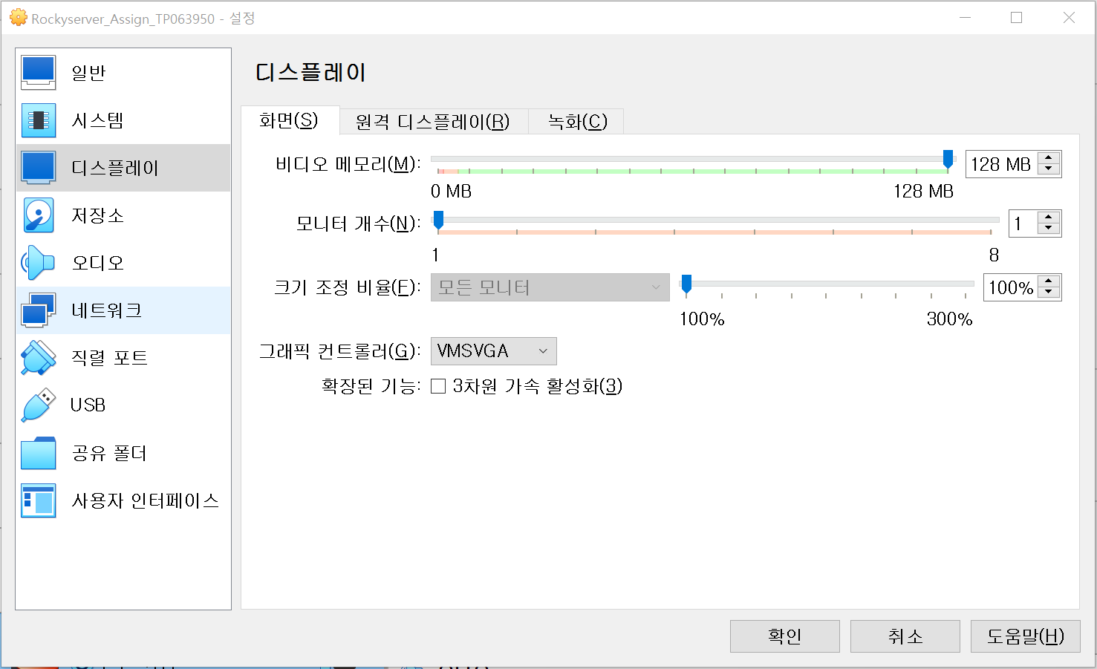

For futher settings, go to settings-Display, and set video memory to MB

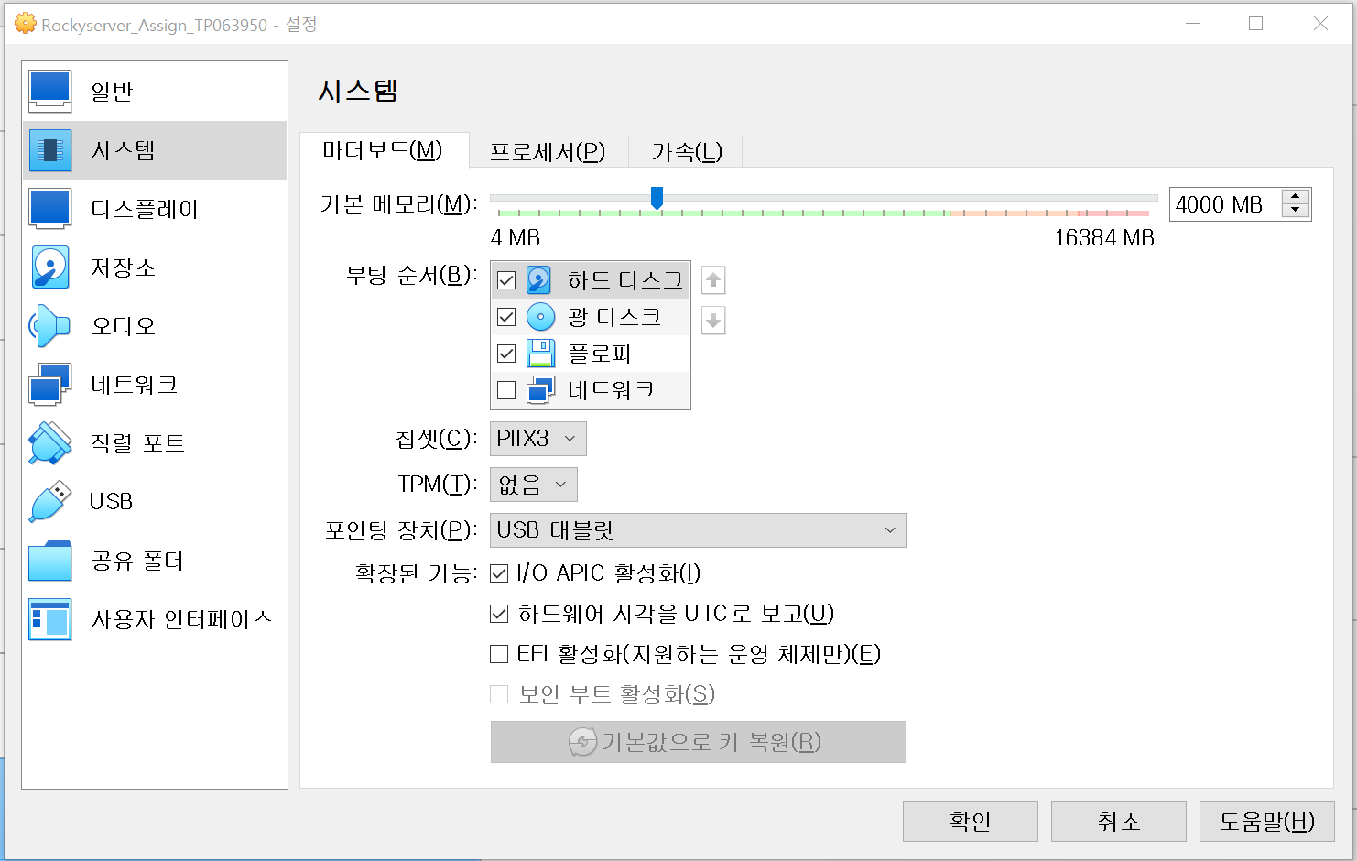

Then, go to system to set basic memory to 4000MB.

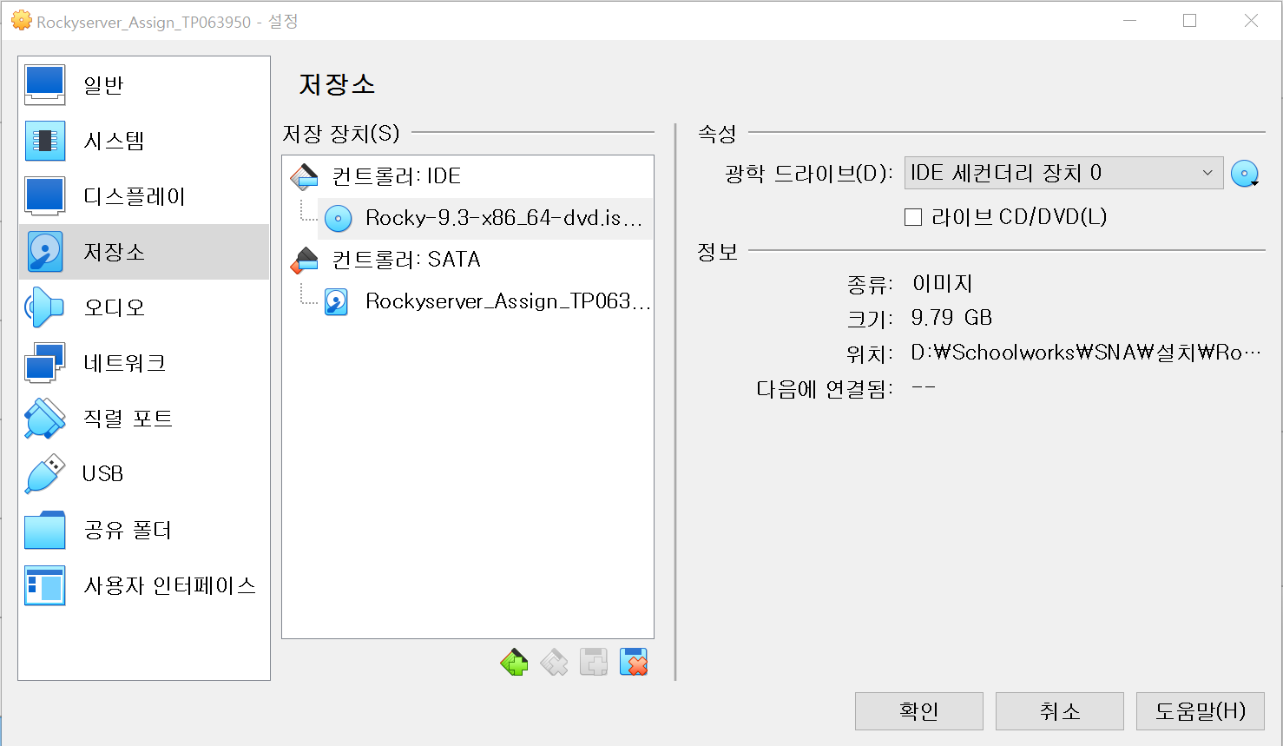

Go to system to put rocky dvd into controler IDE to process further installation.

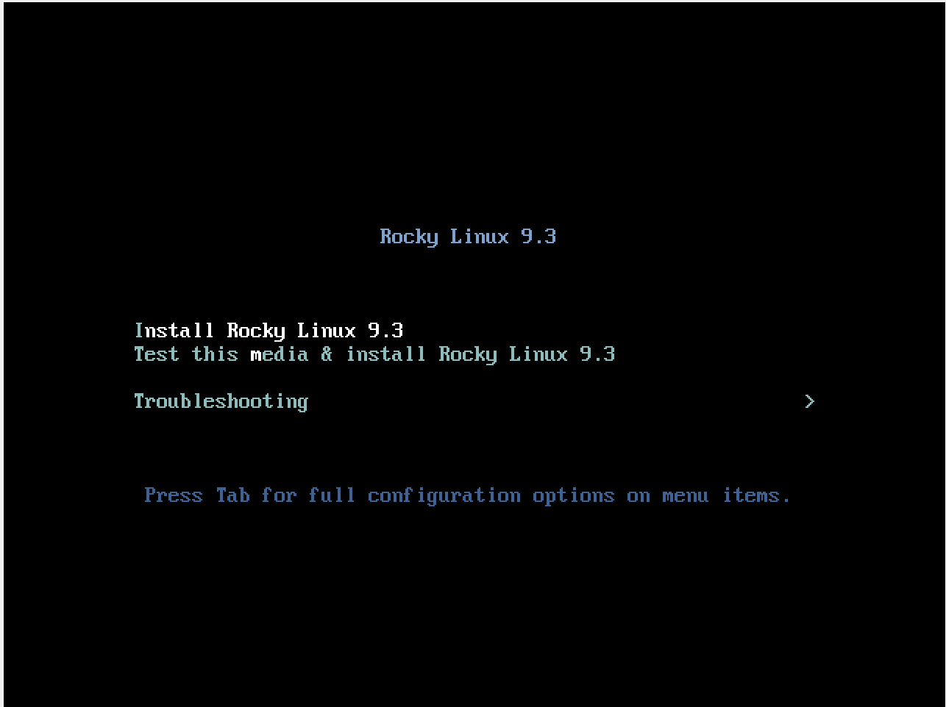

Now, start the rocky lonux. At the start, the diplay will be like this. Using

Arrow keys, move to “**Install Rocky Linux 9.3**” to continue installation.

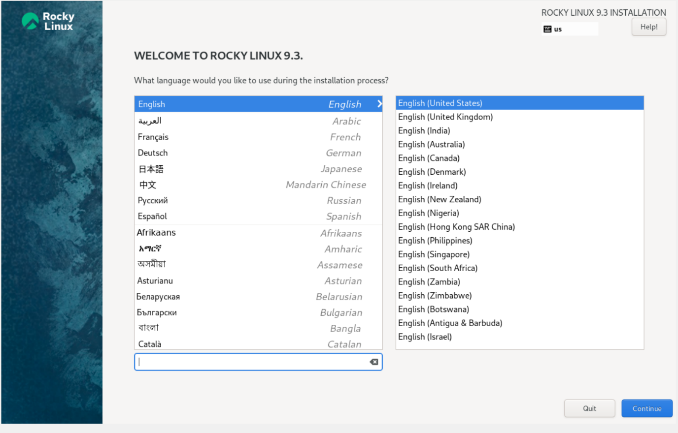

The lanuage is automatically set as United States English. Press continue to proceed.

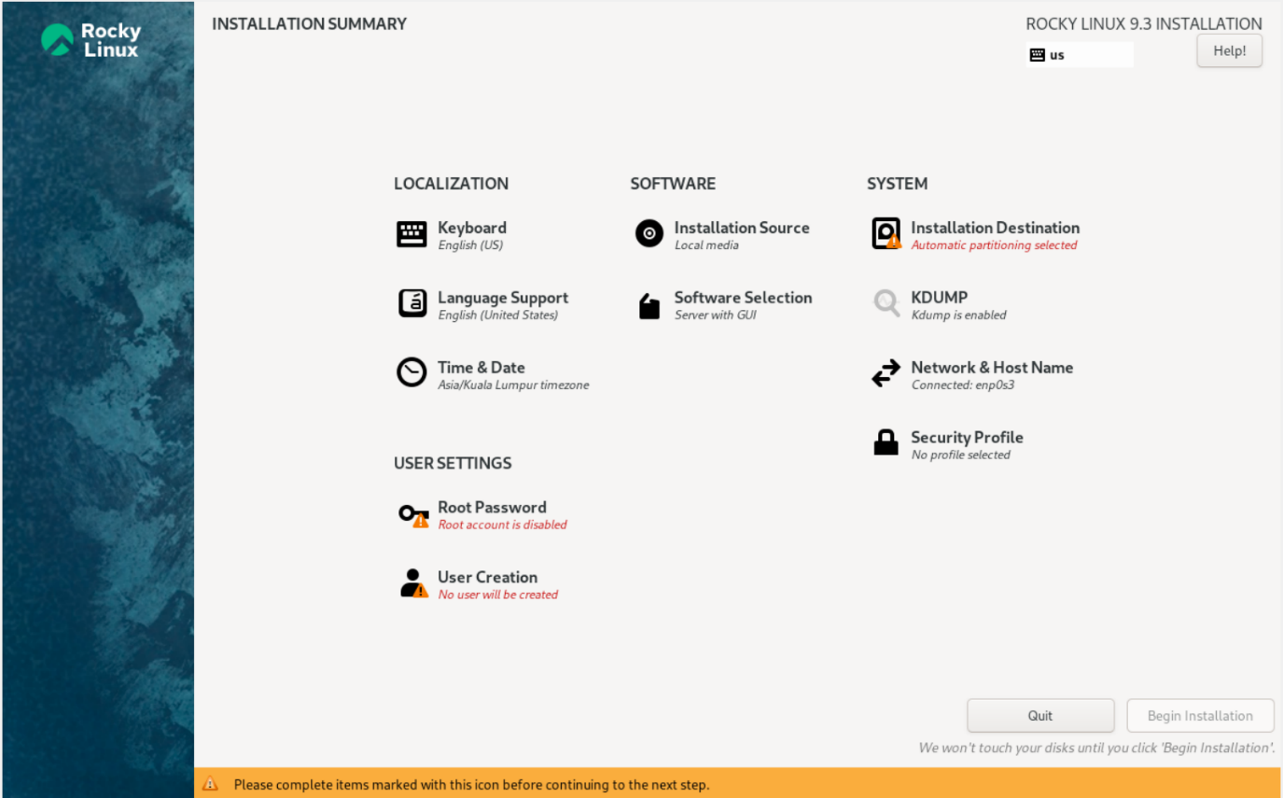

Now, installation summary has poped up. Here, installation destination and root password will be handled.

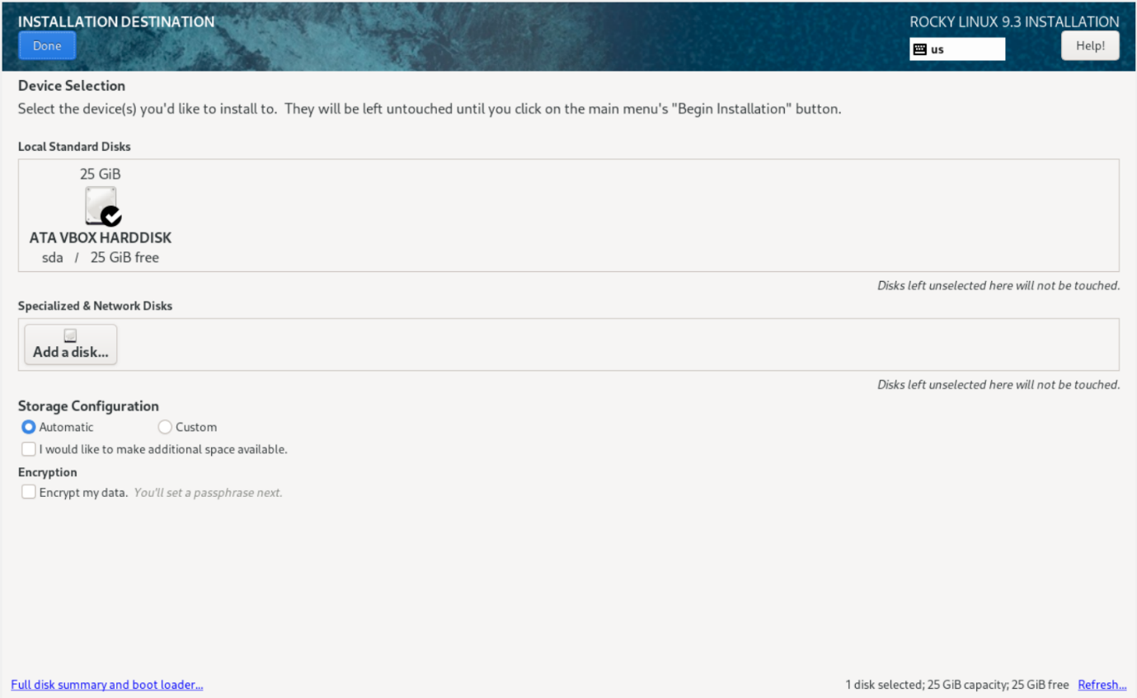

For installation destination, set ATA Vbox Harddisk.

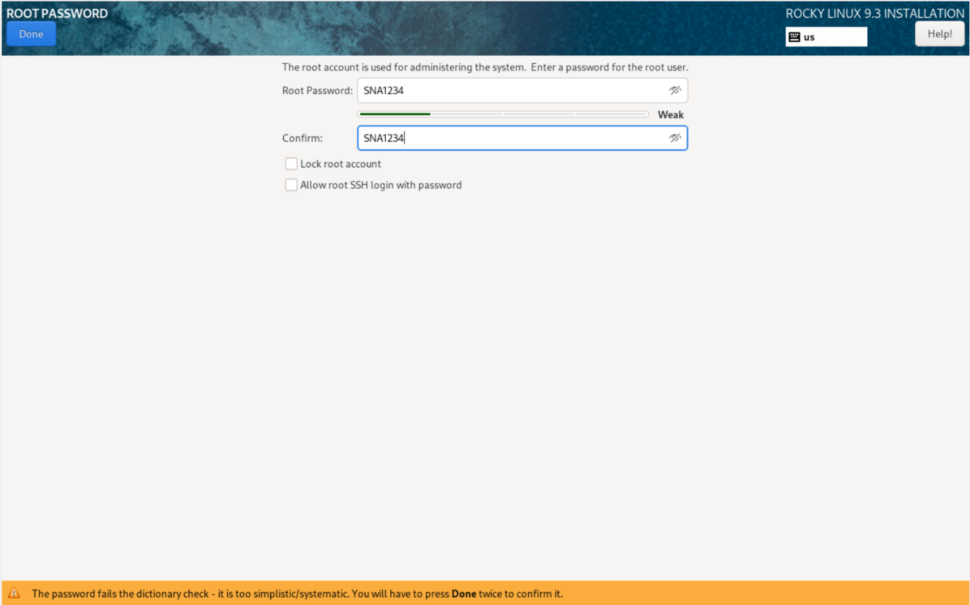

Then, set up root password. I set it as “SNA1234”.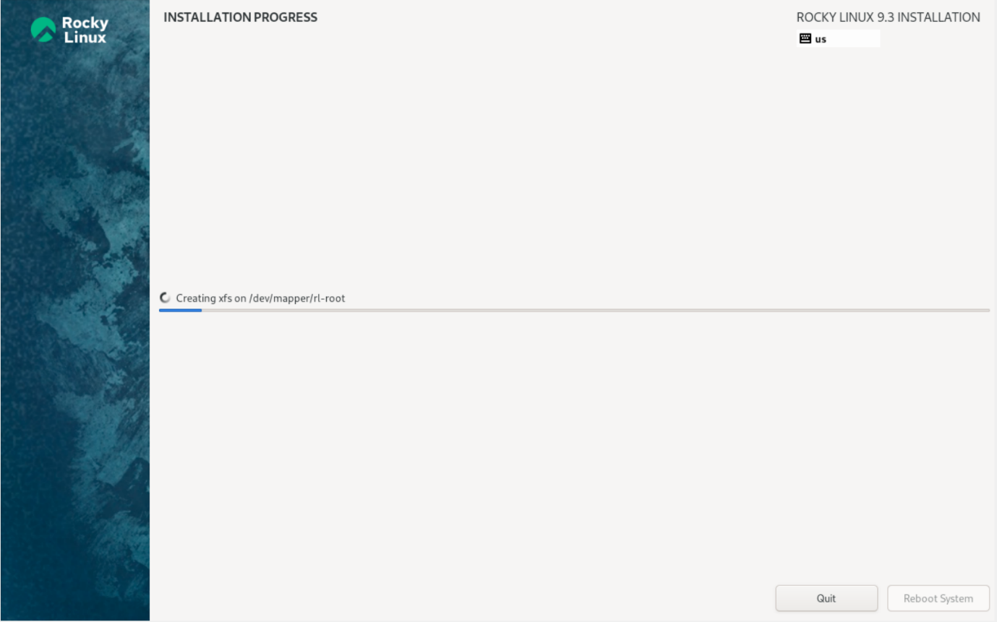

Then begin installation.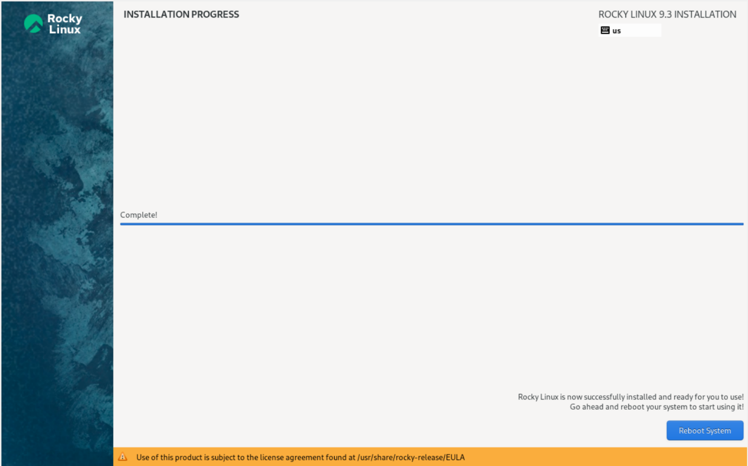

After installation is completed, reboot system.

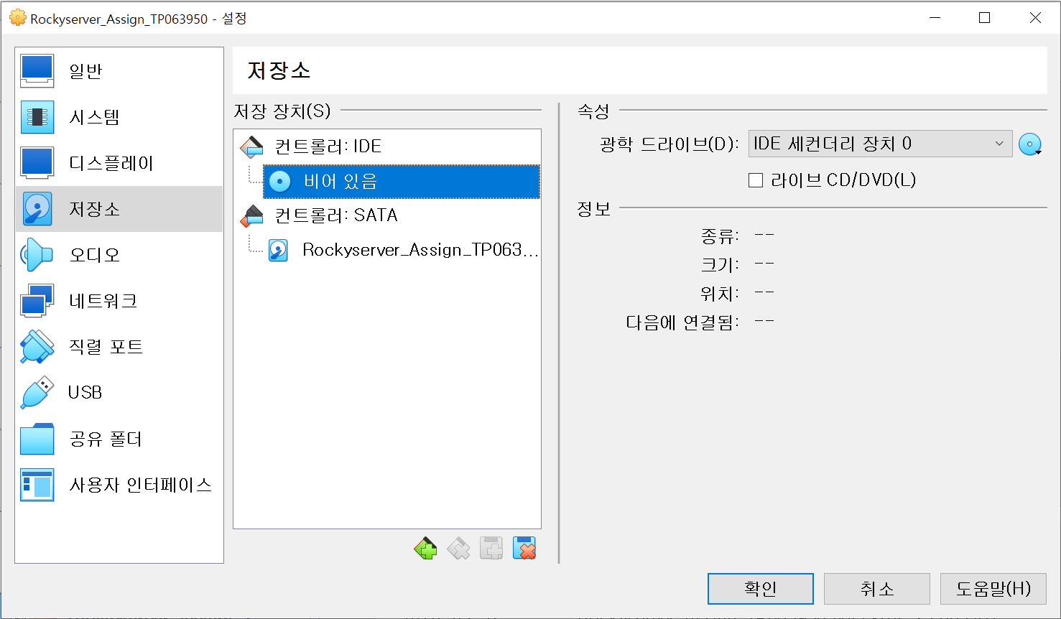

Before reboot, remove the disk form controler IDE.

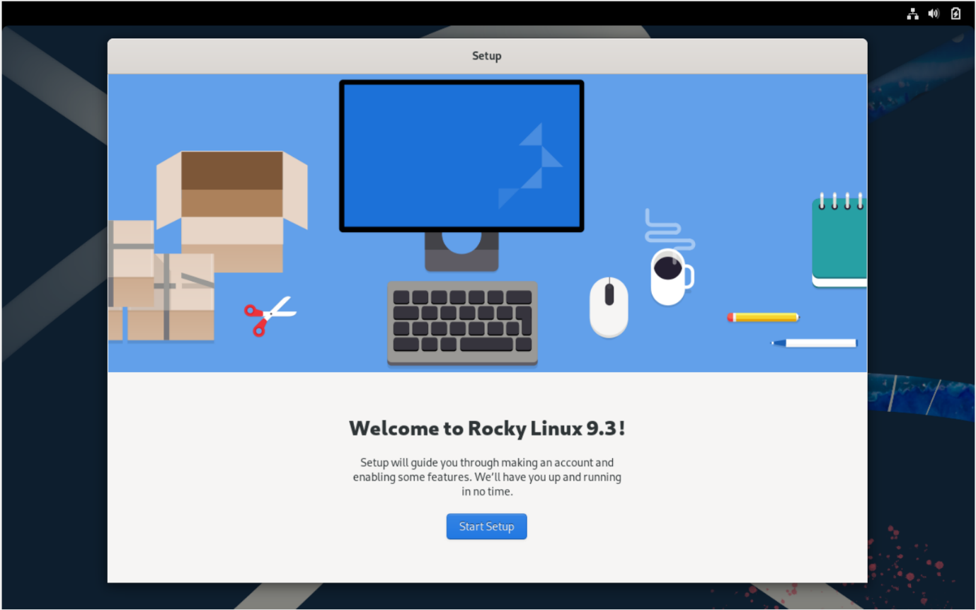

When installation is completed, this screen pops up after reboot. Press start setup.

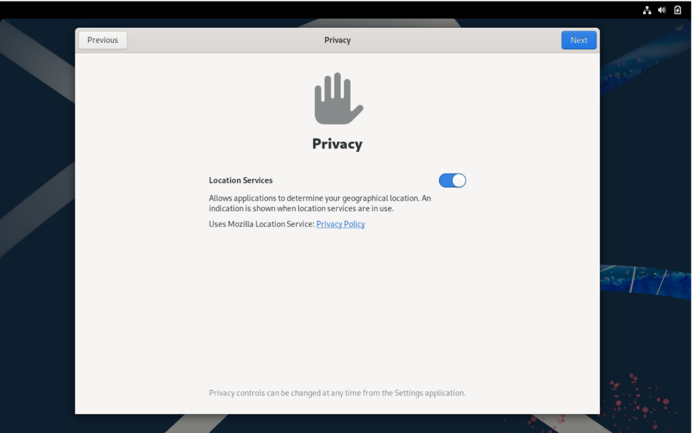

Turn on location service and proceed.

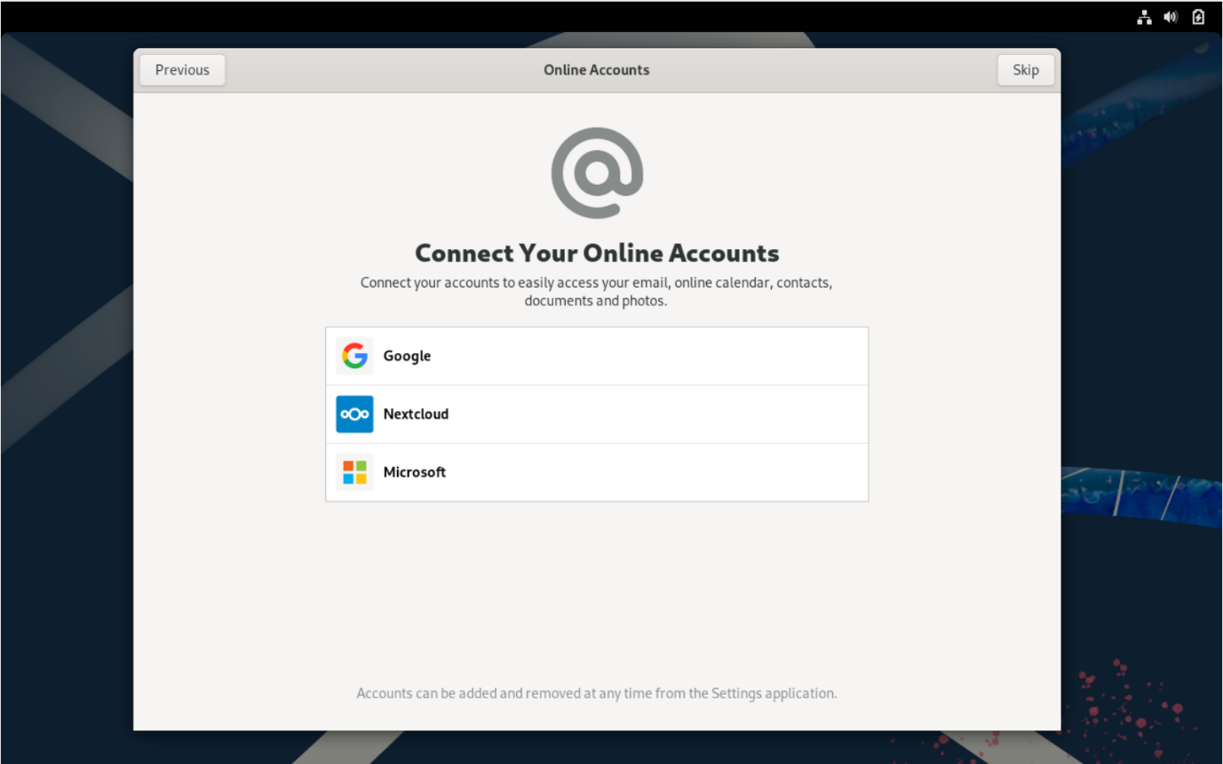

Skip the connecting online account option

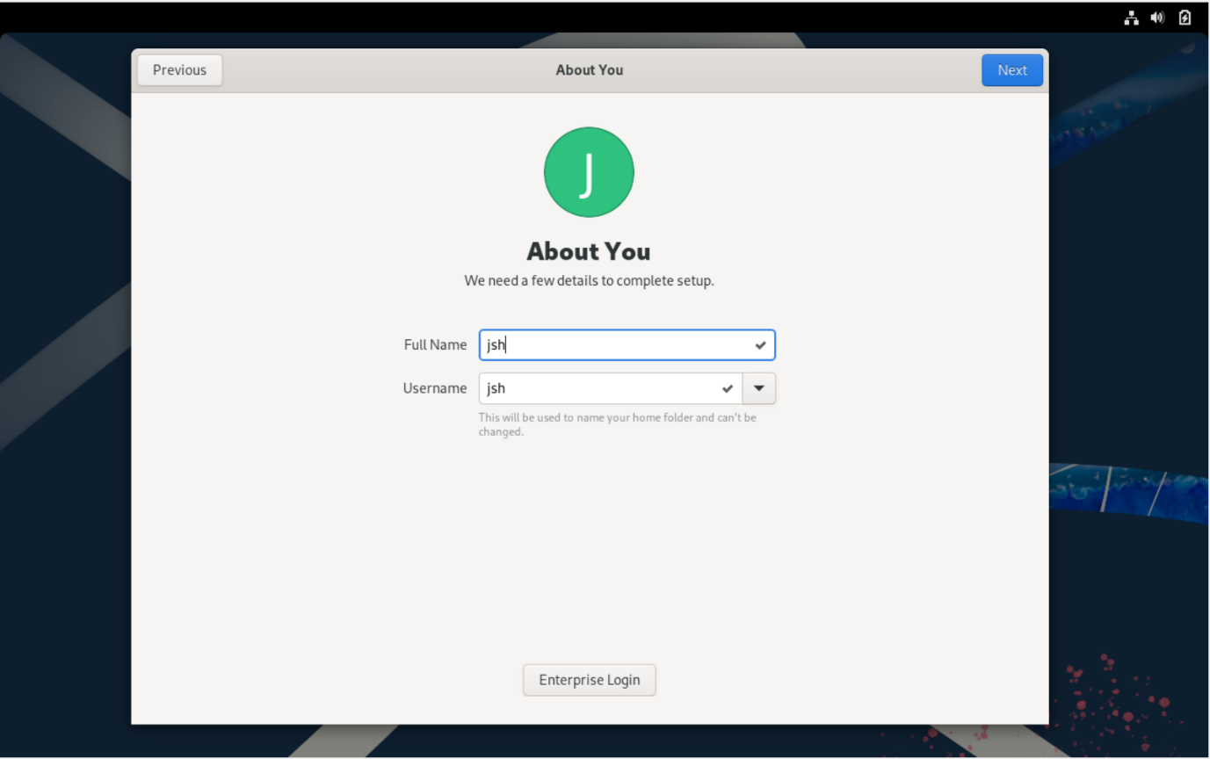

Set username. I chose “jsh” after my initials. Then press next.

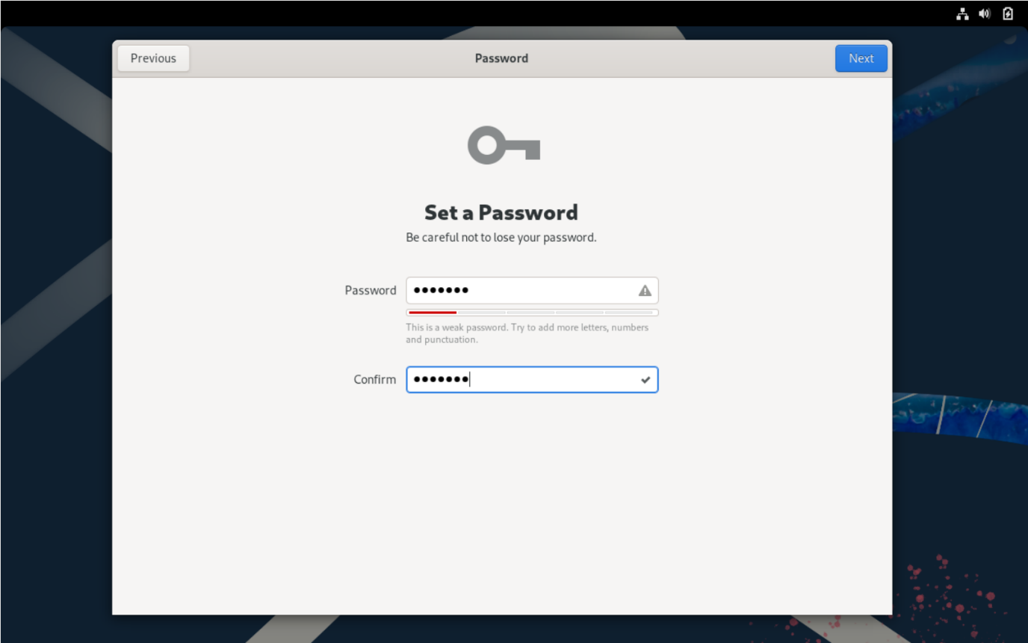

Set password. To avoid confusion, I set this as “SNA1234” as well”. Press next.

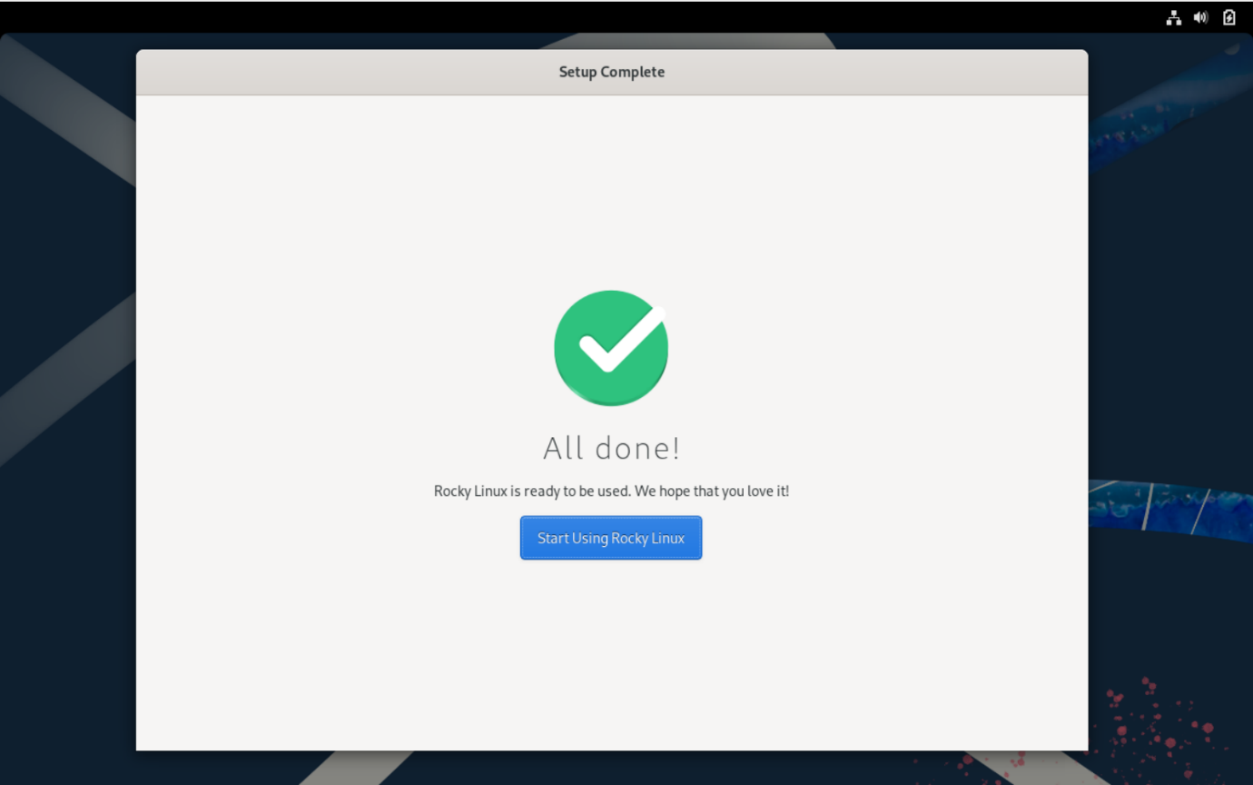

The basic installation process is done.

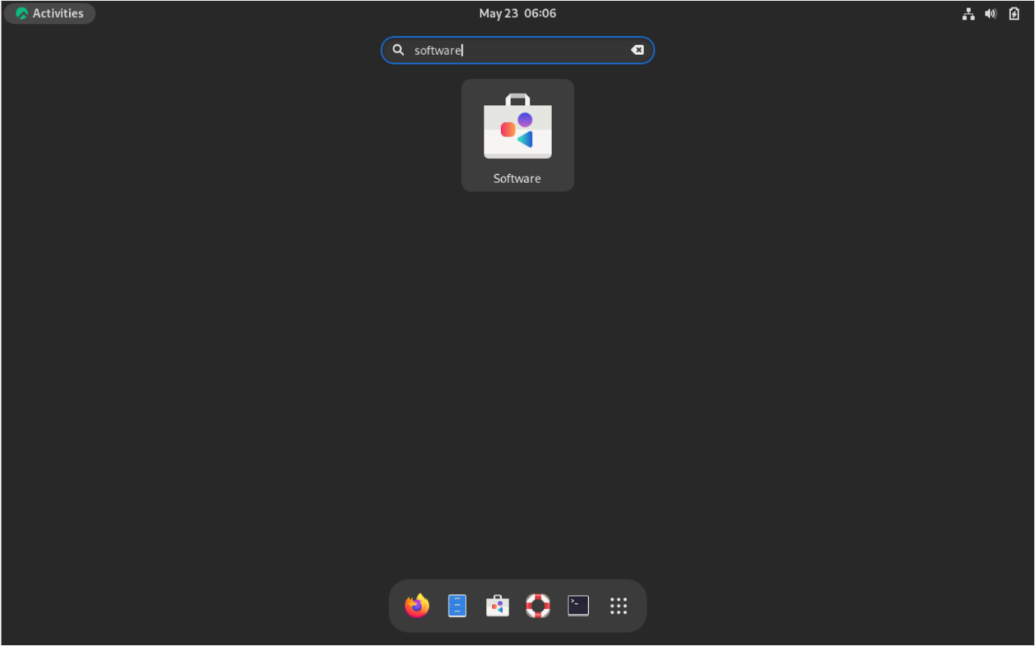

To update software, search software at search menu.

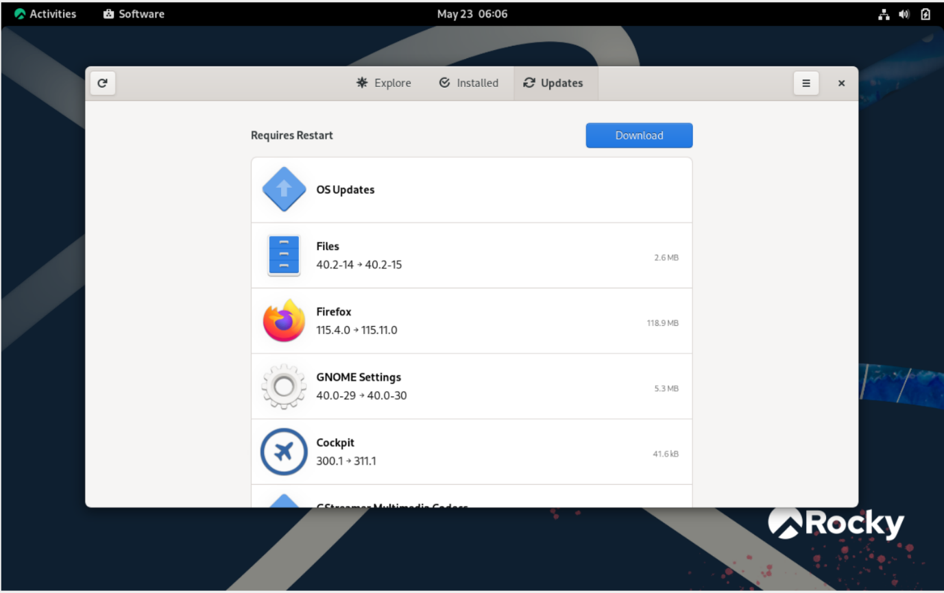

Go to Updates and download the available updates

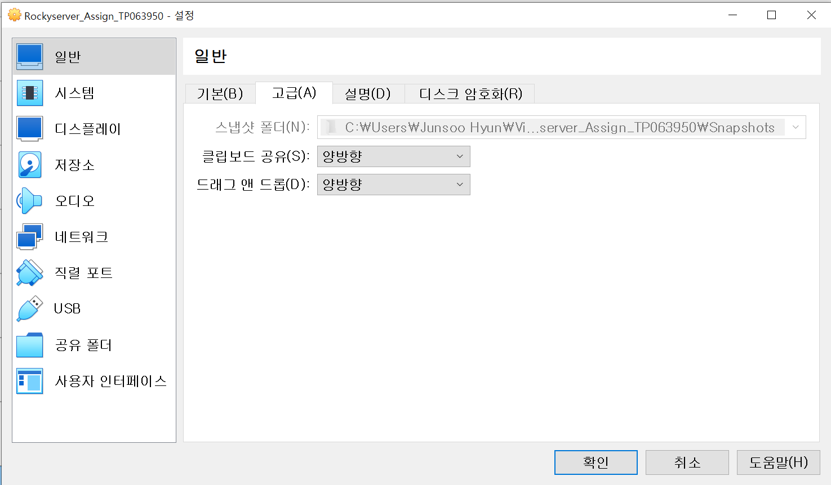

In the settings menu, go to normal-advanced, and set “shared clipboard” and “drag and drop” to bidirectional to ease the entering codes.

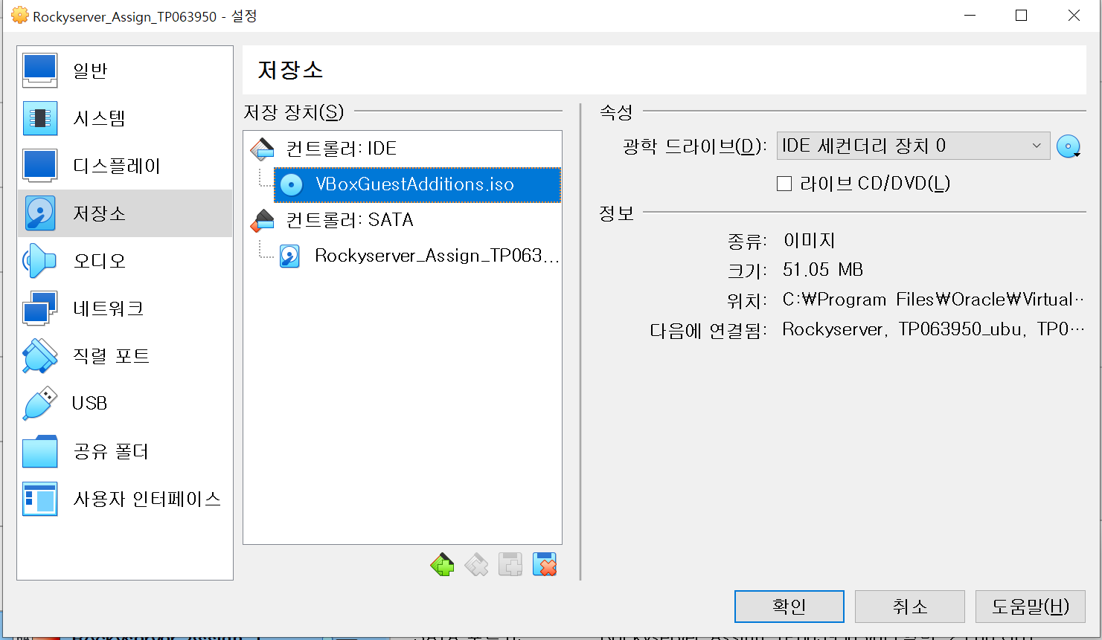

Now, insert VBoxGestAdditions.iso disc to controler IDE to install guest additions.

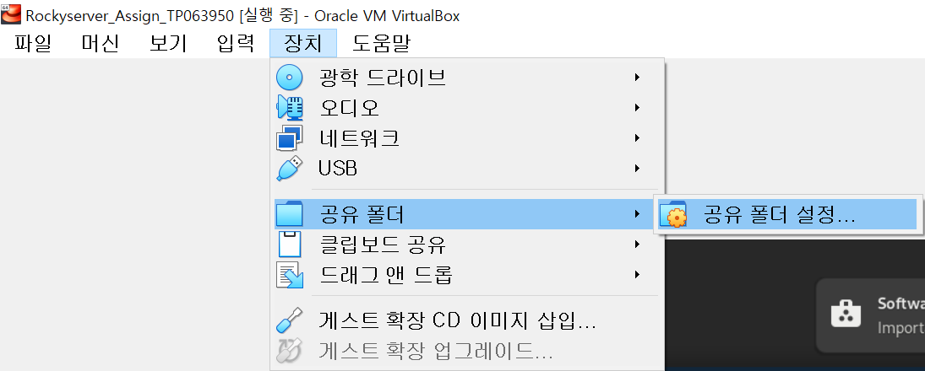

Turn on the machine, then go to device-shared folder-shared folder settings.

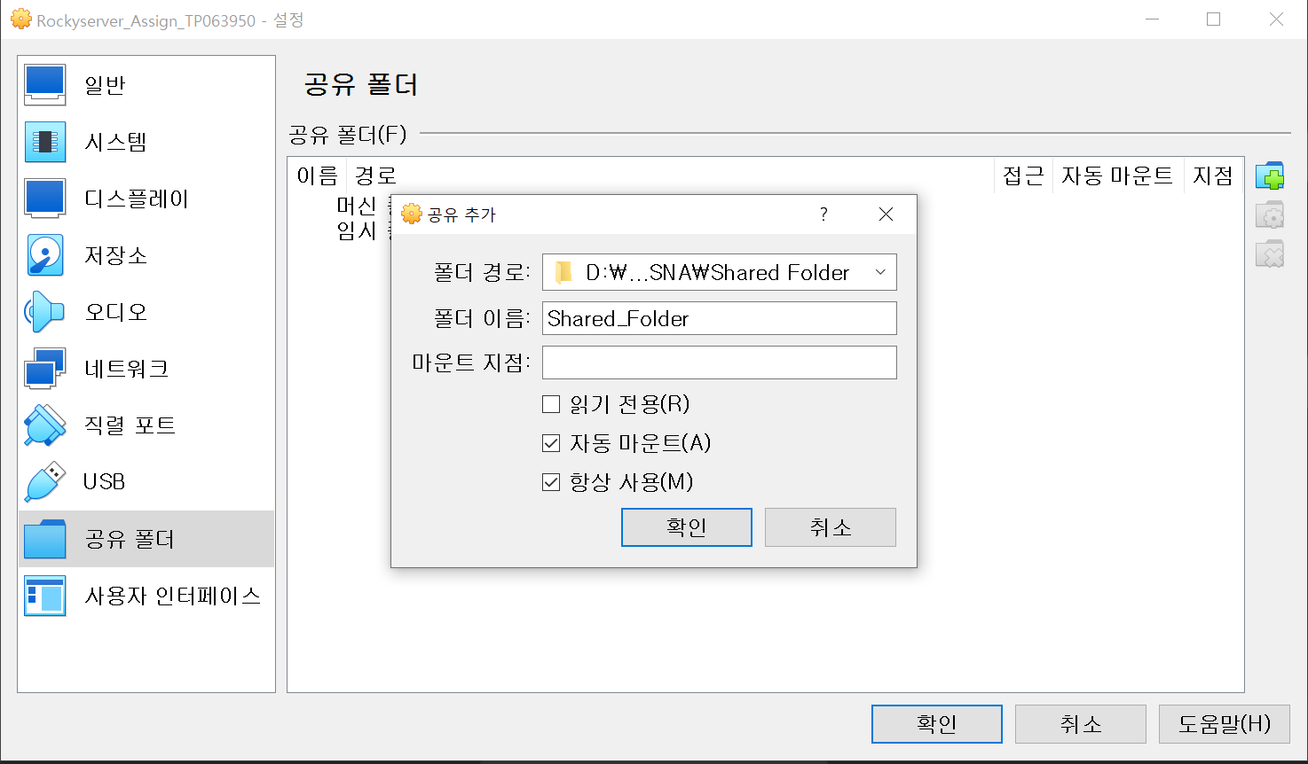

Set shared folder at shared folder-add.

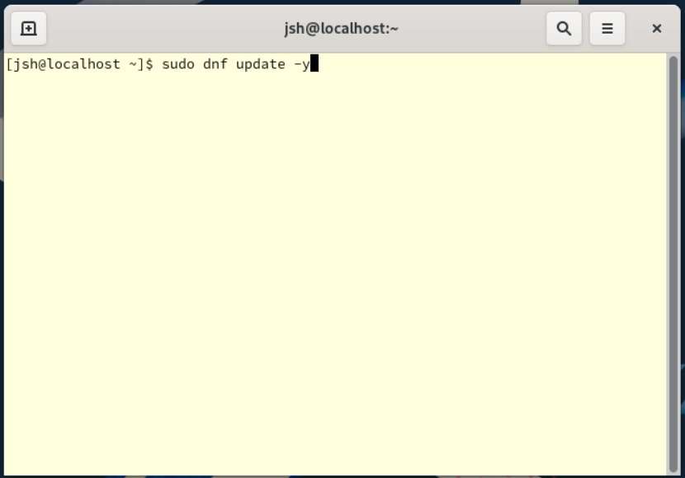

To finish, update using consol, entering “**sudo dnf update -y**”.

### **1.1.2 Install Ubuntu Client**

Now, install Ubuntu to use as a client.

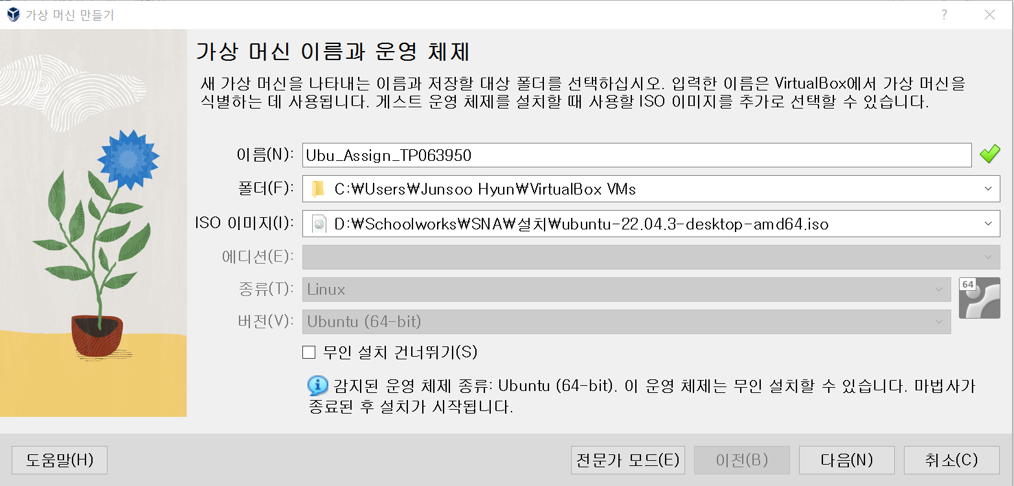

Ubuntu client will be installed now. As shown, name of the client will be **Ubu_Assigne_TP063950**. Using ISO image of Ubuntu dvd, installation will be done.

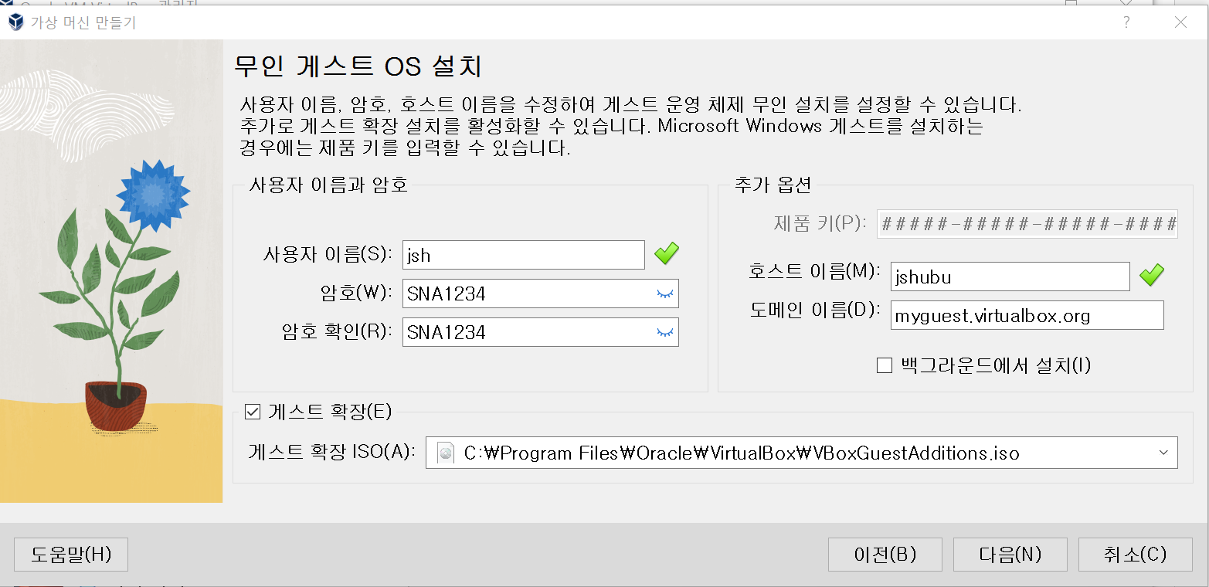

The username and password will be same as server to avoid confusion. Host name is set as jshubu.

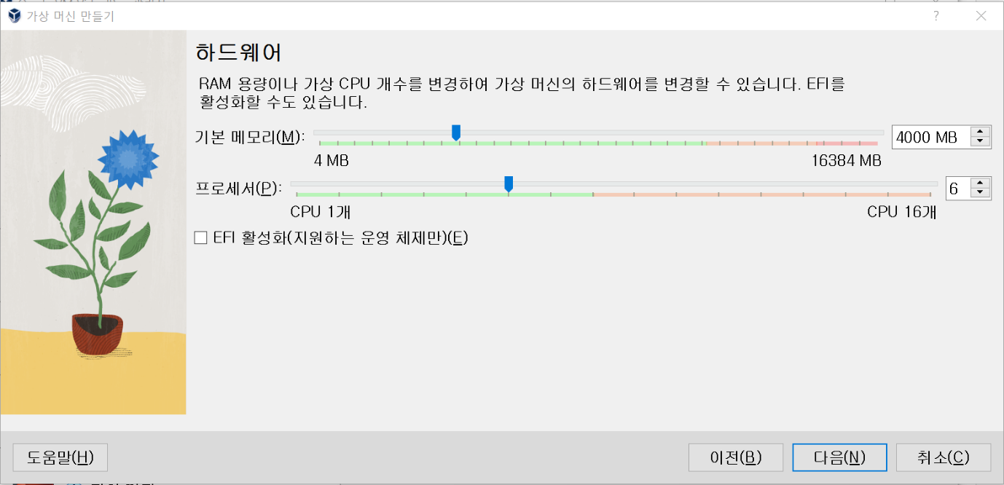

The hardware of the server is set as basic memory of 4000MB and processor of 6 CPUs.

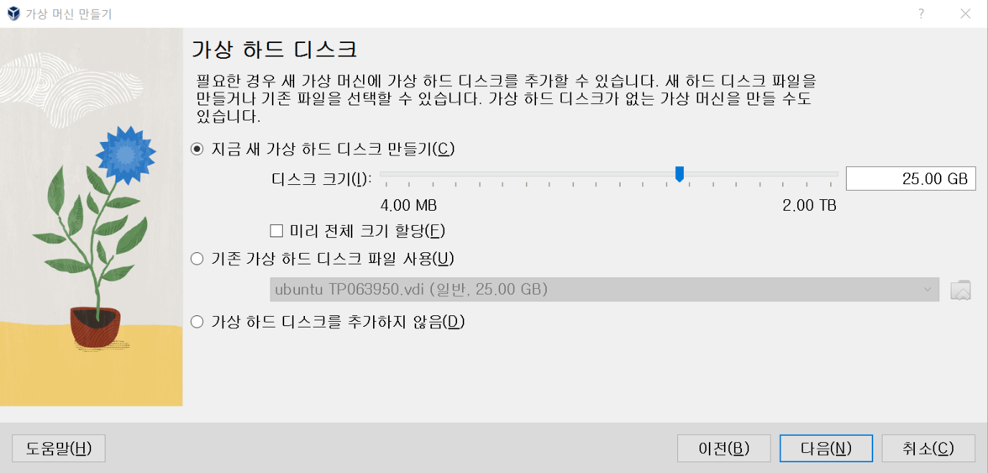

Virtual harddisk’s size has been set as 25GB, creating new virtual harddisk.

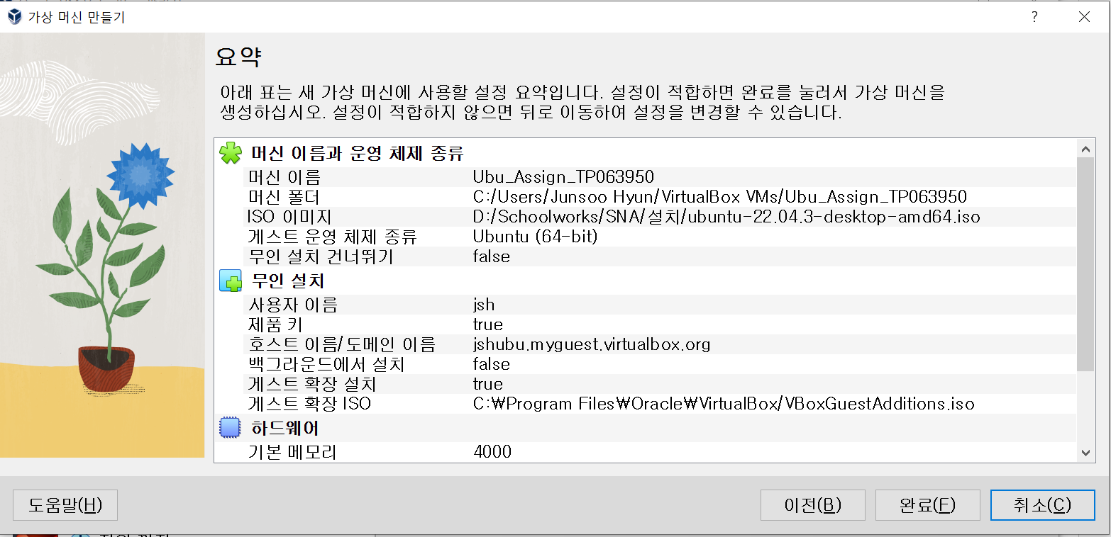

This will be the summerisation for the machine:

Virtual Machine Creation Settings

Name: Ubu_Assign_TP063950

Path: C:/Users/Junsoo Hyun/VirtualBox VMs/Ubu_Assign_TP063950

ISO Image: D:/Schoolworks/SNA/Practical/ubuntu-22.04.3-desktop-amd64.iso

Guest OS Vendor: Ubuntu (64-bit)

Unattended Installation Available: false

Common Settings:

Username: jsh

Provider: true

Host Name/Domain Name: jshubu.myguest.virtualbox.org

Run in Background: false

Install Guest Additions: true

Guest Additions ISO: C:/Program Files/Oracle/VirtualBox/VBoxGuestAdditions.iso

Hardware:

Base Memory: 4000

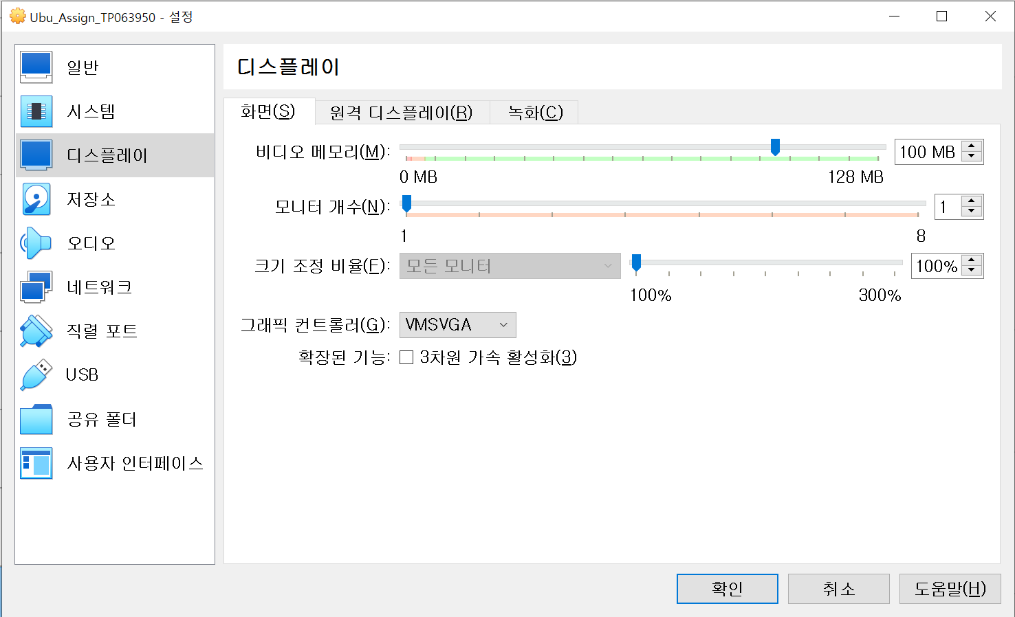

Same as rockyserver, settings of display will be done. Video memory is set as 100MB.

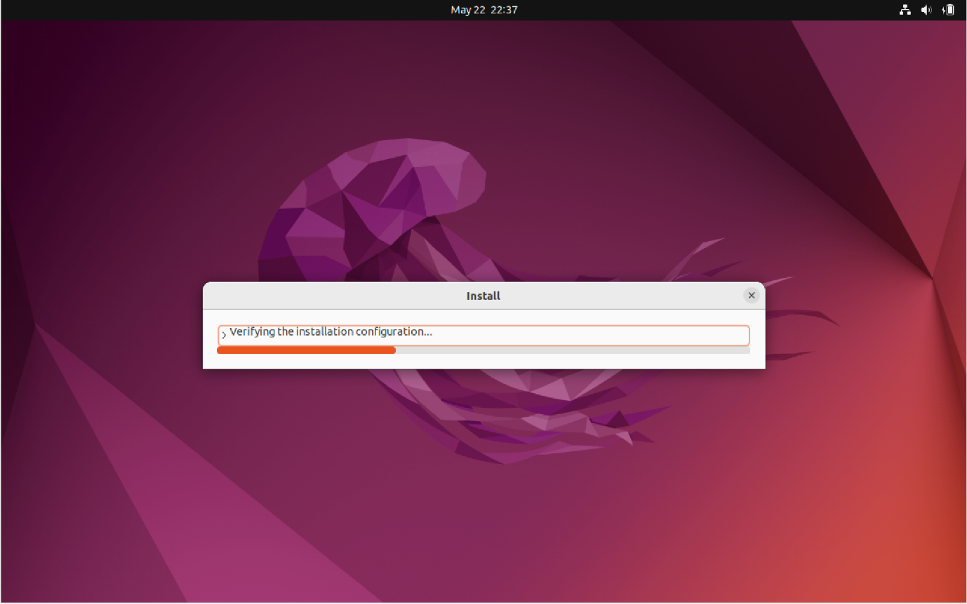

When turn on ubuntu, initial installation starts automatically.

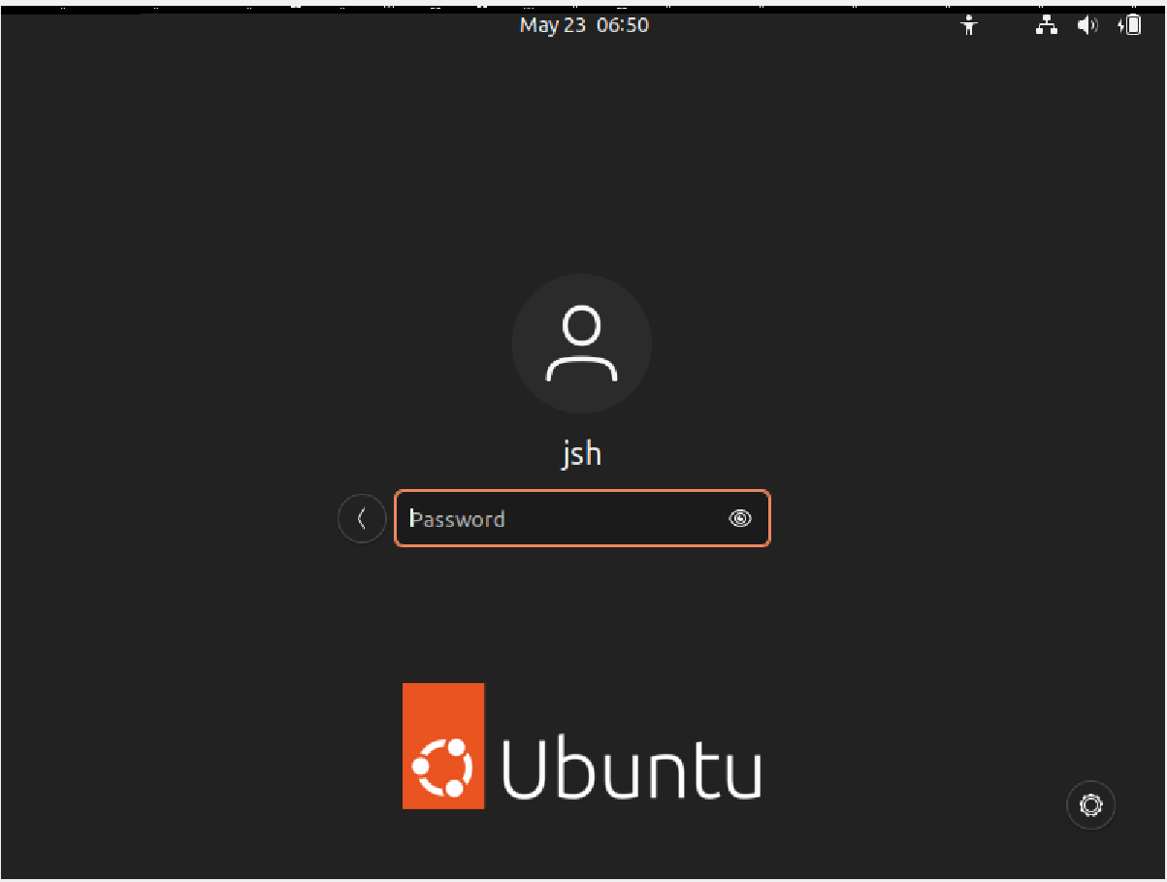

After that, login page pops up. Key in the password and log in.

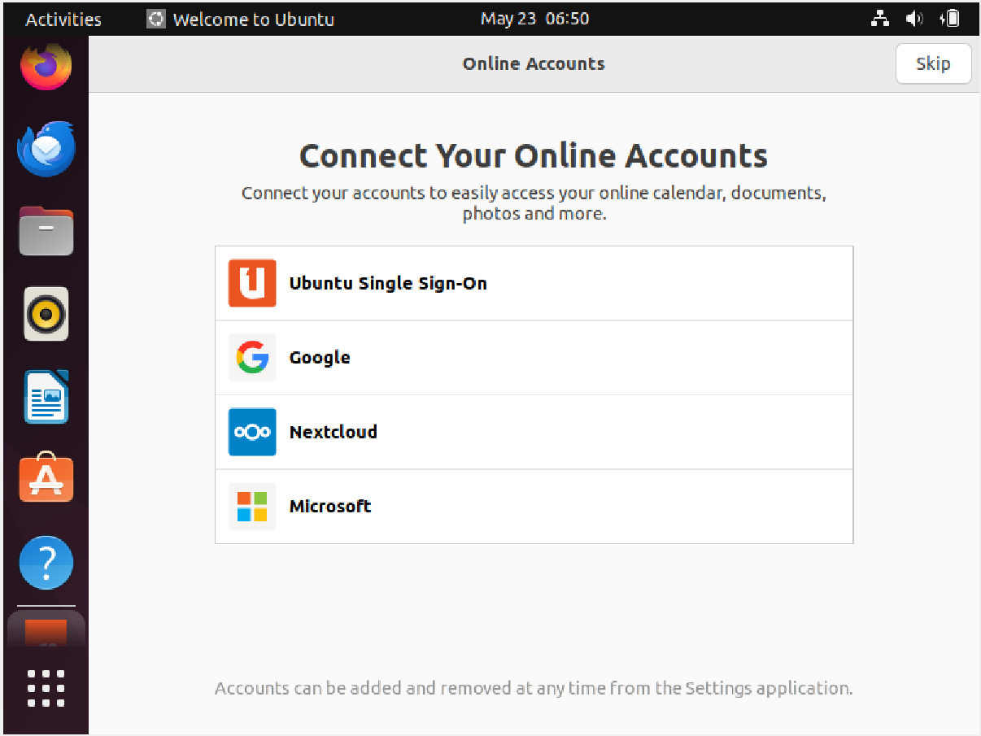

Same as rocky, online account connection window appears. Skip it.

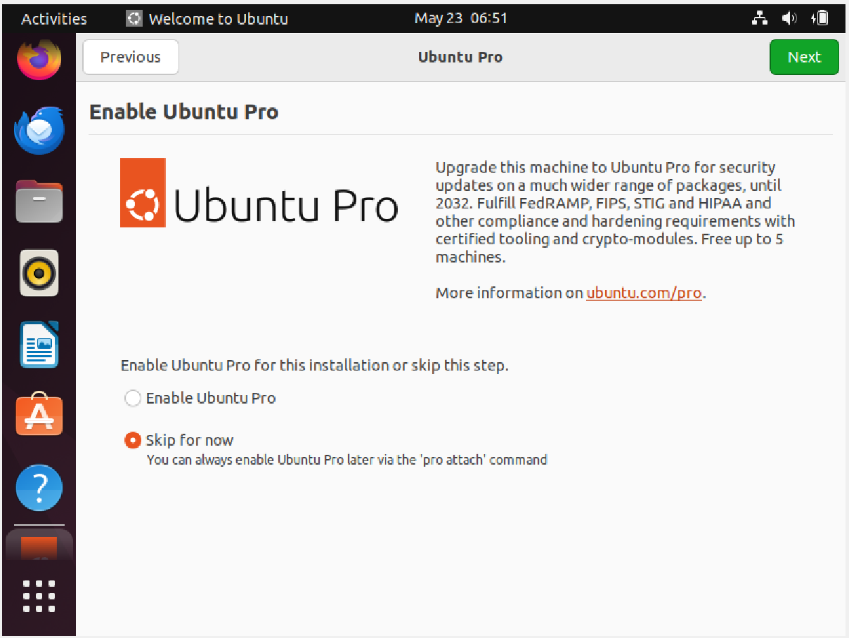

Ubuntu pro page will pop up. Skip it and press next.

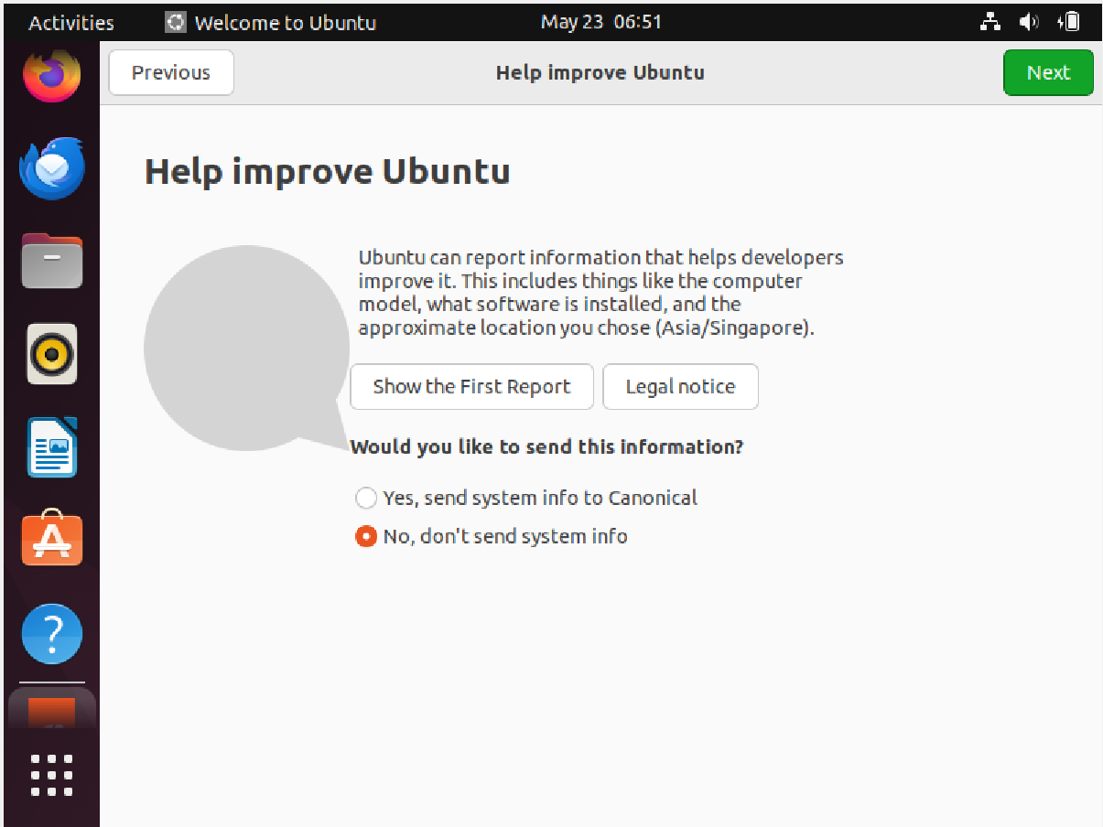

System infor sending page pops up. Skip it.

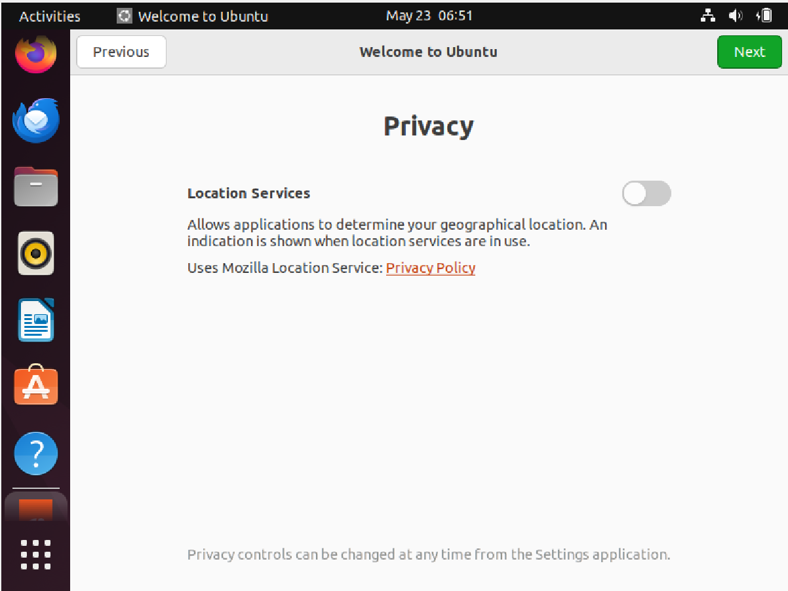

Turn off the location service, and press next.

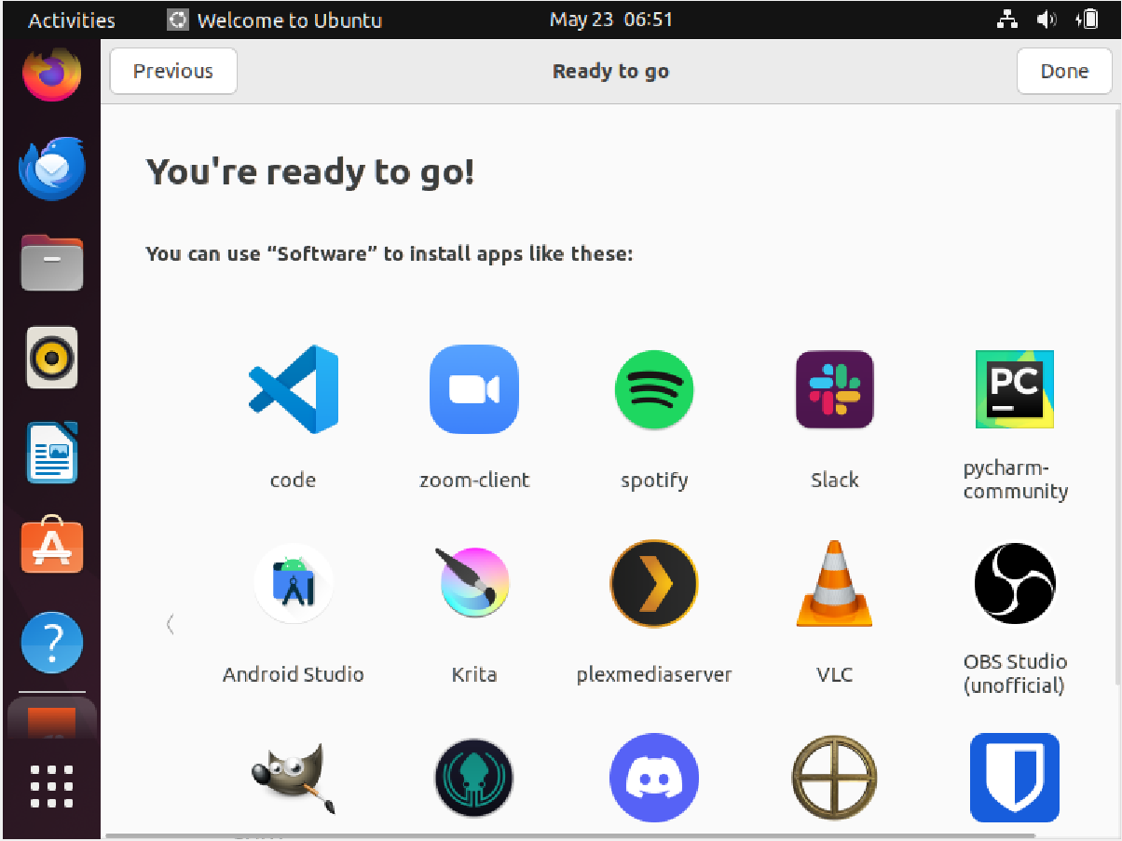

Now, installation is complete.

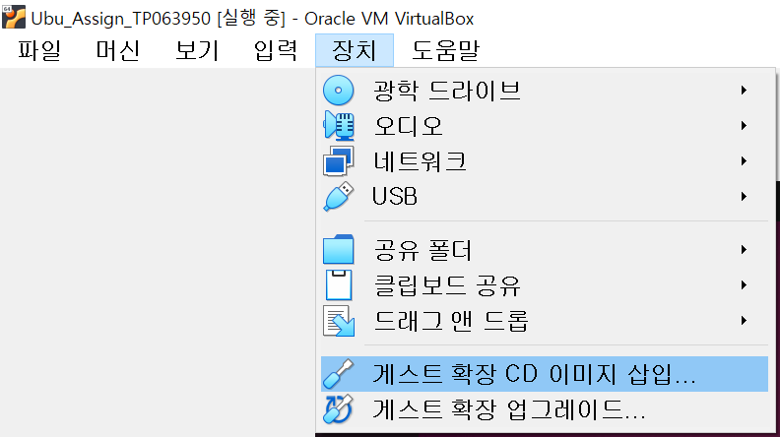

Same as rocky, insert guest addition to ease the coding.

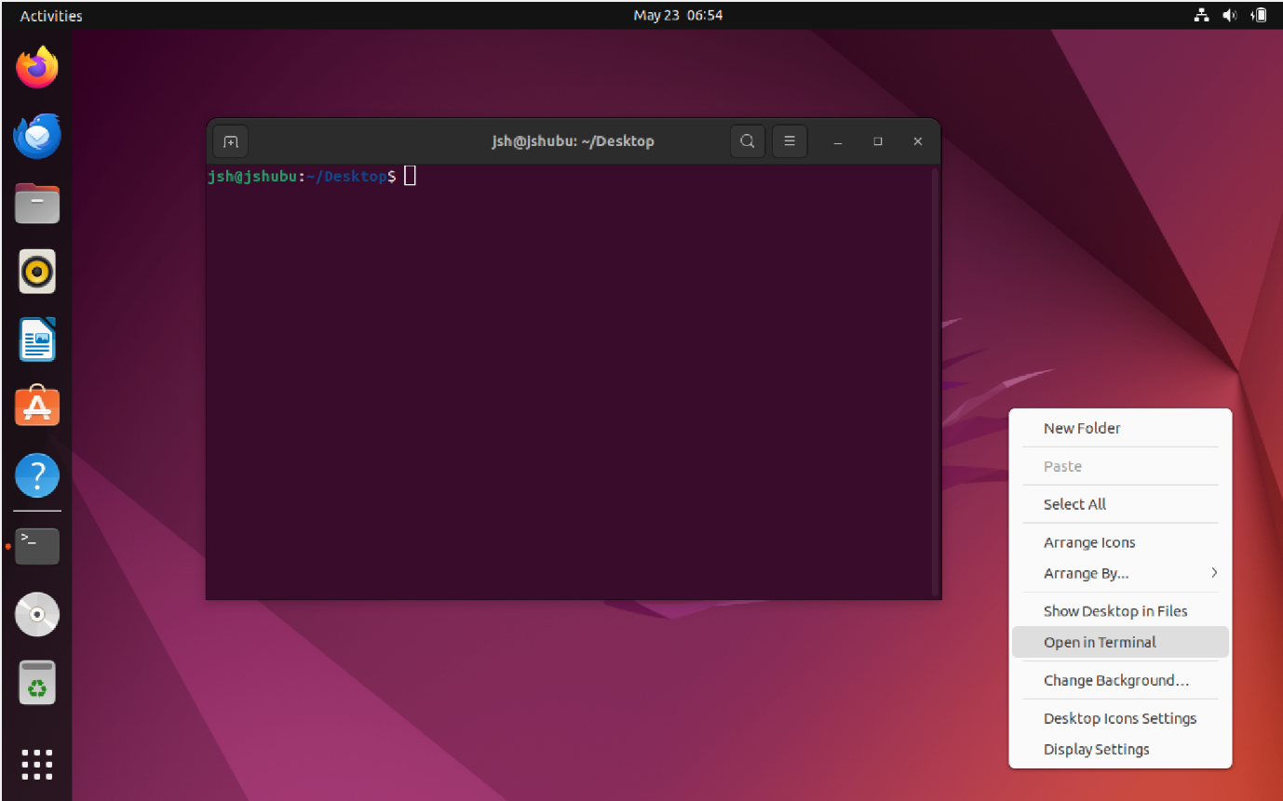

Open terminal from wallpapers to give permision to user.

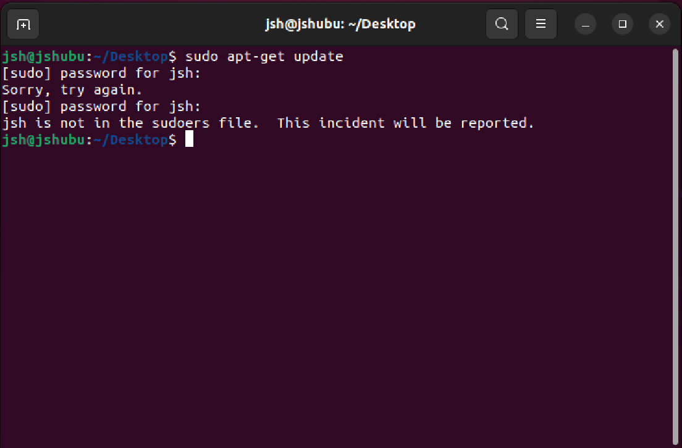

The update cannot be done as user jsh does not have permision.

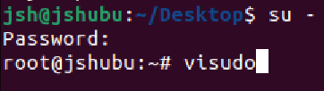

Login to root by “**su –**“. Open sudoers.tmp by “**visudo**”

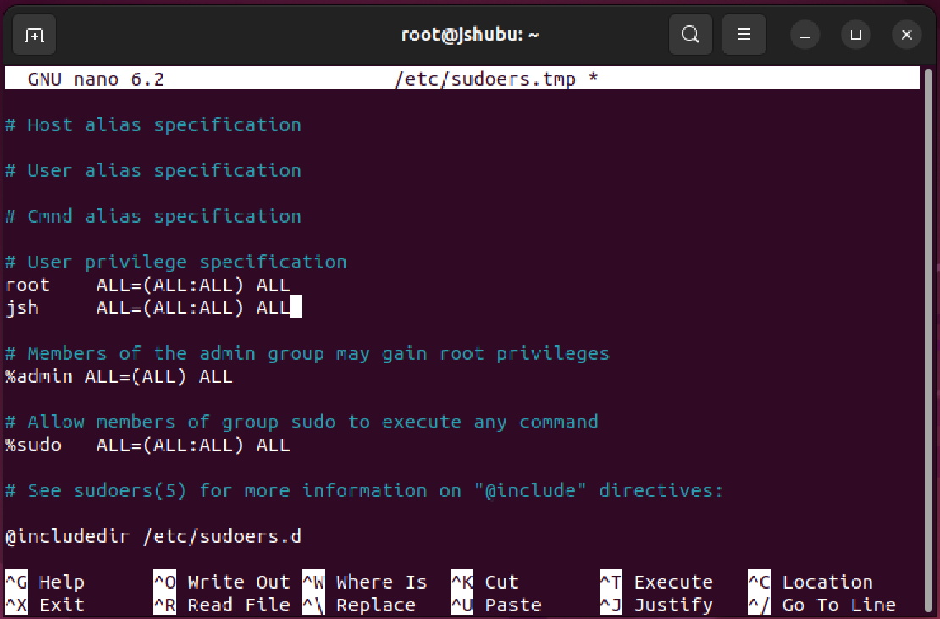

Append “**jsh ALL=(ALL:ALL) ALL**” to give permission. Save and exit by ctrl+X, Y and enter.

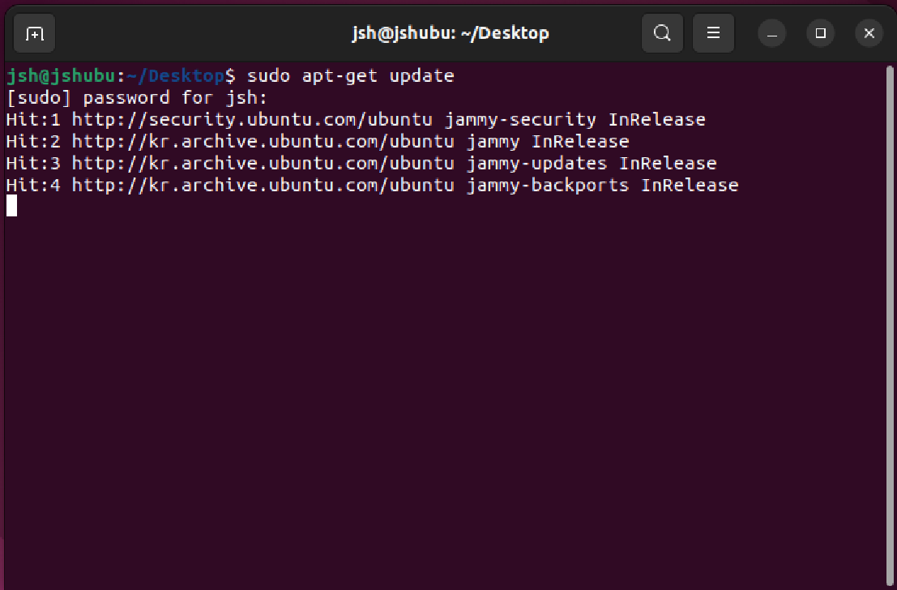

Apply updates. Now, sudo works fine with user account jsh.

## **1.2 Obstacles encountered, obstacles overcome**

AS the installation was done before during lecture, there was not so many obstacles that I encountered. However, even though I installed guest addition using the disk, still, copy-paste from outside virtual machine does not work for rocky server. As it works for ubuntu, it is an outstanding issue that I failed to make it work.

Also, because of the questions of assignment document mentioned about the command apt, I installed and made everything work on ubuntu at the first time. Changing every command and re applying for rocky was obstacle for every part of assignment as well.

# **2. Install and configure a DNS server using BIND on the virtual machine. Ensure that the DNS server can resolve local and external domain names.**

## **2.1 Setting DNS server**

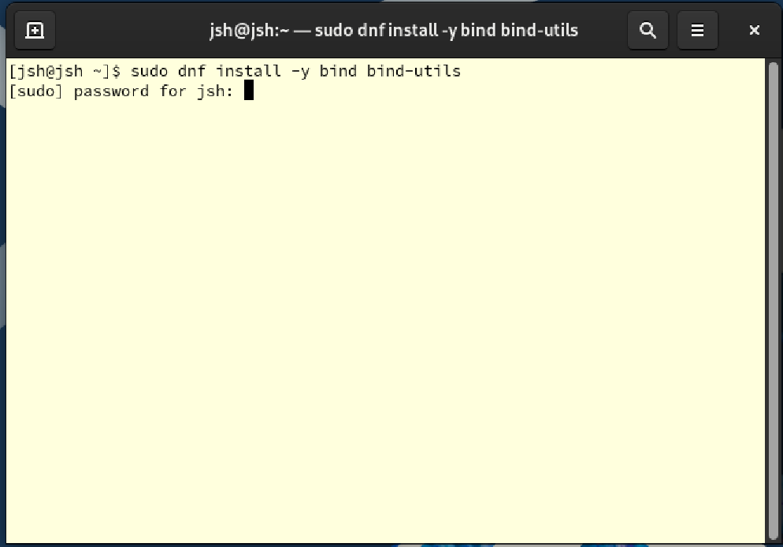

First, install the DNS tool ‘bind’and it’s utils using **sudo dnf install -y bind bind-utils**.

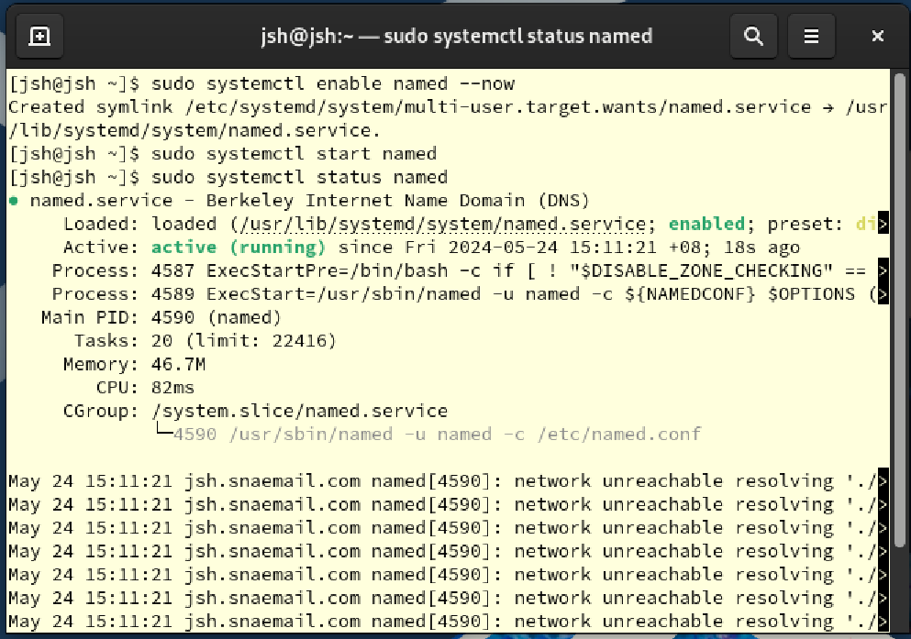

Enable it, start and see the status to check if it is properly working.

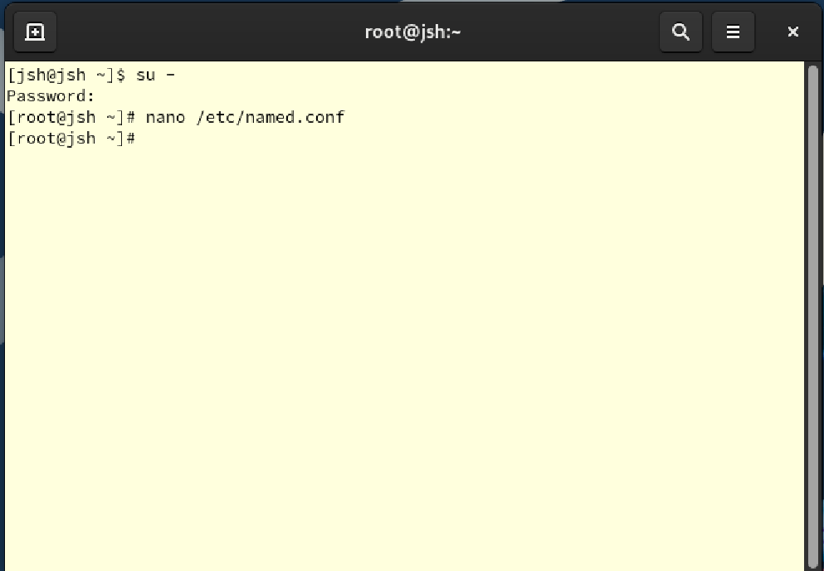

To reduce effort, get into root account by **su -**. Then open “named.conf” using **nano**.

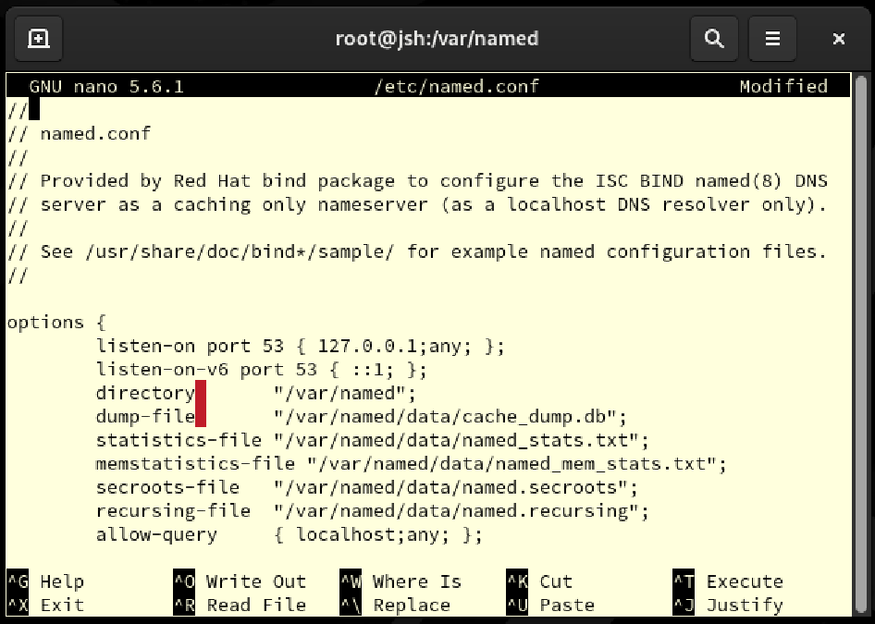

At the top of the file, edit options:

listen-on port 53 { 127.0.0.1; any; }: This option sets the DNS server to accept incoming DNS queries on port 53 from the IPv4 address 127.0.0.1 (localhost) and from any address.

listen-on-v6 port 53 { ::1; }: This option sets the DNS server to accept incoming DNS queries on port 53 from the IPv6 address ::1 (localhost).

Save and exit.

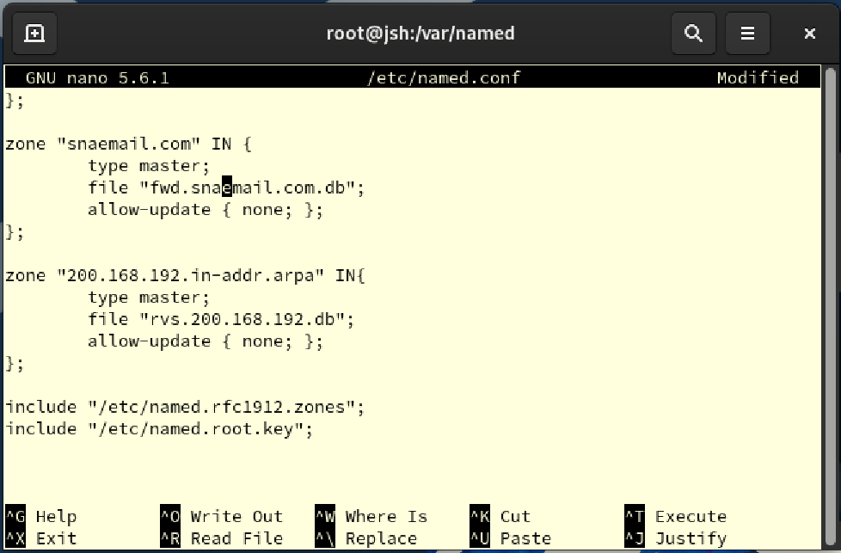

Here, write to set domain for DNS server. The name will be **jsh.snaemail.com**, so set as “**snaemail.com**”. It will not allow updates, and database will be recorded at “**fwd.snaemail.com.db**”. Same process is done for reverse DNS.

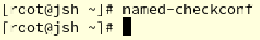

Using **named-checkconf**, check if there was any mistake.

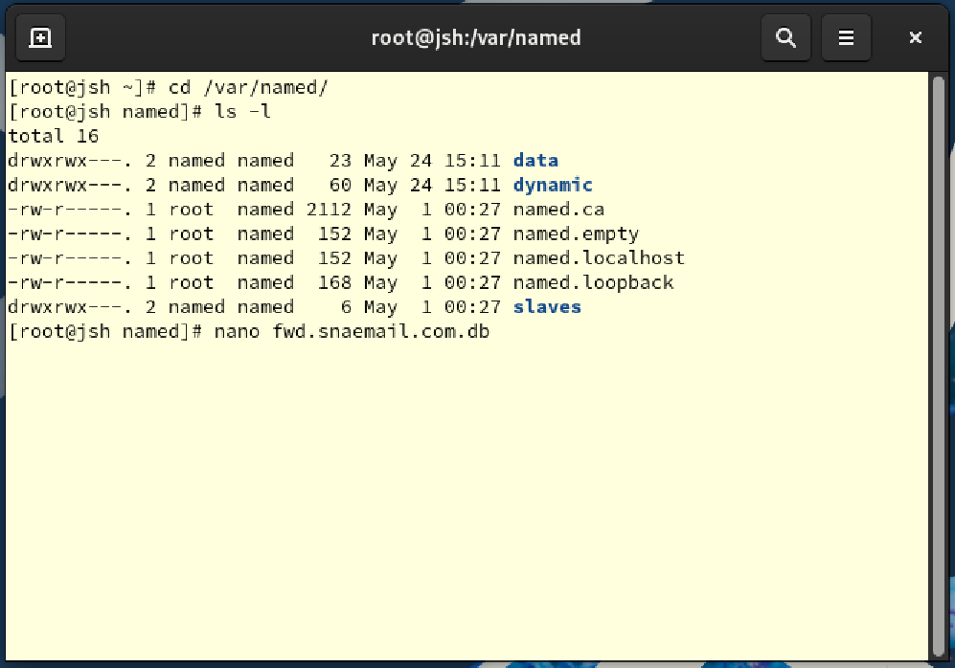

Now, move to /var/named using **cd** command, and list files and directories with details using **ls -l** command. Then create fwd. snaemail.com.db with nano.

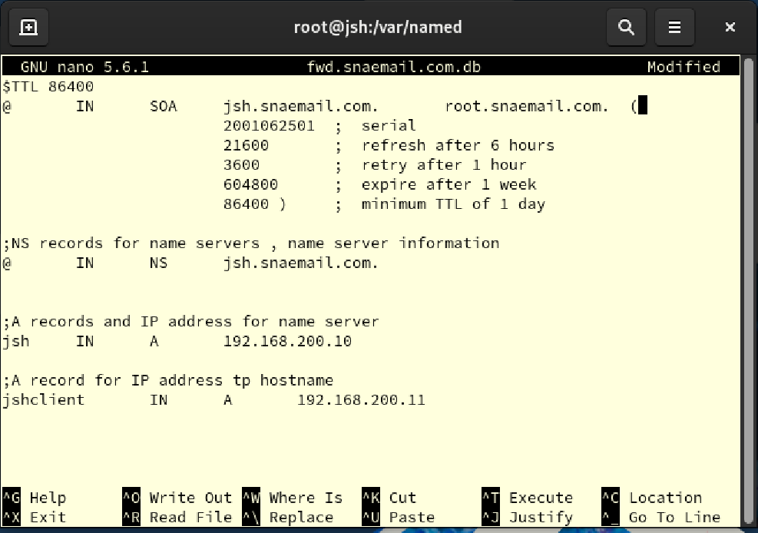

Here, write to set:

@IN SOA jsh.snaemail.com. root.snaemail.com.: This line defines the SOA record for domain. jsh.snaemail.com represents the primary nameserver and root.snaemail.com represents the email address of the administrative contact

2001062501: Serial number, indicating when this file was last changed.

21600: Refresh time (6 hours).

3600: Retry time (1 hour).

604800: Expiration time (1 week).

86400: Minimum TTL (1 day).

@ IN NS jsh.snaemail.com.: This line specifies jsh.snaemail.com as the name server for the snaemail.com domain.

jsh IN A 192.168.200.10: Specifies the IP address of jsh.snaemail.com as 192.168.200.10.

jshclient IN A 192.168.200.11: Specifies the IP address of the additional host, jshclient.snaemail.com, as 192.168.200.11.

Save and exit.



Now, create rvs.200.168.192.db to do the same.

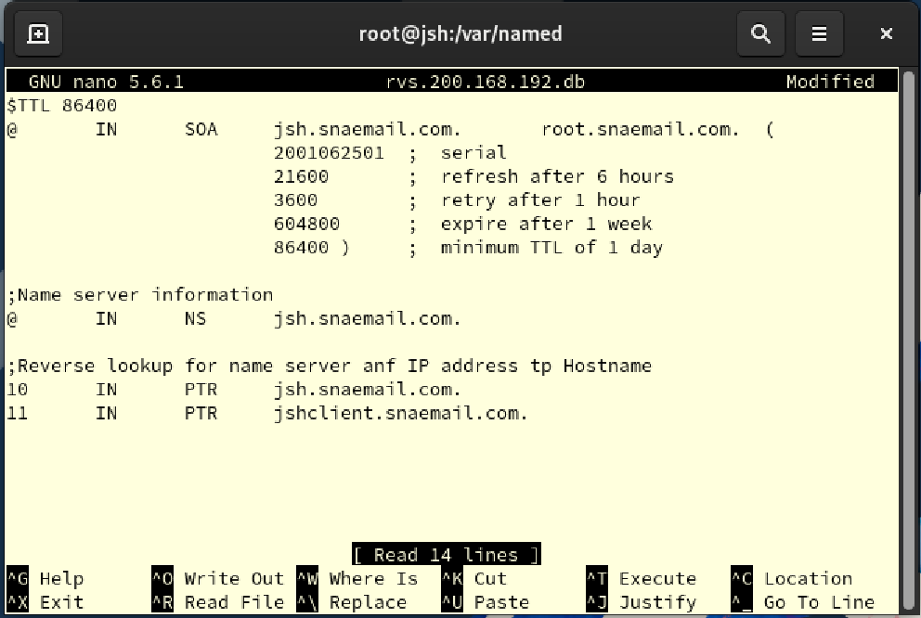

@IN SOA jsh.snaemail.com. root.snaemail.com.: This line defines the SOA record for the domain, where jsh.snaemail.com represents the primary nameserver and root.snaemail.com represents the email address of the administrative contact.

2001062501: Serial number.

21600: Refresh time (6 hours).

3600: Retry time (1 hour).

604800: Expiration time (1 week).

86400: Minimum TTL (1 day).

@ IN NS jsh.snaemail.com.: This line specifies jsh.snaemail.com as the name server for the network.

10 IN PTR jsh.snaemail.com.: Reverse maps IP address 192.168.200.10 to jsh.snaemail.com.

11 IN PTR jshclient.snaemail.com.: Reverse maps IP address 192.168.200.11 to jshclient.snaemail.com

Save and exit.

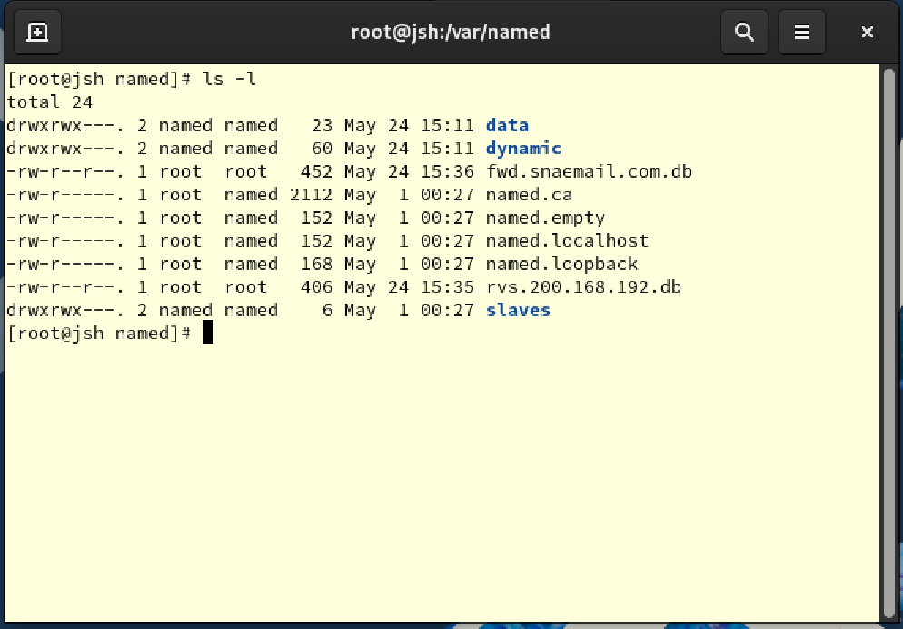

Now two database files are successfully created.

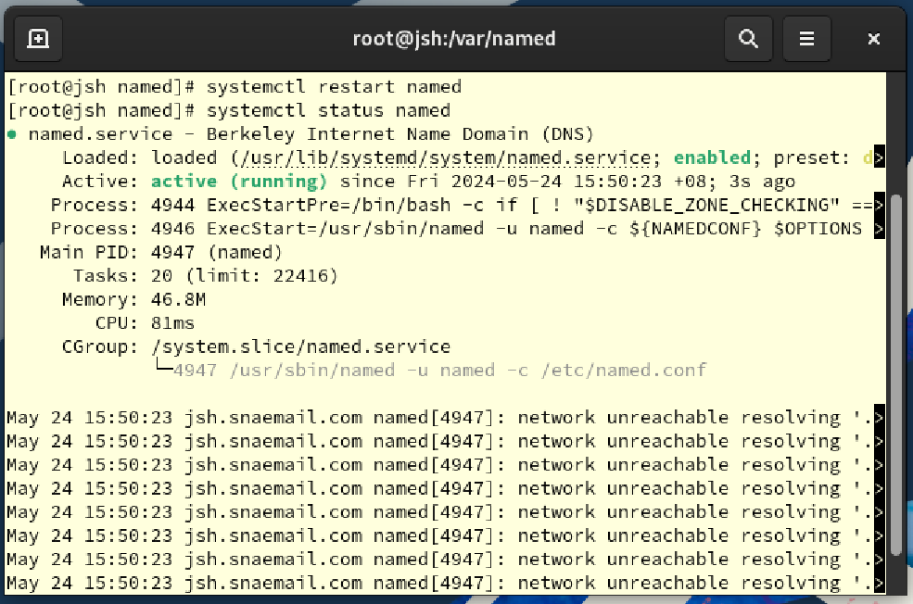

Restart DNS and check it is well functioning after the change. As shown in the screenshot, it does.

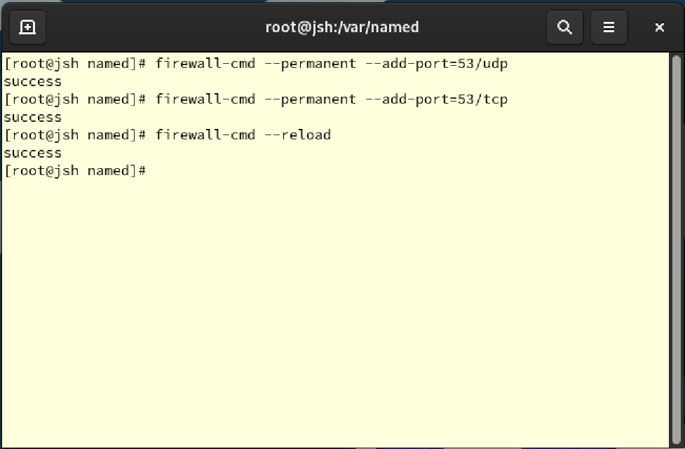

Set firewall using **firewall-cmd --permanent --add-port=53/udp**, **firewall-cmd --permanent --add-port=53/tcp** and **firewall-cmd –reload**. Here, to receive DNS queries, add port 53 using udp and tcp to firewall rules. Then reload firewall to apply change.



Open enp0s3.nmconnection using nano to set Network Manager.

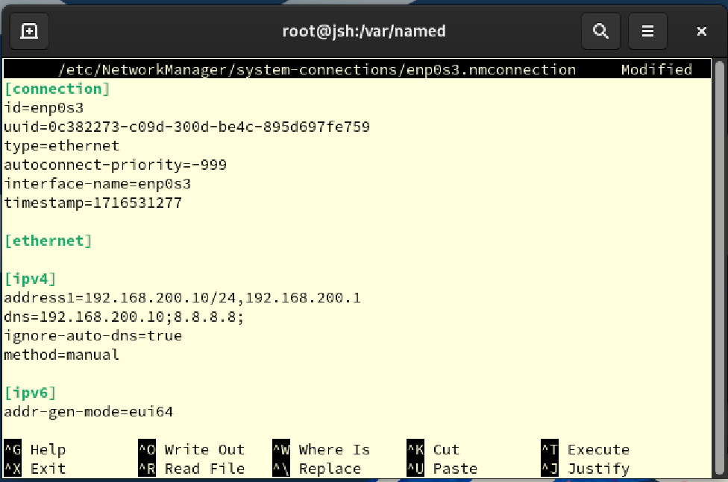

Enter dns ip to 192.168.200.10 which is ip of rocky server in local network, and 8.8.8.8 for google’s open source dns server. This ip will be used by network interface as dns server address. Also, add ignore-auto-dns=true, which will causes the network interface to override the DNS settings automatically provided by the DHCP server and use the DNS settings manually specified above. Save and exit.



Now, restart Network Manager to apply change. Then open resolv.con using nano.

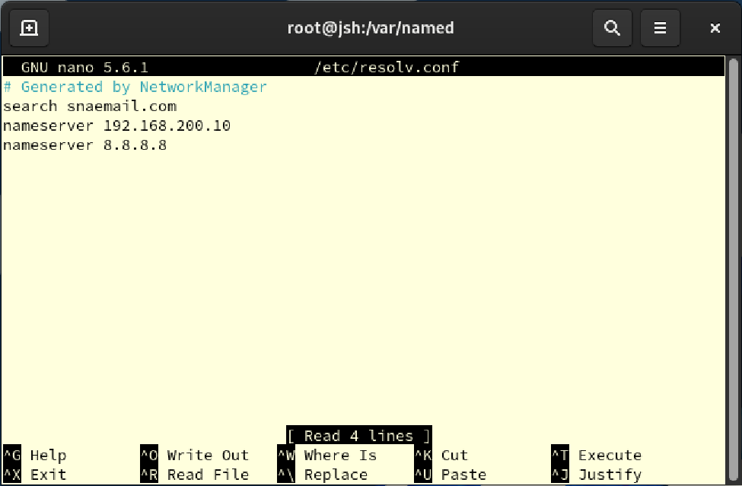

Add lines to the file shown as screenshot. This will automatically add snaemail.com to dns domain, make dns query to use 192.168.200.10 ip for the first server then 8.8.8.8 when 192.168.200.10 does not answer. Save and exit.



Restart named to apply change.

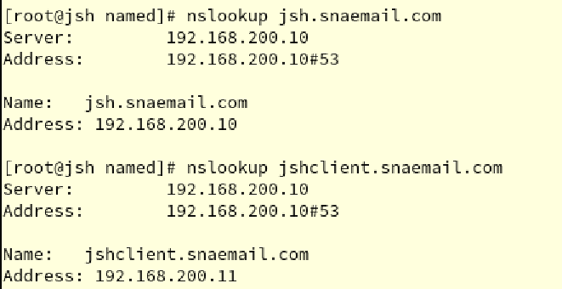

Now, using nslookup, test if dns is working. As set, it answers correctly. For ip address 192.168.200.11 which is address for ubuntu client, it also responds correctly, showing name jshclient.snaemail.com as set.

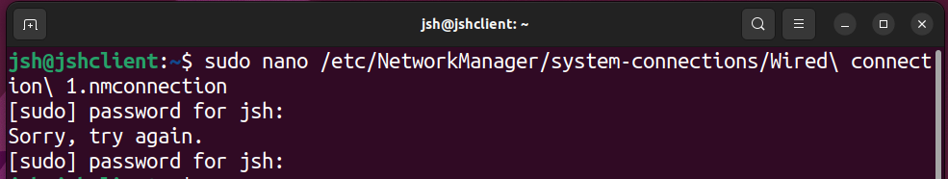

To set ubuntu as well, for ubuntu, open current connection using nano.

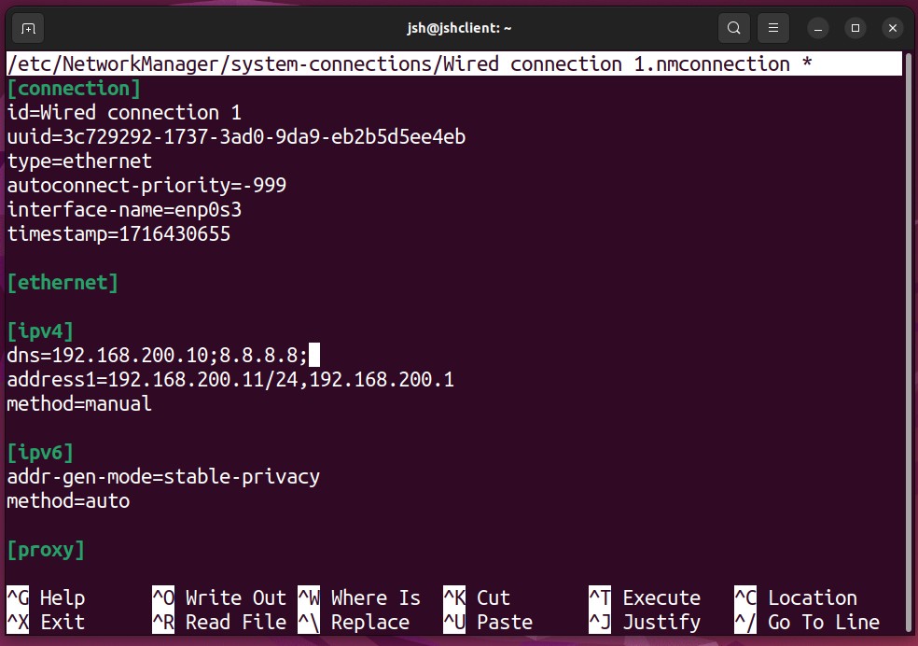

Here, same as in rocky, set dns at ipv4 settings according to ip address of ubuntu client which is 192.168.200.11. Save and exit.

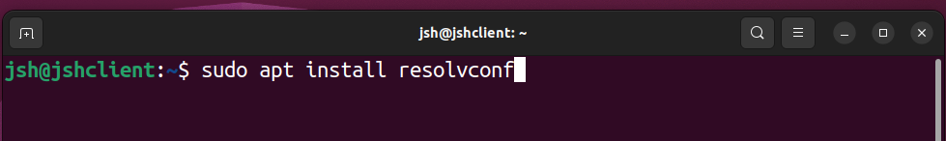

Then, install resolveconf package to automatically update dns configuration when system and network settings are changed.

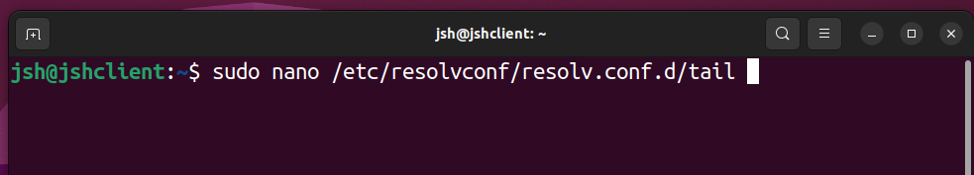

Open resolv.conf.d/tail to modify settings using nano.

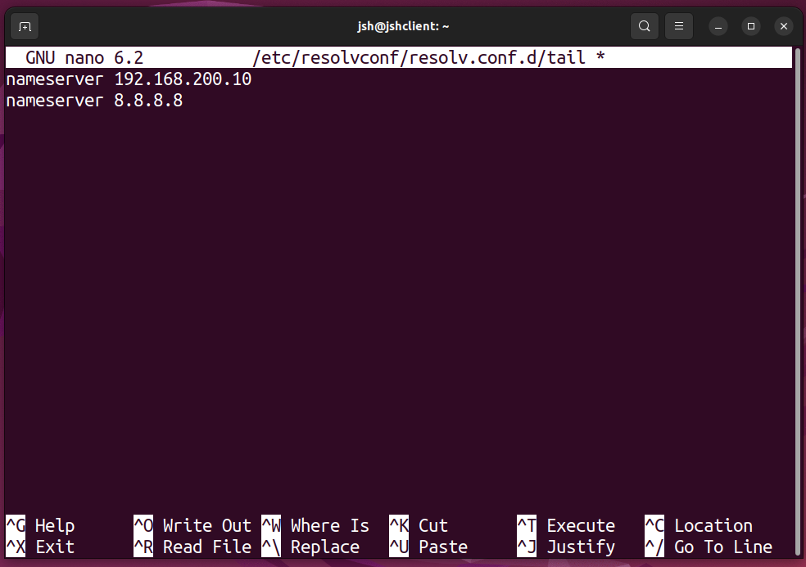

Here, same as in rocky, dns quary will be sent first to ip 192.168.200.10, then 8.8.8.8. Save and exit.



Open NetworkManager.conf using nano.

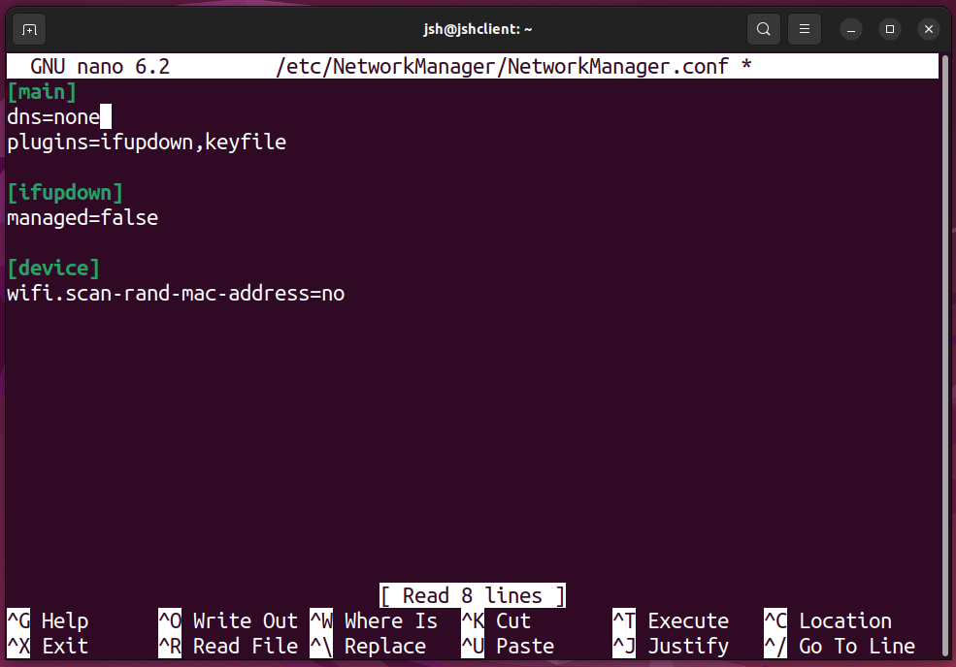

Add dns=none to prevent NetworkManager from changing resolve.conf file. Save and exit.

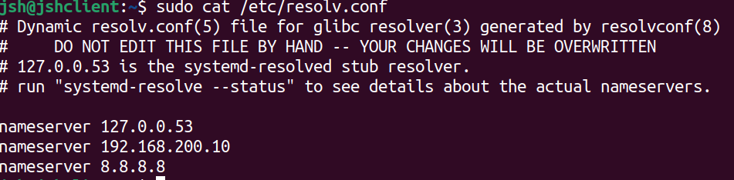

See the details of resolve.conf file using **cat** command. Ips’ are added.

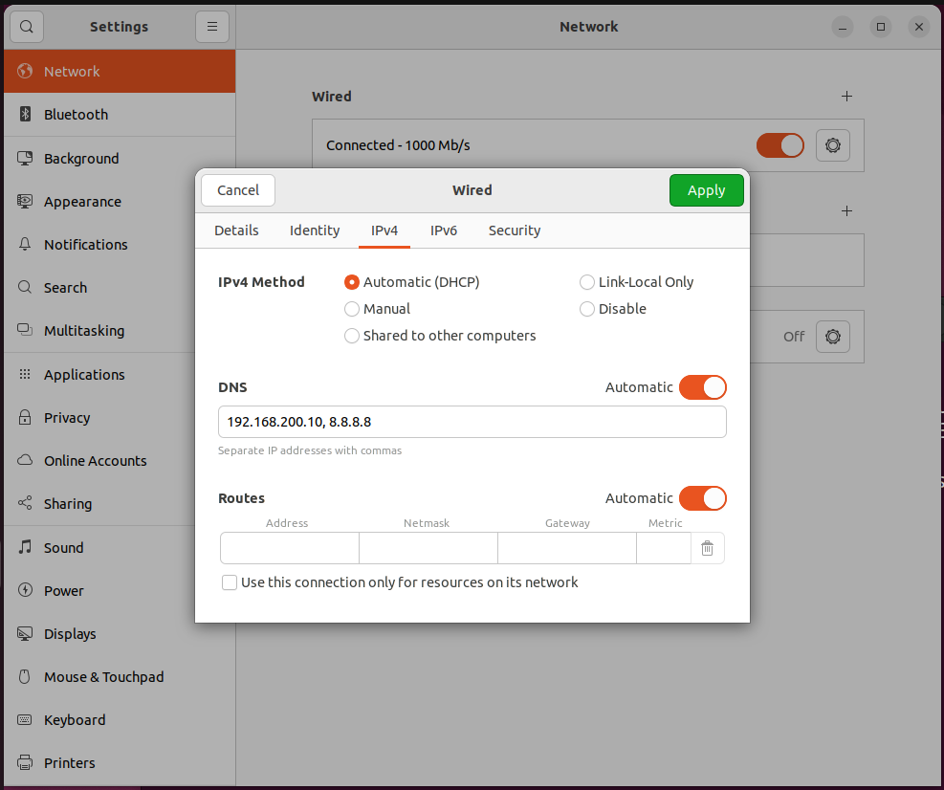

To check wired connection, using ui of ubuntu, check if the network is following the settings and change it accordingly.

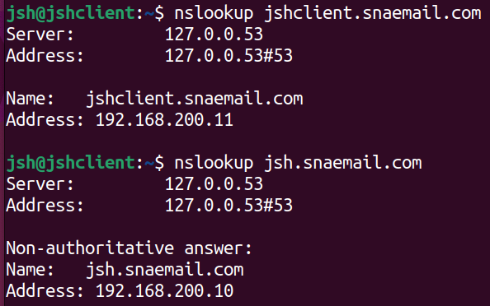

Using nslookup, check dns at ubuntu client. As shown in the screenshot, it is functioning well.

## **2.2 Obstacles encountered, obstacles overcome**

As same as installation, as this process was done before in tutorial classes, there was no hard obstacles that I encountered. However, there were some minor issues that I faced. While setting the dns for rocky server, I accidentally skipped modifying named.conf file’s upper part. Because of the issue, bind was not restarting correctly. To fix it, I needed to do everything from start.

# **3. Install and configure a DHCP server using DHCPd on the virtual machine. Configure the DHCP server to assign IP addresses to clients on the local network.**

## **3.1 Setting DHCP server**

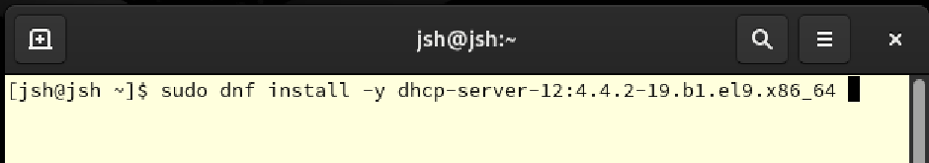

First, install dhcp server.



Open dhchp.conf file using nano to change settings.

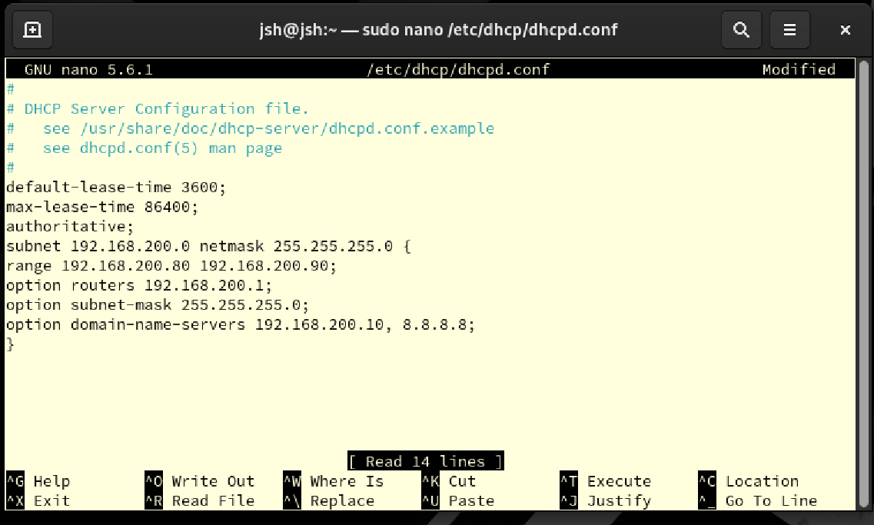

Write following to set dhcp:

default-lease-time 3600;

Set the default validity time for DHCP leases to 3600 seconds (1 hour).

max-lease-time 86400;

Set the maximum valid time for a DHCP lease to 86400 seconds (24 hours).

authoritative;

Indicates that this DHCP server is the authoritative server for the network segment. This option serves to protect clients from other misconfigured DHCP servers.

subnet 192.168.200.0 netmask 255.255.255.0 {

This subnet declaration defines a network with IP addresses ranging from 192.168.200.0 to 192.168.200.255.

range 192.168.200.80 192.168.200.90;

Limits the range of IP addresses that a DHCP server can assign to between 192.168.200.80 and 192.168.200.90.

option routers 192.168.200.1;

Specify 192.168.200.1 as the IP address of router to use as the default gateway for ubuntu client.

option subnet-mask 255.255.255.0;

Specify 255.255.255.0 as the subnet mask to assign to the client.

option domain-name-servers 192.168.200.10, 8.8.8.8;

Specifies the address to use as the DNS server for the client. Use the ip for rocky server 192.168.200.10 and Google's public DNS server 8.8.8.8.

Save and exit.

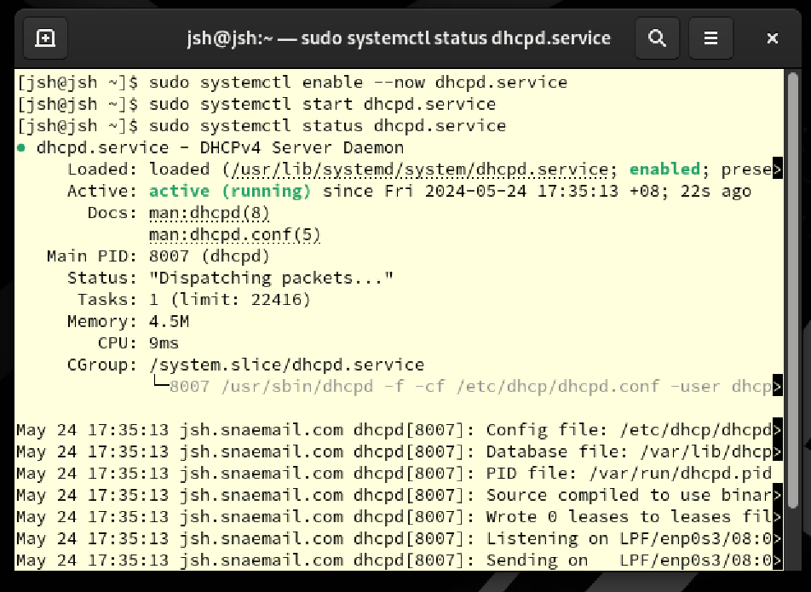

Enable, start, and check status of dhcpd. As the screenshot shows, it is working well.

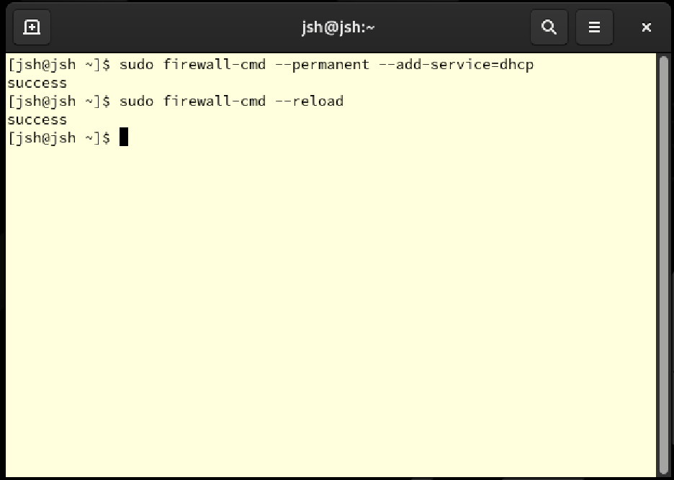

Update firewall rule to accept dhcp and reload firewall to apply change.

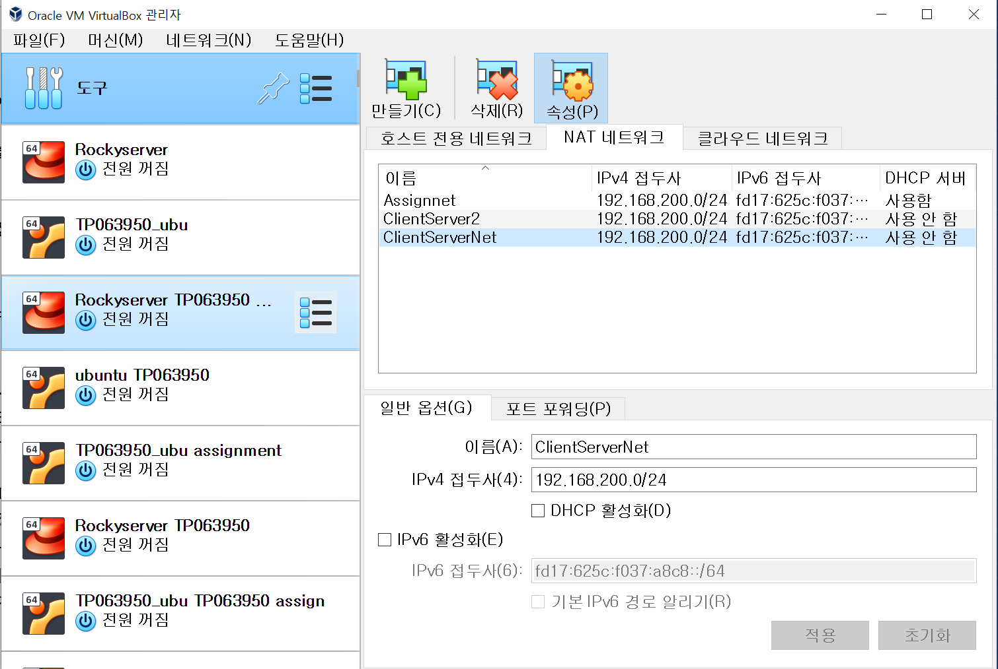

Now, change the network to ClientServerNet which has disabled DHCP.

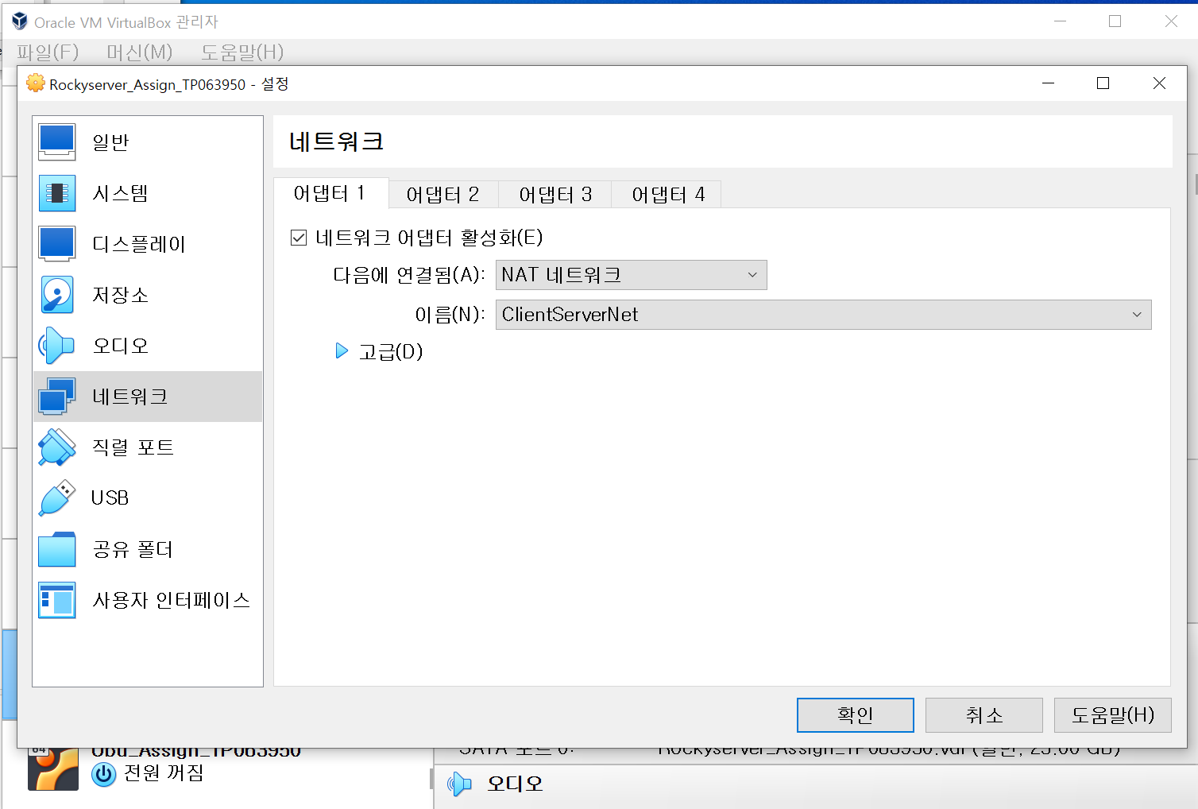

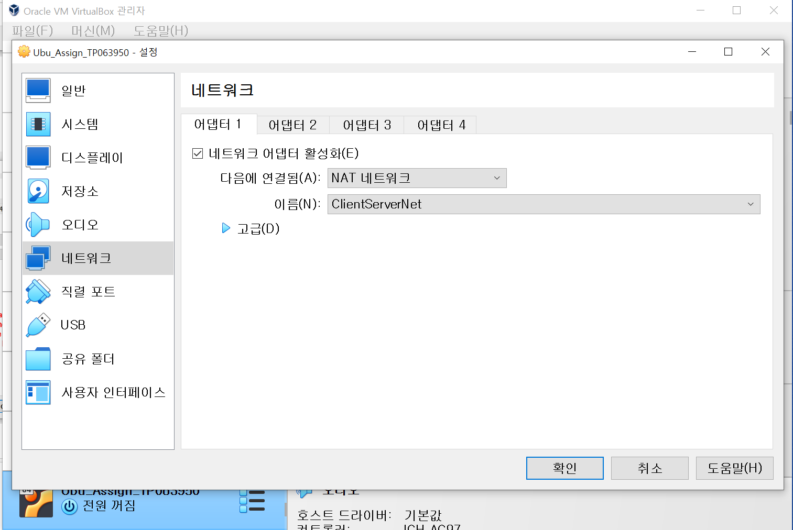

For both rocky server and ubuntu client, change the network to ClientServerNet.

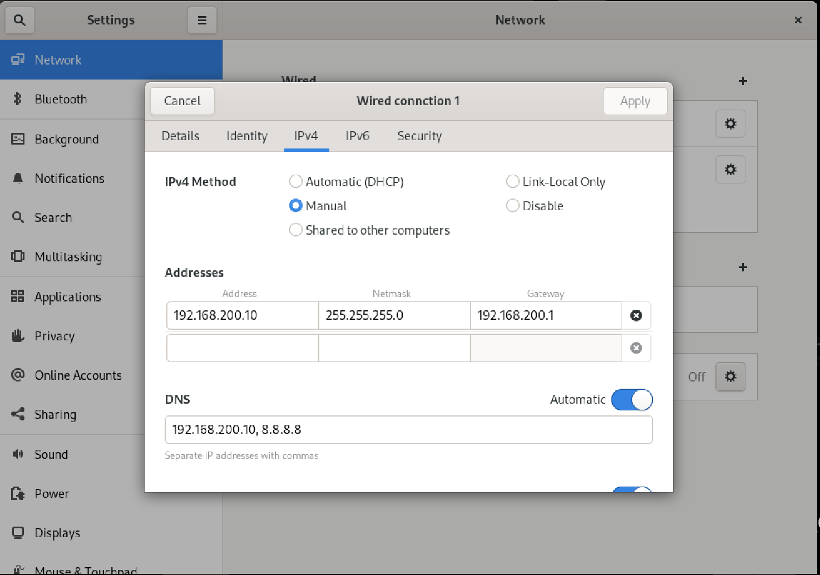

Now, for rocky server, check connection by ui and set the method to manual, set addresses and dns.

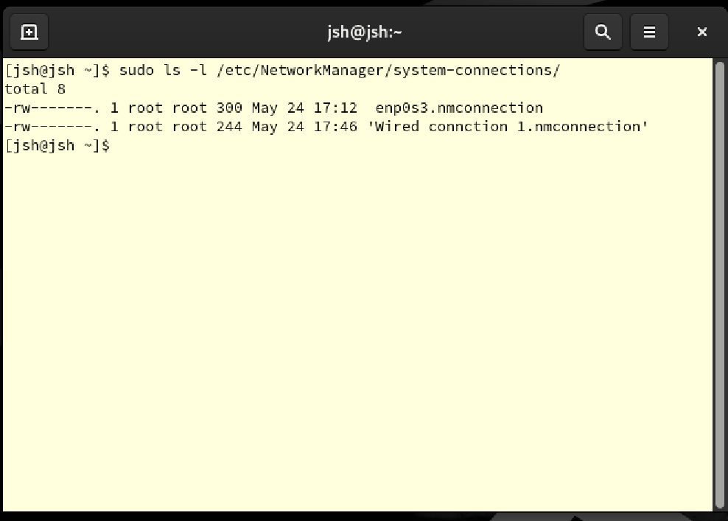

To change the settings for network, check what network the server is connected using ls -l for existing files. Here, enp0s3 and Wired connection 1 are shown.



Using nano, open settings for Network Manager for network Wired connection 1.

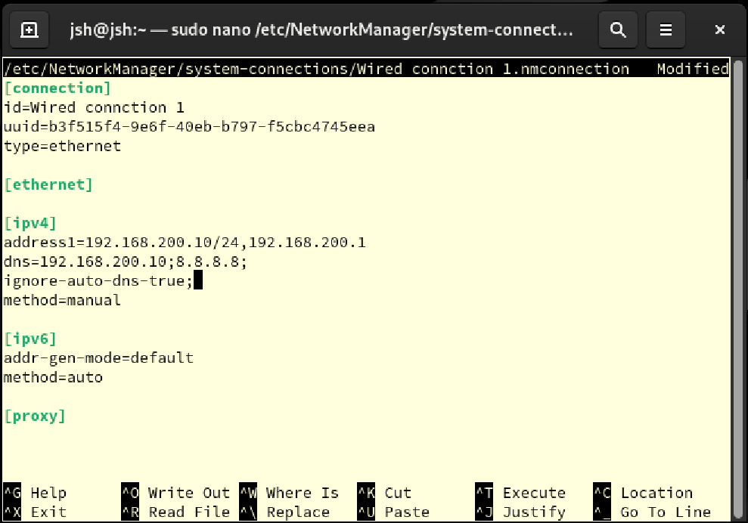

Here, check id of connection matches the network ui, and set ipv4 area.

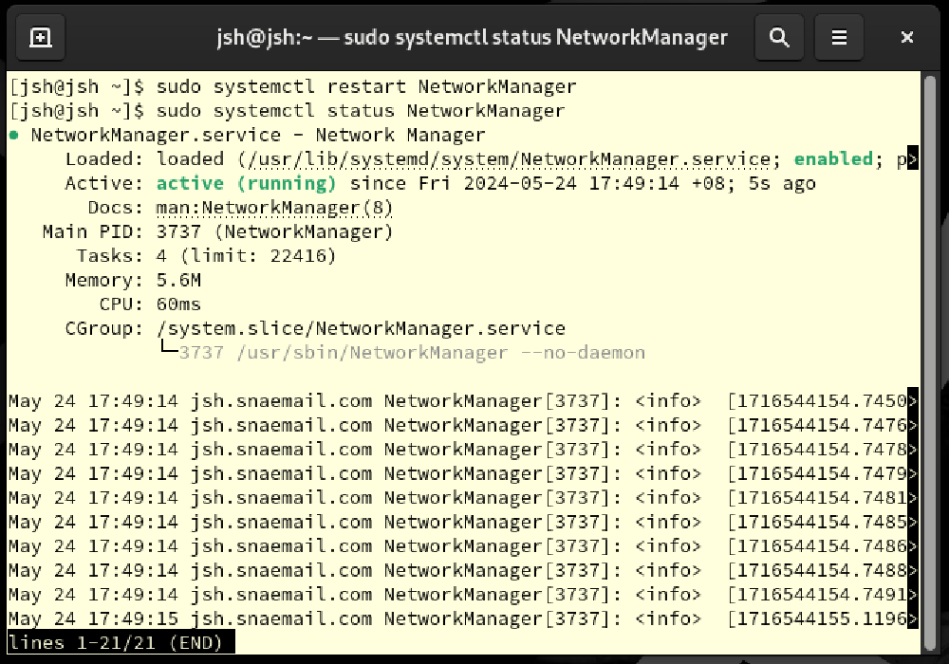

Restart to apply change to Network Manager and view status using **status** command. As shown, it is functioning well.

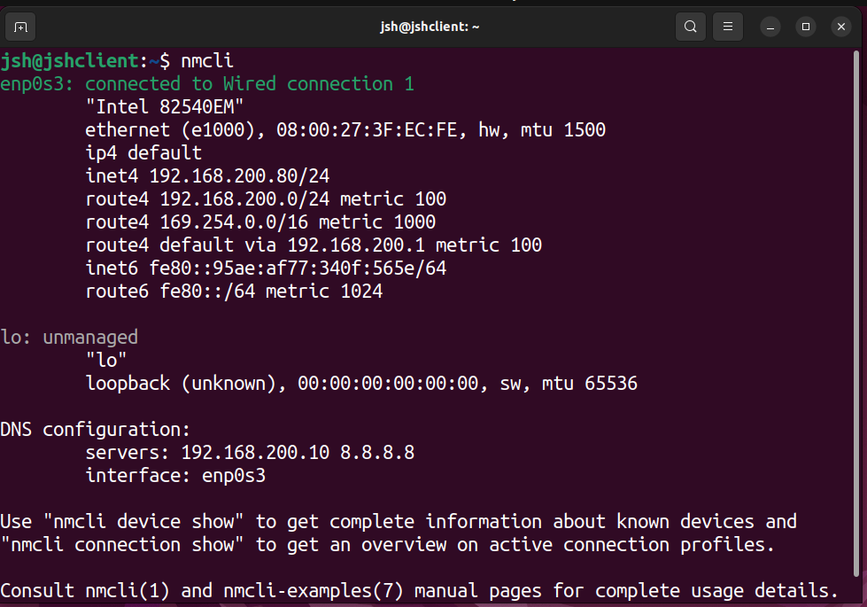

For ubuntu client, check the connection using nmcli to check the connection. Here, it is showing that it is connected correctly to server 192.168.200.10.

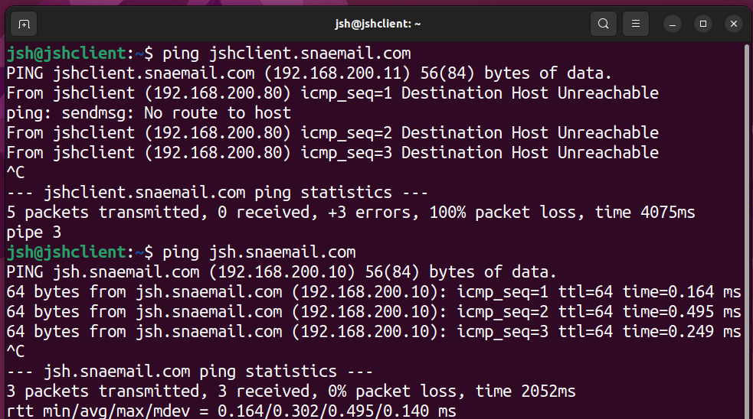

Now, using ping command, check if the dhcp is correctly set. As dhcp is set, pinging to jshclient.snaemail.com does not work, while pining to jsh.snaemail.com works.

## **3.2 Obstacles encountered, obstacles overcome**

As same as before, as this process was done before in tutorial classes, there was no hard obstacles that I encountered. Here, reason of jshclient.snaemail.com not working was unknow for the first time, so I sent time to evaluate the reason. However, unlike other parts of the assignment, this part was done smoothly.

# **4. Install and configure an email server using Postfix and Dovecot on the virtual machine. Configure the email server to allow local users to send and receive emails.**

## **4.1 Setting email server**

### **4.1.2 Setting Postfix**

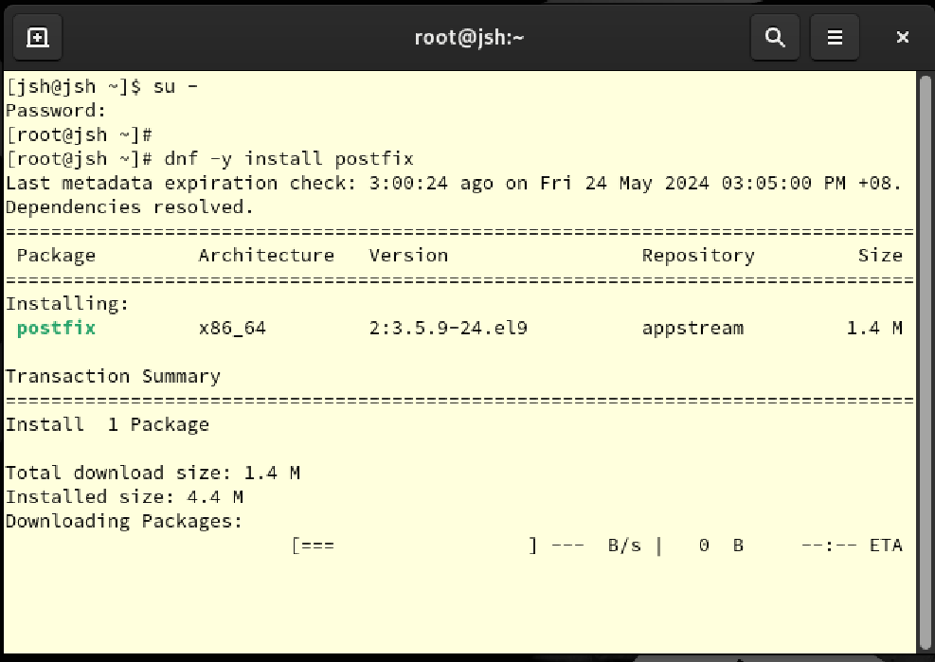

To reduce procedure, login to root account by su – command. Then, install postfix.



Open main.cf to change setting of postfix.

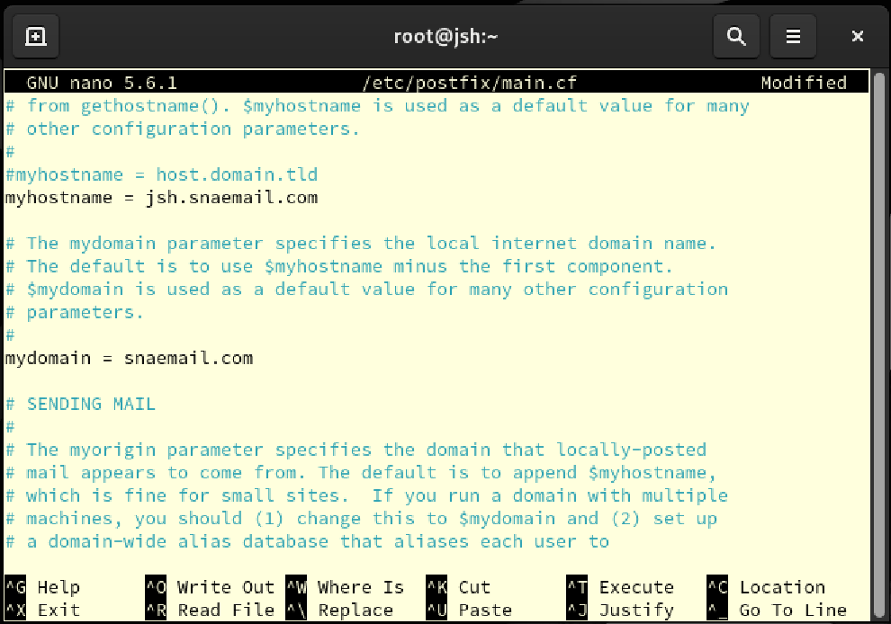

Write the hostname and domain to “jsh.snaemil.com” and “snaemail.com” each.

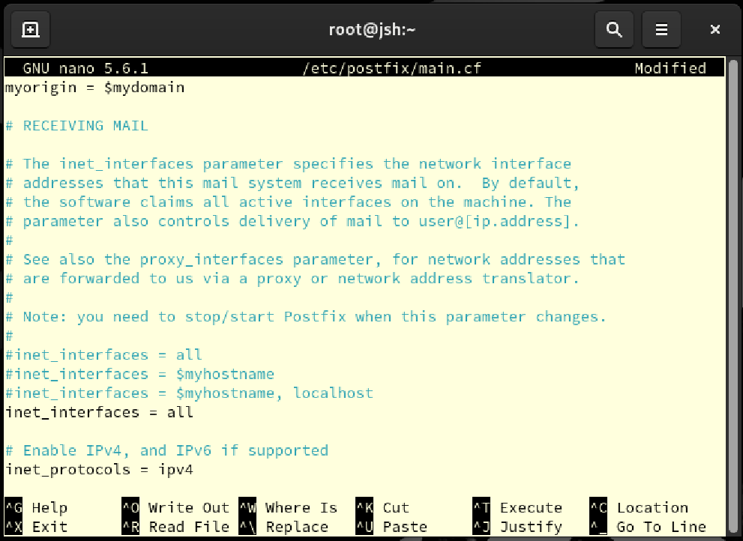

Write myorigin = $mydomain, inet_interfaces = all, and inet_protocols = ipv4 to set domain for mail as snaemail.com, listen to all network interface, and set postfix to use ipv4 address only.

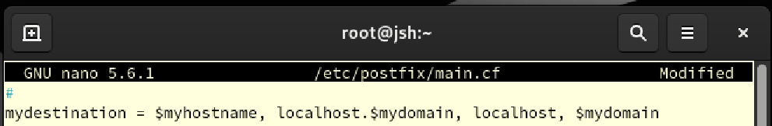

Specify a list of domains from which Postfix can directly deliver mail.

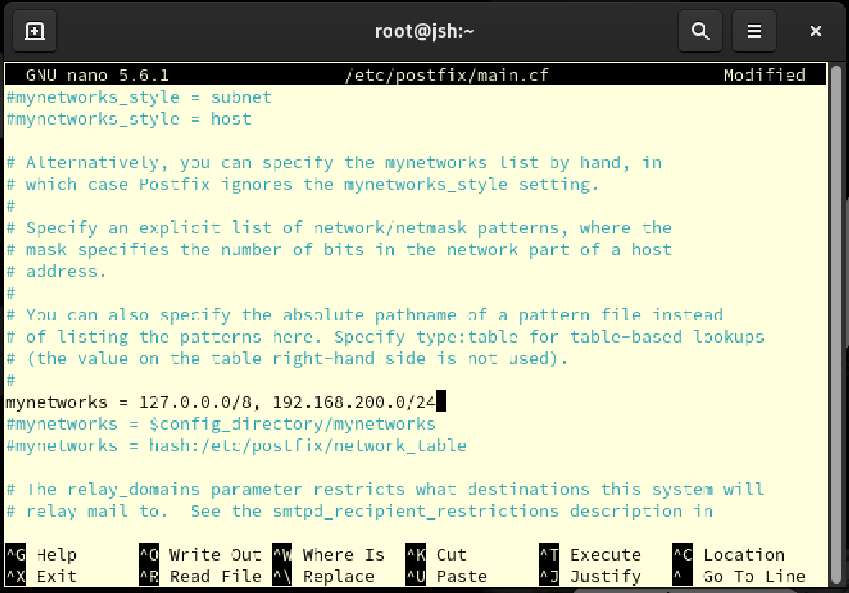

Set networks which can send email without certification. Here, ip addresses 127.0.0.0/8 which is localhost and 192.168.200.0/24 which is local network are chosen.

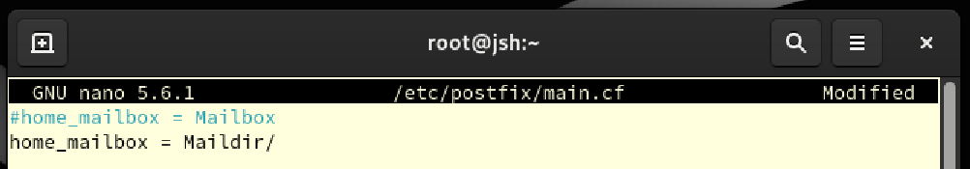

Set home directory as Maildir/.

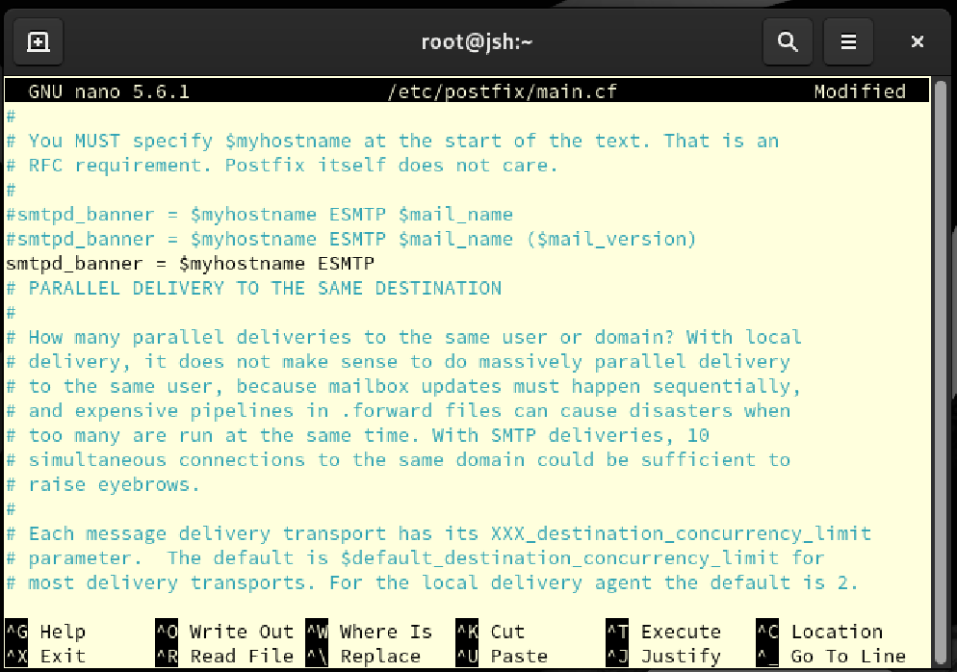

Set banner as ESMTP using myhostname which is set as jsh.snaemail.com.

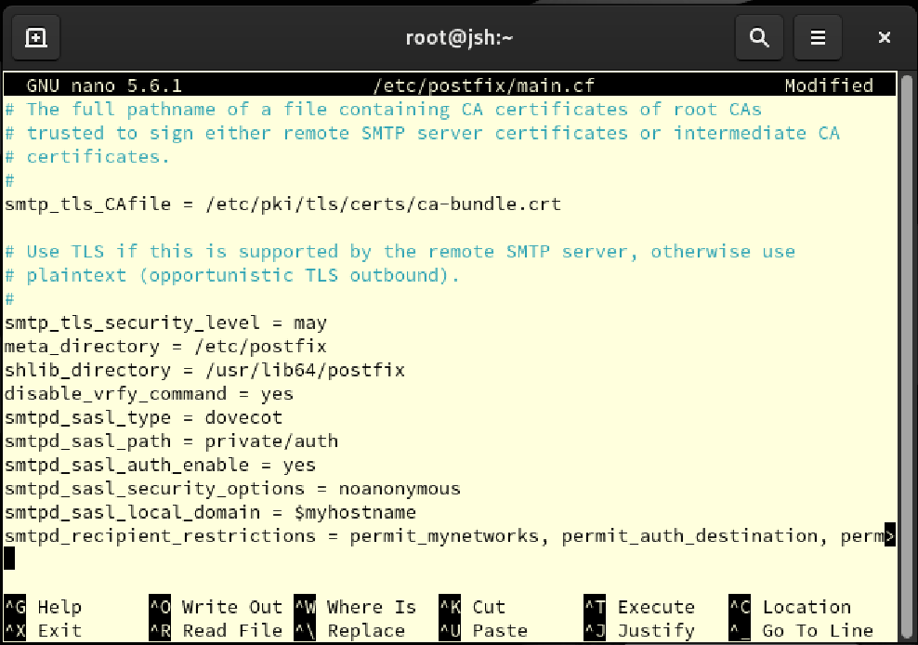

At the end of file, add following commands:  
  
smtp_tls_security_level = may

This setting specifies that Postfix should use TLS in connections with remote SMTP servers if TLS is available. The "may" option uses TLS only if TLS is available, and if not, continues transmission as plain text. This is known as opportunistic TLS (outbound).

disable_vrfy_command = yes

This setting disables the VRFY command. The VRFY SMTP command is used to check with a mail server whether a given mail address is valid. Disabling this command makes spamming more difficult and is often used to increase system security.

smtpd_sasl_type = dovecot

Specifies the type of mechanism used to handle Simple Authentication and Security Layer (SASL) authentication. Here I use dovecot to manage authentication.

smtpd_sasl_path = private/auth

Specifies the path to the socket that contains SASL authentication data. This route is used to exchange authentication information between Postfix and Dovecot.

smtpd_sasl_auth_enable = yes

Enable SASL authentication to require authentication during mail transmission.

smtpd_sasl_security_options = noanonymous

This setting prevents SASL authentication for anonymous users. This means that all users must provide valid identification information.

smtpd_sasl_local_domain = $myhostname

Specifies the local domain to use for SASL authentication.

Save and exit.

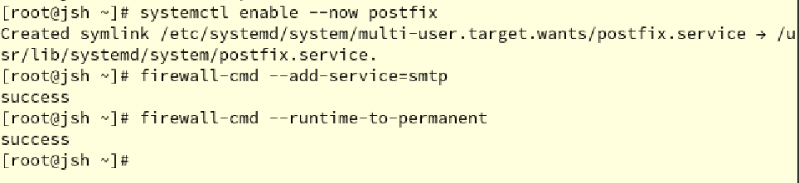

Now, enable the postfix and add firewall rule to allow smtp.

### **4.1.2 Setting Dovecot**

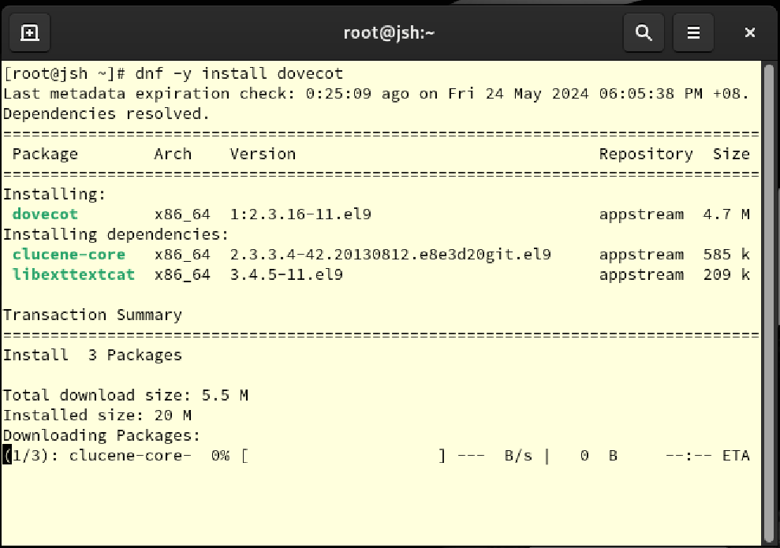

Install Dovecot

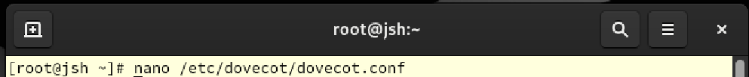

Open dovecot.conf file using nano to change setting of dovecot.

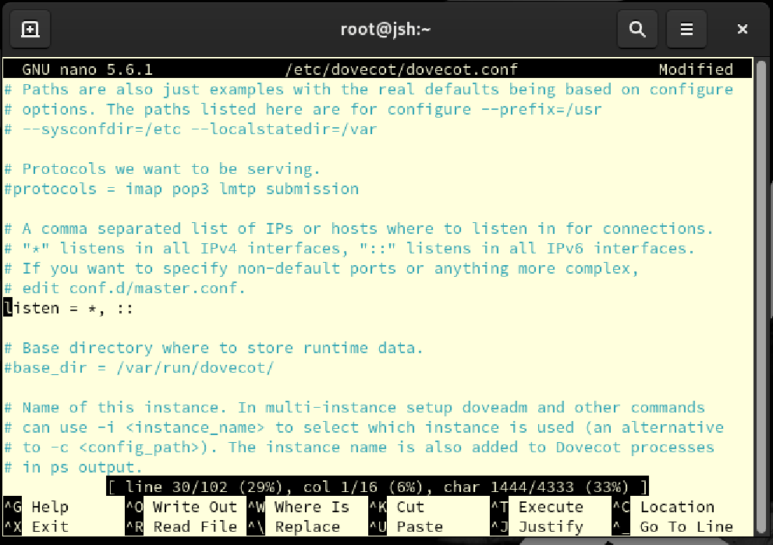

Set *listen = , :: , which will let dovecot accept every connection from ipv4 and ipv6.

Save and exit.

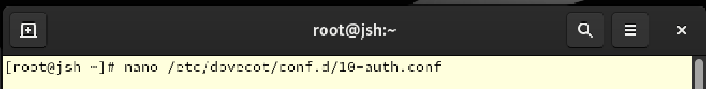

Open 10-auth.conf to change setting of dovecot using nano.

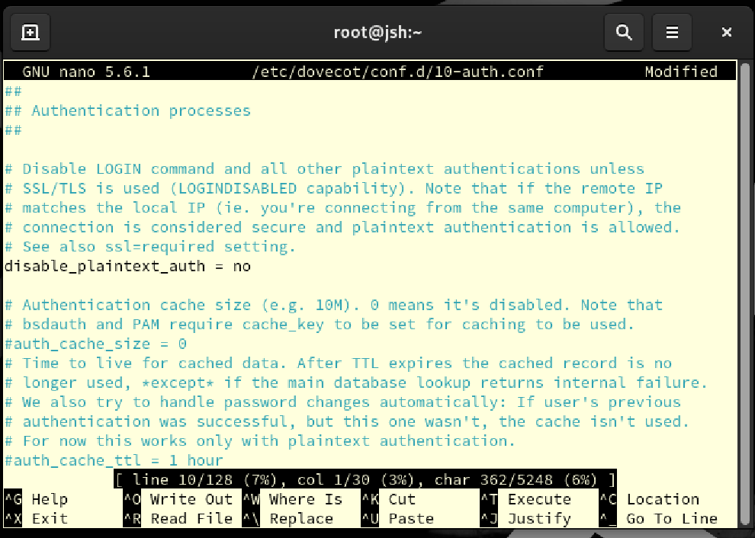

disable_plaintext_auth = no will let it to send user name and password even in connection not in SSL/TLS.

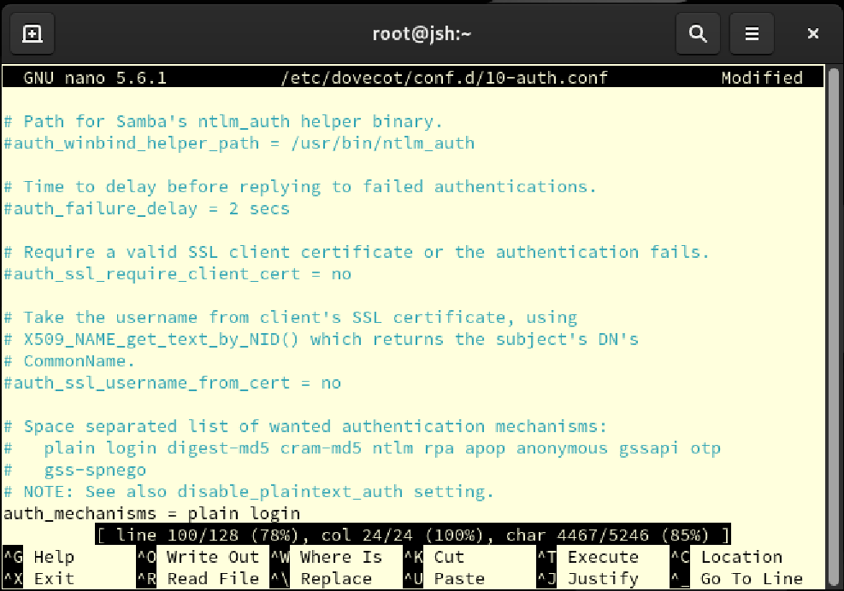

auth_mechanisms = plain login will set certification mechanism to plain and login. Save and exit.

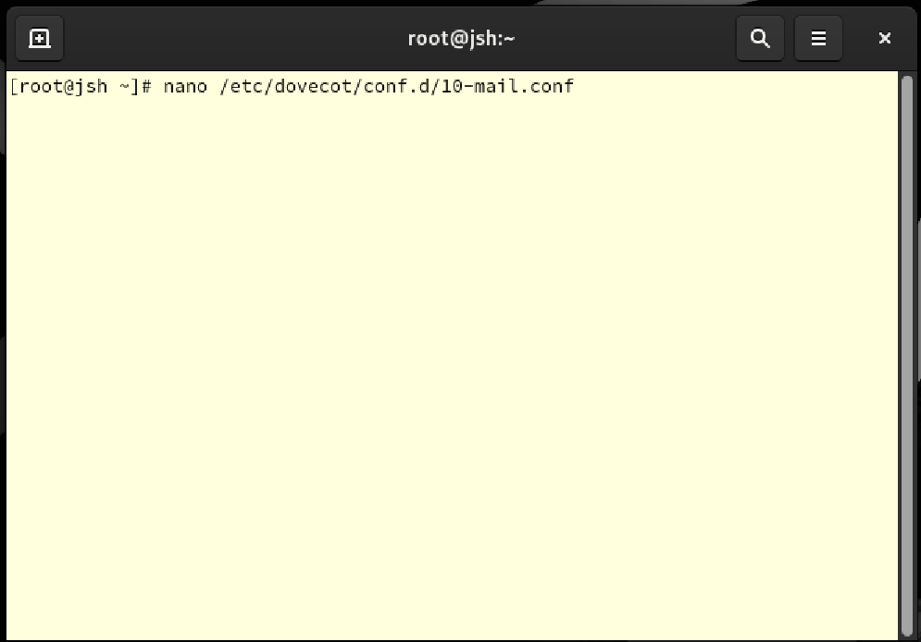

Open 10-mail.conf to change setting of dovecot using nano.

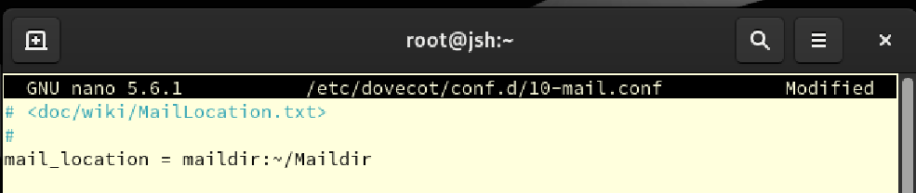

Set mail location at /Maildir in maildir form. Save and exit



Open 10-master.conf to change setting of dovecot using nano.

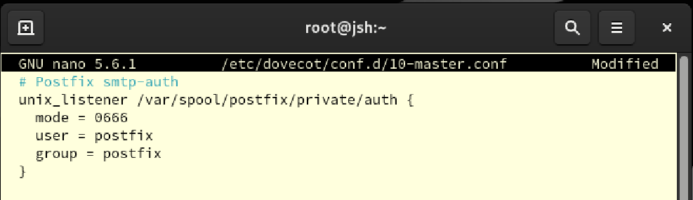

Here, let postfix to have all permission and own unix socket file, so that it can certify SMTP using dovecot while sending email. Save and exit.

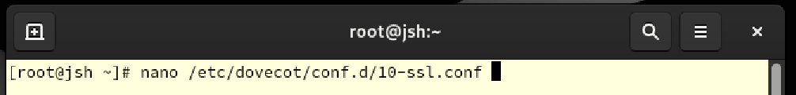

Open 10-ssl.conf to change setting of dovecot using nano.

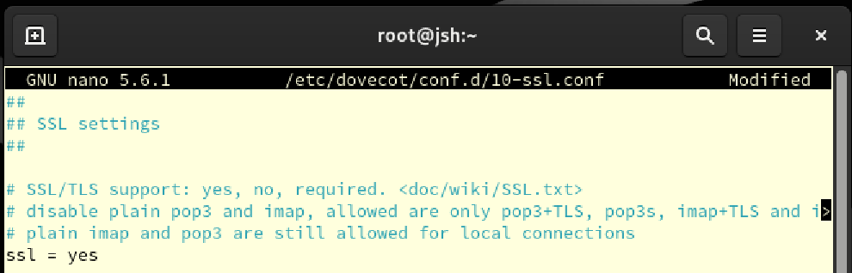

This set SSL/TLS enabled for dovecot which will make it to use SSL/TSL while sending emails. Save and exit.

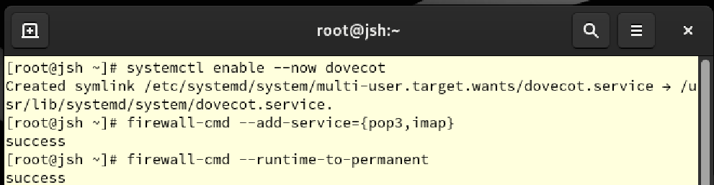

Add firewall rule to accept dovecot, add pop3 and imap which are the services used for dovecot while sending the email. Update the firewall rule.

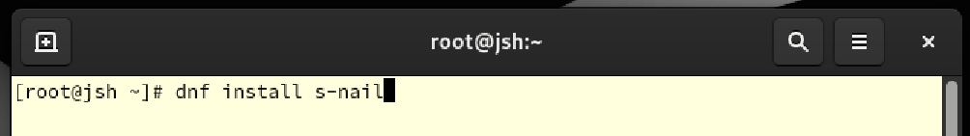

To check the postfix and dovecot, test mail will be sent. Install s-nail to use it for sending email.



Now, Maildir directory is set as mail storage automatically.

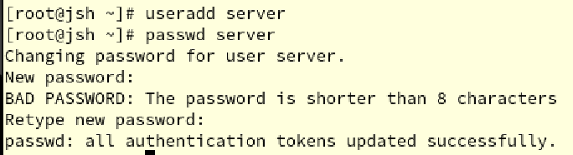

Add user ‘server’ for testing purpose. The password is set as “SNA1234” as well.

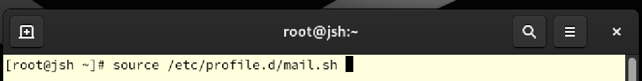

Apply setting to current profile.

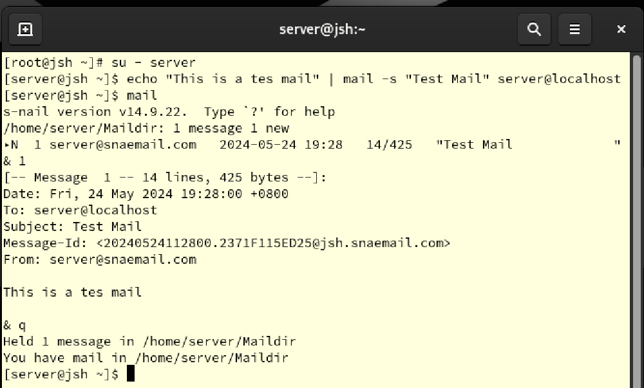

Login as server, and send email using s-nail. From the end of the script, the fact that the email was sent can be checked.

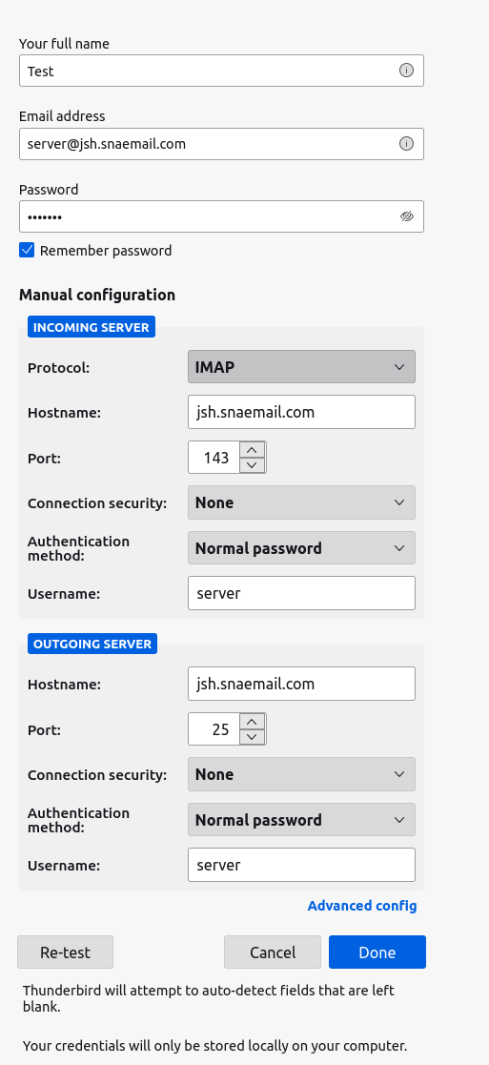

Now, add user “server” to thunderbird in ubuntu. As this is check purpose, no SSL/TLS is applied.

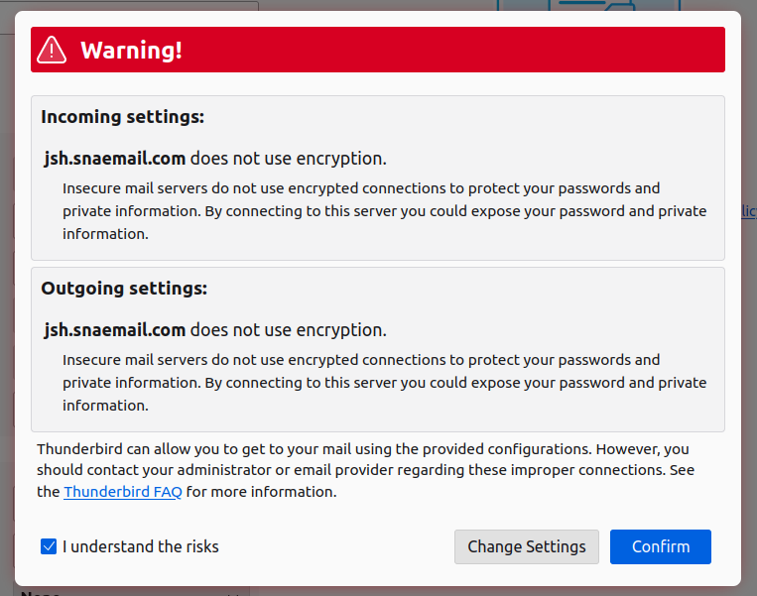

Because of it, warning sign shows up. Check the understand and press confirm to proceed.

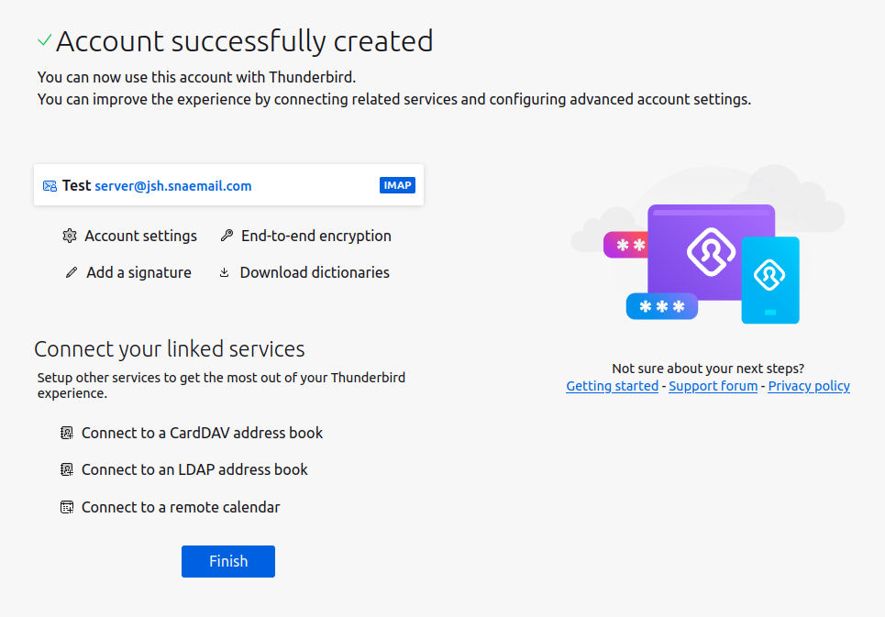

Now, account is successfully created in thunderbird.

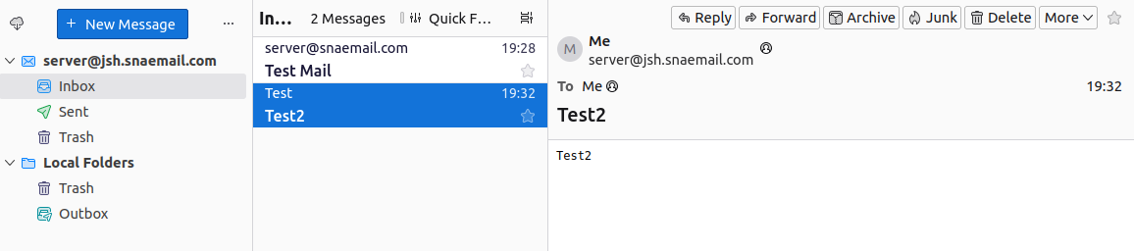

In the thunderbird, new mail “Test2” was sent using thunderbird, which went well as shown.

## **4.2 Obstacles encountered, obstacles overcome**

Installation of postfix and dovecot was totally new to me. While setting up, there were multiple attempts, as the mail was not being properly sent.

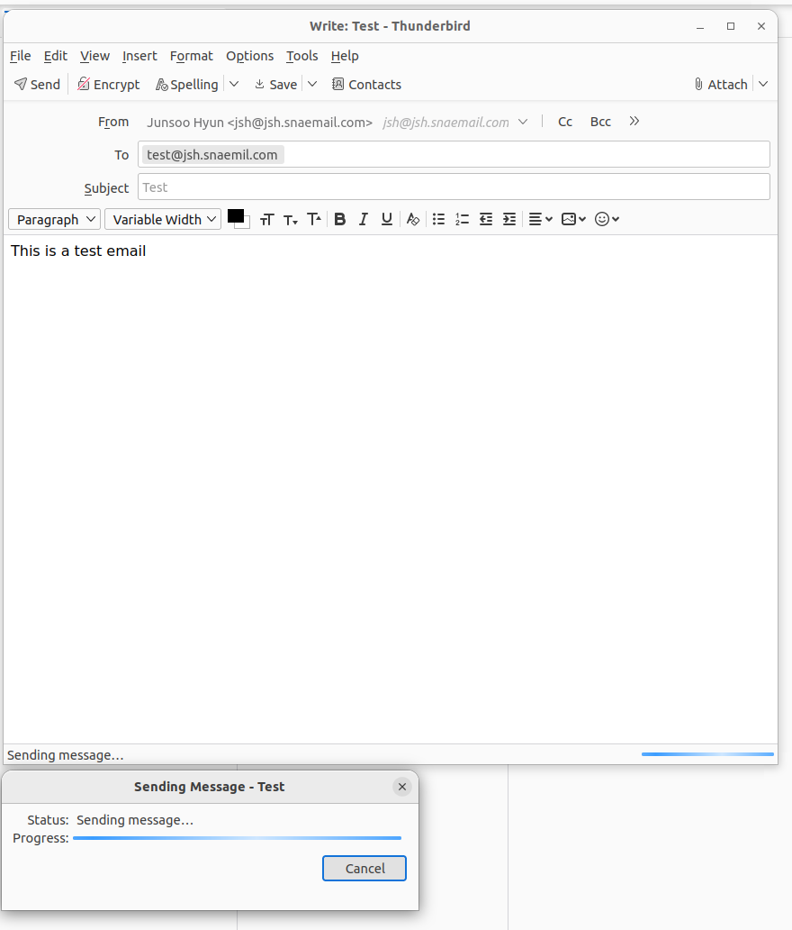

Like in this screenshot, the email was not being sent, being halt in sending state. This was because of other settings that I did in tutorials and didn’t figure out which is it exactly until now. As I used copy of the server which I used for tutorials, settings that I did not finish made it more complicated. And my attempts to fix it made it harder to figure out the problem.

To solve it, I needed to set totally new server from scratch.

# **5. Install and configure a web server using Apache on the virtual machine. Configure the web server to host a basic website that can be accessed by clients on the local network.**

## **5.1 Setting web server**

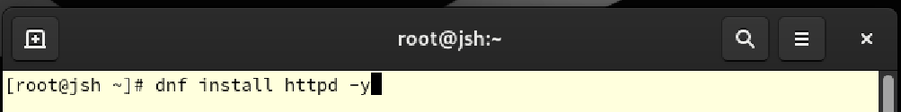

Install httpd package to set web server.

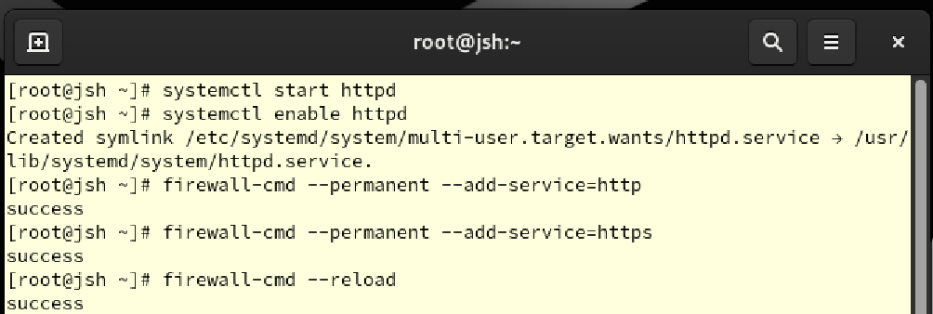

After installation, start and enable the httpd package. Then, add firewall rule to accept http service and https. Reload the firewall to apply changes.

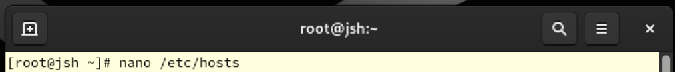

Open hosts file using nano.

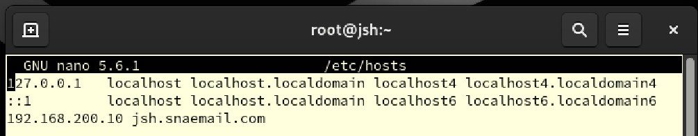

Add line “**192.168.200.10 jsh.snaemail.com**” to map the ip 192.168.200.10 to domain jsh.snaemil.com so that local network will get this ip as the domain and vise versa. Save and exit.

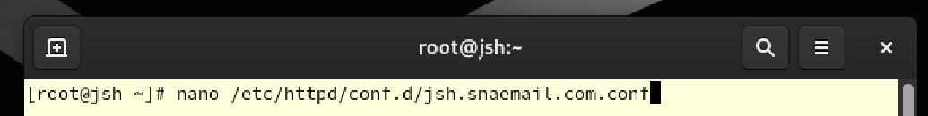

Open jsh.snaemail.com.conf usin nano to set domain for web server.

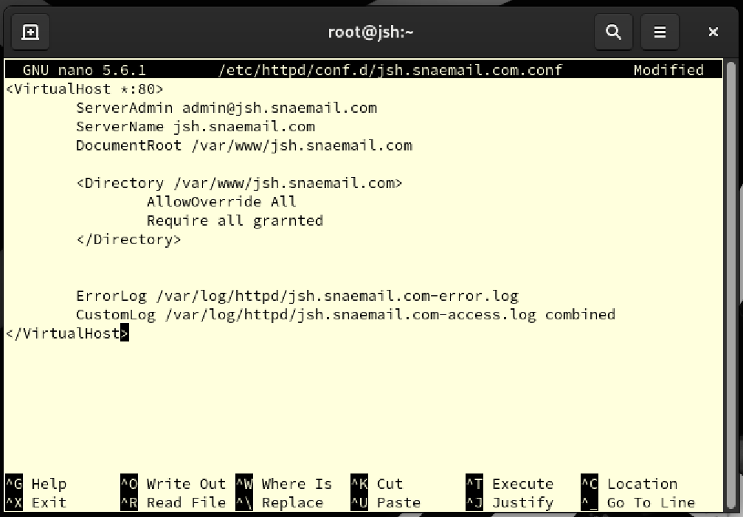

Add lines as screenshot. This will work as following:

<VirtualHost *:80>

This line instructs Apache to handle incoming requests on port 80 from any IP address to this virtual host setting. Port 80 is the standard port for HTTP traffic.

ServerAdmin admin@jsh.snaemail.com

Set the web server's administrator email address. This address is provided as contact information for users to contact in case of an error.

ServerName jsh.snaemail.com

Specifies the server name on which this virtual host will respond.

DocumentRoot /var/www/jsh.snaemail.com

Specifies the document root directory for this virtual host. The web server reads web page files from this directory.

<Directory /var/www/jsh.snaemail.com>

Provides additional settings for this directory.

AllowOverride All

Allows configuration overrides via .htaccess files within this directory. This allows various setting changes at the individual directory level.

Require all granted

Allow all users access to this directory.

ErrorLog /var/log/httpd/jsh.snaemail.com-error.log

Specifies the file path to save the error log for this virtual host.

CustomLog /var/log/httpd/jsh.snaemail.com-access.log combined

Specify the file path to save the access log of this virtual host, and record the log using the 'combined' format.

Save and exit.

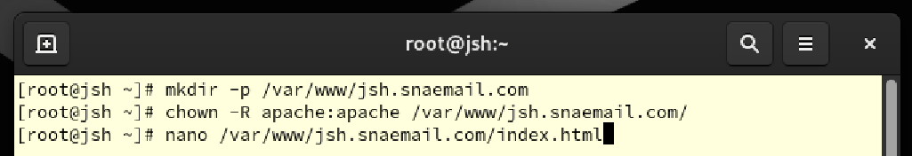

Make directory of /var/www/hsg.snaemail.com using mkdir command. Give ownership of it to apache web server user and group. They will be able to read the files in the directory. Then, create index.html using nano.

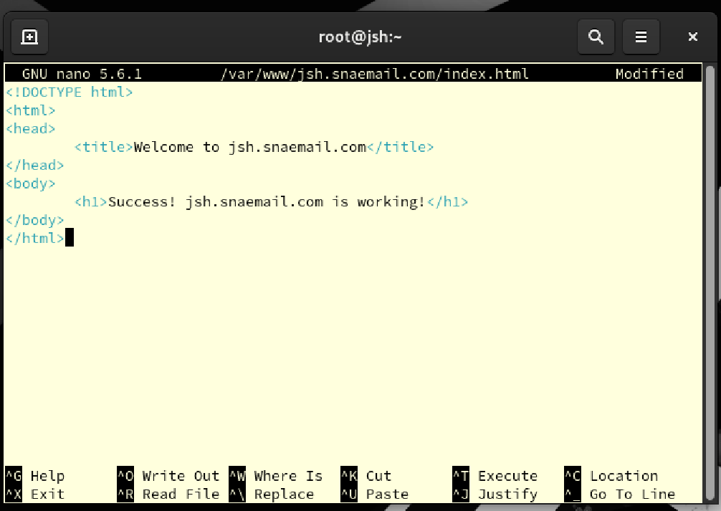

By writing lines as screenshot states, when get into the web server, welcome message and success message will appear. Save and exit.

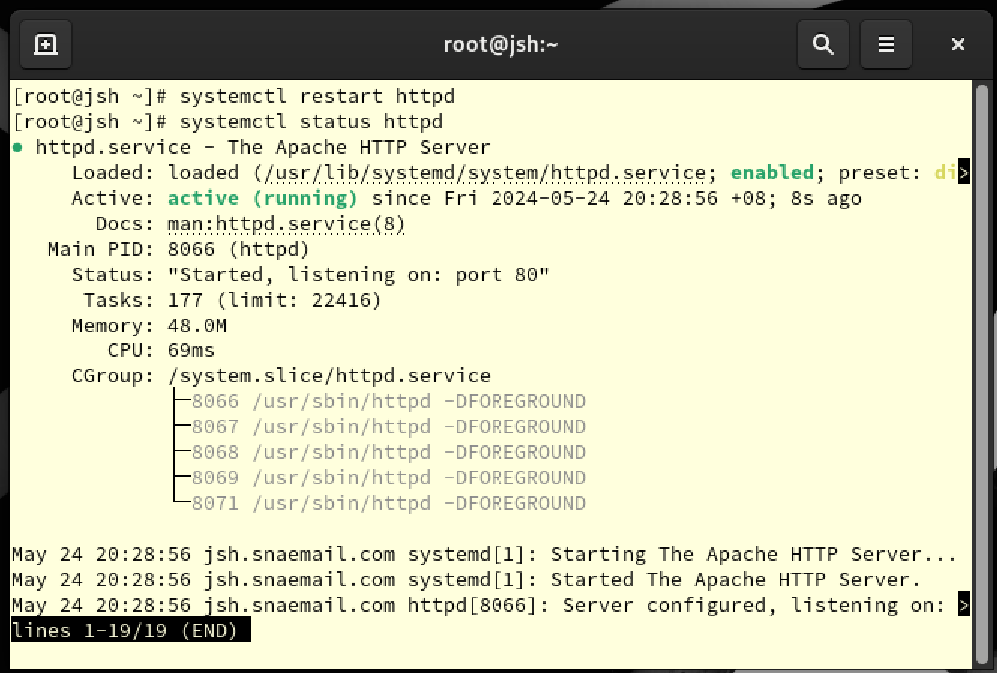

Restart httpd to apply change and use status command to show the condition of httpd. As shown the httpd is working well.

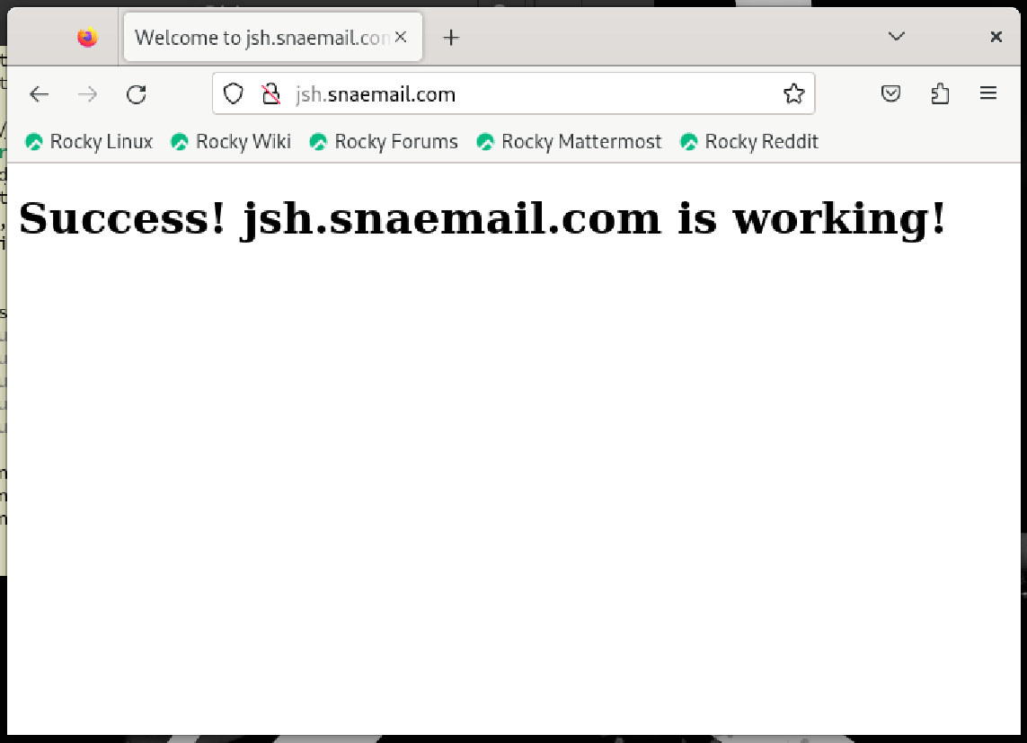

When get into jsh.snaemail.com using Firefox at rocky server, it is showing that the httpd service is working well. Success message is showing correctly as set.

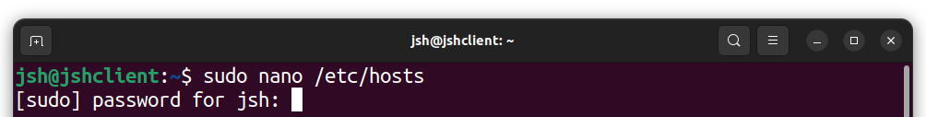

Now, to make it work at ubuntu, open hosts file using nano to apply change.

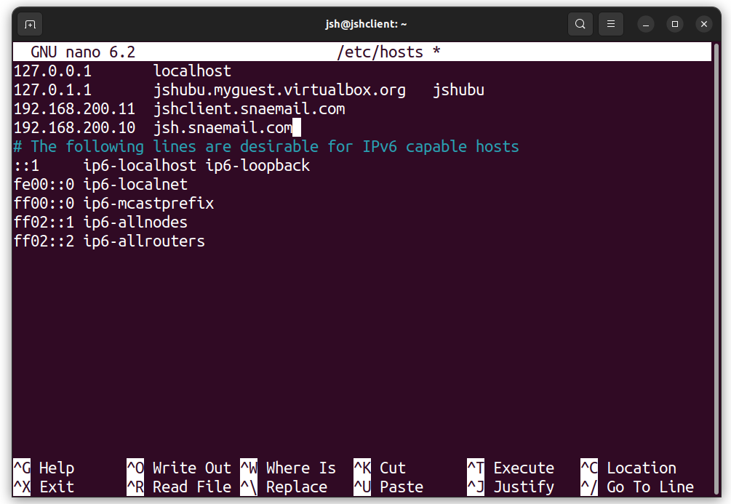

Add line “**192.168.200.10 jsh.snaemail.com**” so that the ubuntu client will accept jsh.snaemail.com as given ip 192.168.200.10. Save and exit.

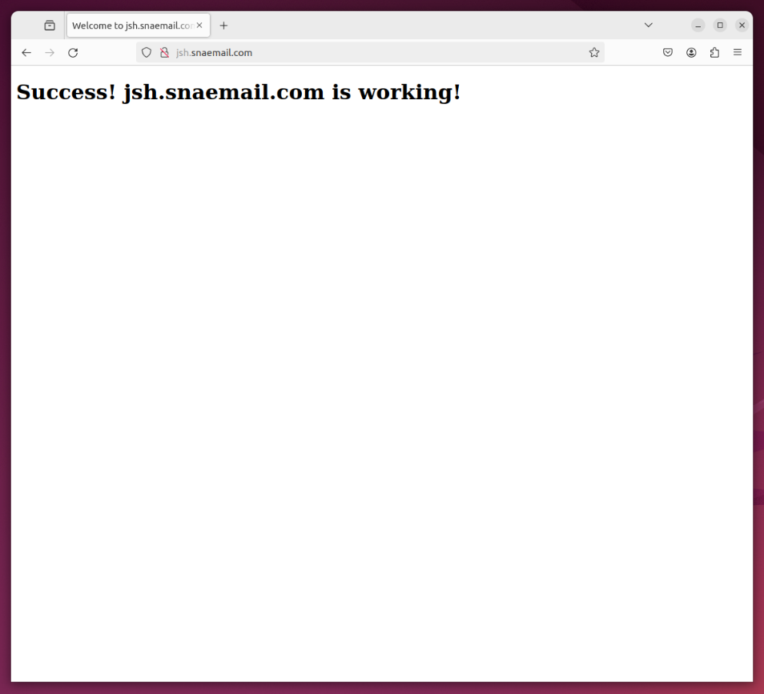

Now, using Firefox in ubuntu as well, it is showing that the web server is working properly.

## **5.2 Obstacles encountered, obstacles overcome**

For setting up web server, most part worked well. However, for making it to work at ubuntu as well, I did not know the reason at the first time. As it was easy for me to install it in ubuntu, I thought the procedure will be same. So, what I did made it only harder, and this page kept showed up.

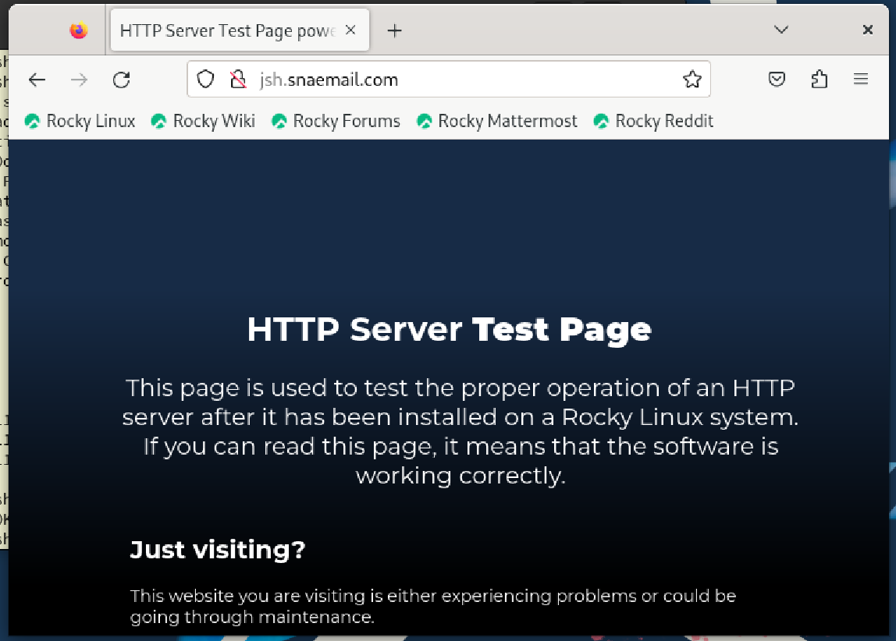

Thankfully, the solution was much easier than I thought, so I removed all the things I did wrong, and applied change to hosts file.

# **6 . Implement SSL/TLS encryption for email and web services on the virtual machine. Generate and install SSL certificates for the email and web servers.**

## **6.1 setting up SSL/TLS encryption**

### **6.1.1 Setting up SSL/TLS encryption for email**

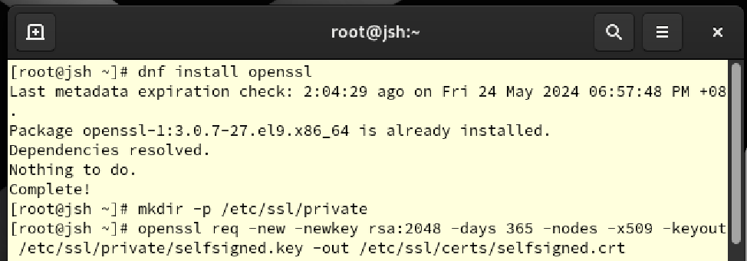

For encryption, install openssl to create certificates. Make directory using mkdir command, and create certificate by **openssl req -new -newkey** command.

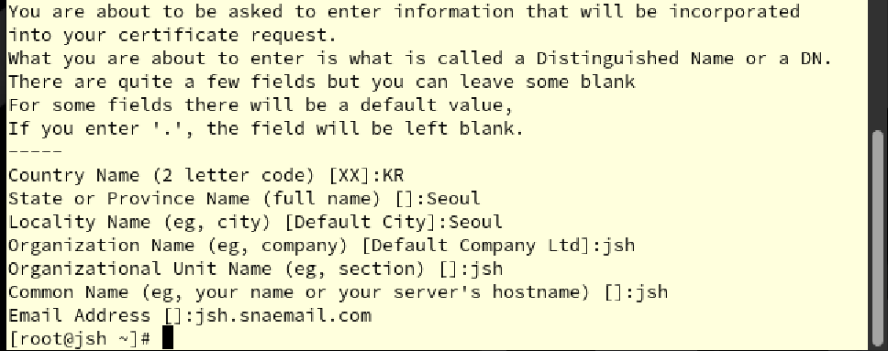

Enter details to create certificate.

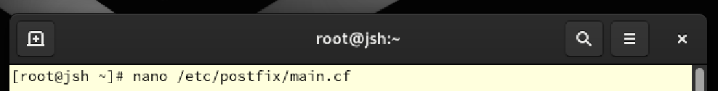

Open main.cf using nano to change settings.

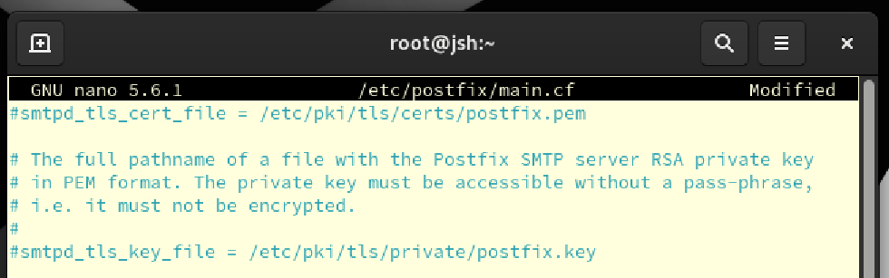

Apply annotation to existing cert file and key file.

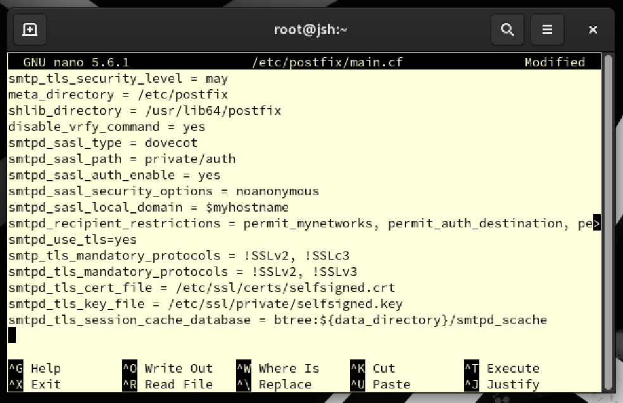

Add protocols and file directory lines, to make it use TLS and created certificates.

${data_directory}/smtpd_scache will be database saving TLS session catch. Save and exit.

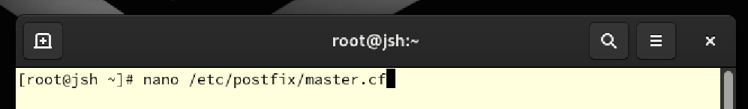

Open master.cf as well to change setting.

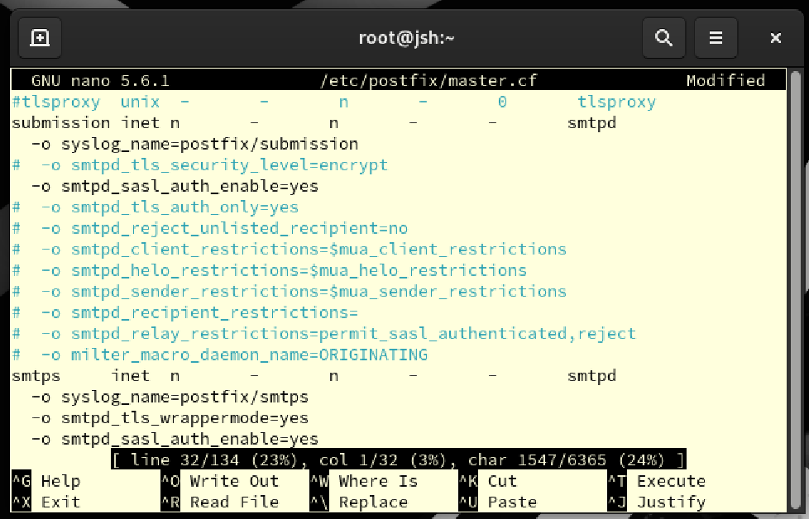

Remove # from annotation to set following setting:

submission inet n - n - - smtpd

This line defines the SMTP server's Submission (port 587) service.

-o syslog_name=postfix/submission

This option sets the name of the syslog to use when writing logs to 'postfix/submission', allowing logs for this service to be managed specifically.

-o smtpd_tls_security_level=encrypt

This option sets the TLS security level to 'encrypt', requiring all connections through this port to be encrypted.

-o smtpd_sasl_auth_enable=yes

This option enables authentication via Simple Authentication and Security Layer (SASL), requiring users to authenticate before submitting their email.

-o smtpd_relay_restrictions=permit_sasl_authenticated,reject

This setting defines restrictions on email relaying. Allow only users authenticated via SASL to send email, denying otherwise.

smtps inet n - n - - smtpd

This line defines the SMTPS service. SMTPS traditionally provides encrypted connections over SSL on port 465.

-o syslog_name=postfix/smtps

This option sets the name of the syslog that will be used to manage logs for this service.

-o smtpd_tls_wrappermode=yes

This option enables TLS wrapper mode, which requires the connection to be encrypted with TLS/SSL from the start.

-o smtpd_sasl_auth_enable=yes

This option also enables SASL authentication for SMTPS services.

Save and exit.

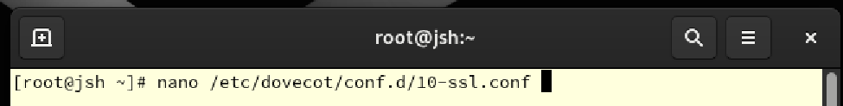

Open 10-ssl.conf file to apply change to setting.

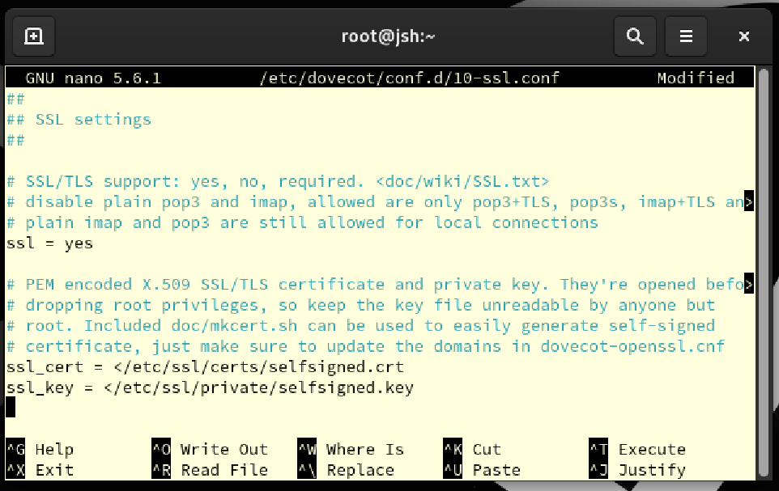

Add line ssl_cert and ssl_key to get certificate from created certificate directory. Save and exit.

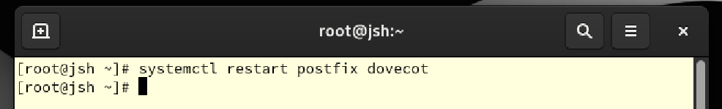

Restart both dovecot and postfix to apply change.

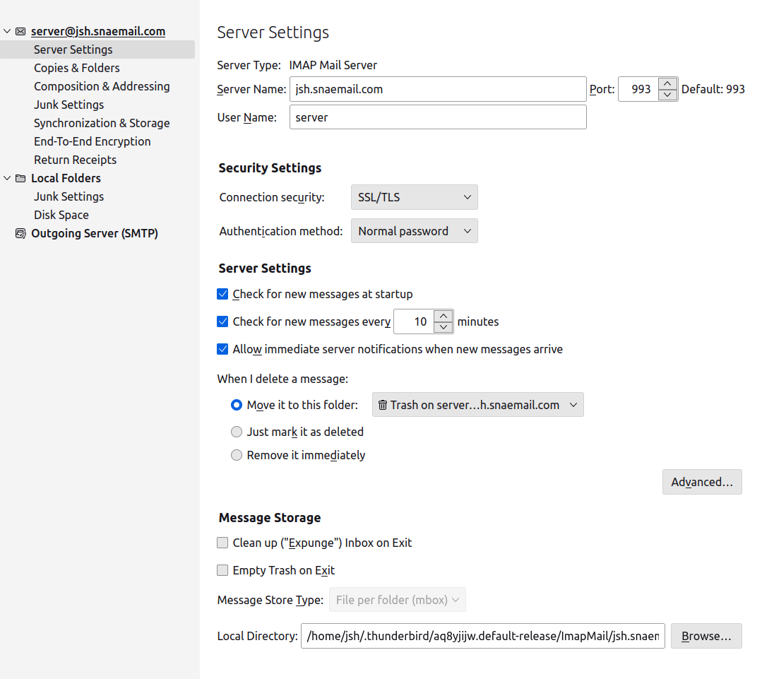

Now, change the security settings of thunderbird in ubuntu for “server” account from “None” to “SSL/TLS” to use security settings.

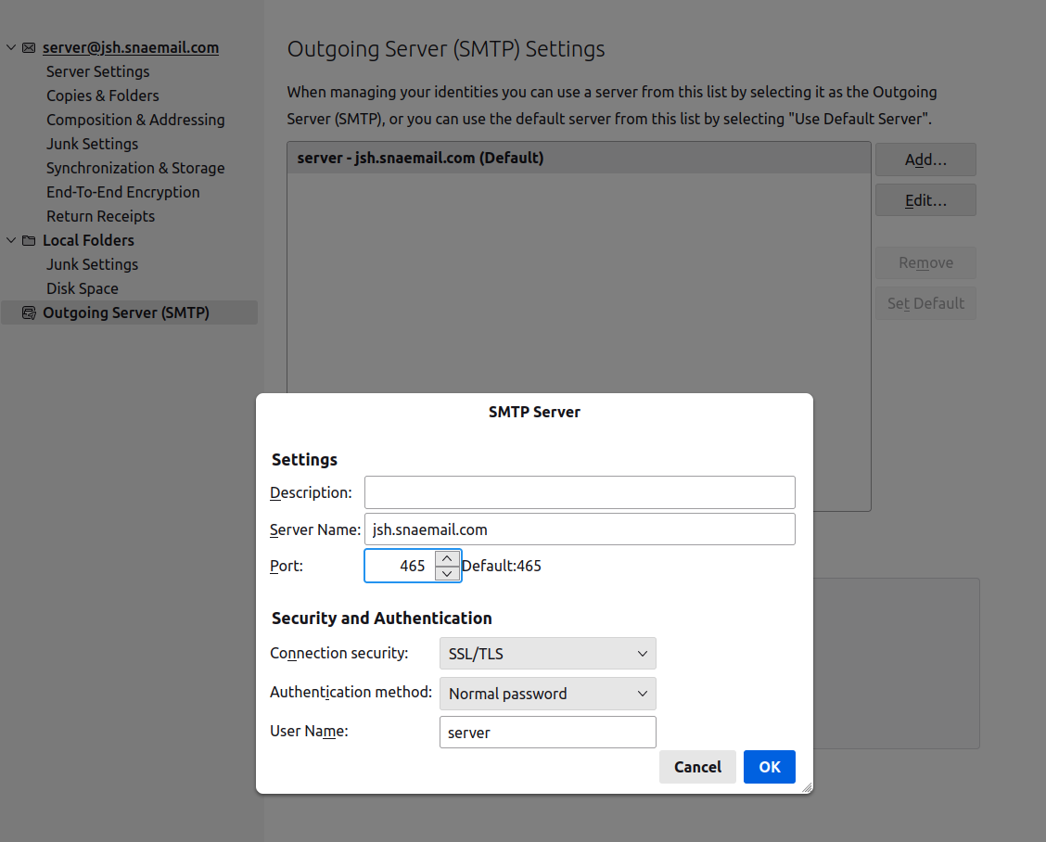

For SMTP server, same change is done.

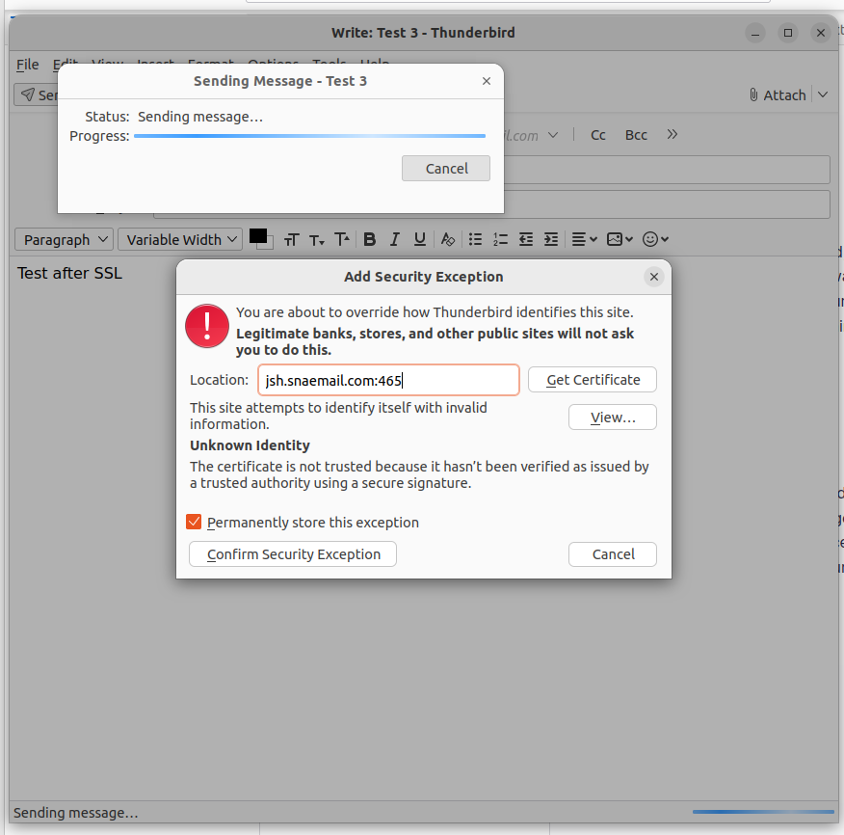

However, as the certificate is self-signed, error shows up as the screenshot shows.

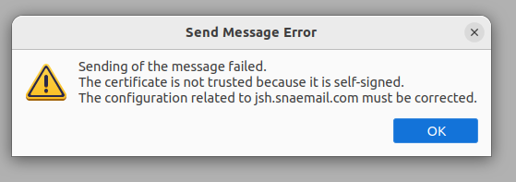

Even after the confirmation of security exception, this message pops up. I could not fix the issue.

### **6.1.2 Setting up SSL/TLS encryption for web server**

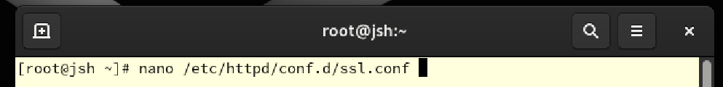

Open ssl.conf using nano to change setting.

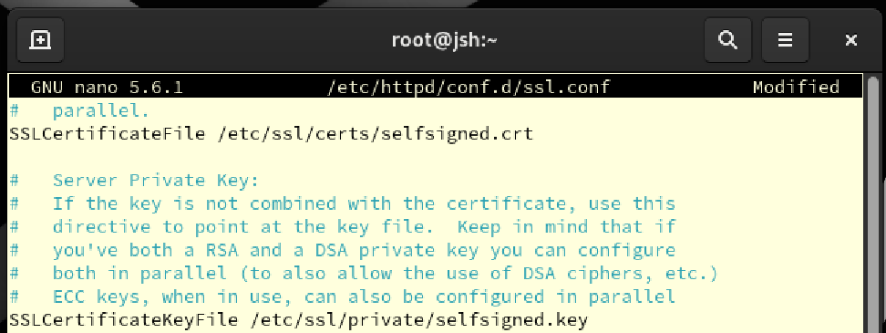

Change the directions of SSL certificate to existing crt file and key file. Now, for SSL/TLS, http will use these files. Save and exit.

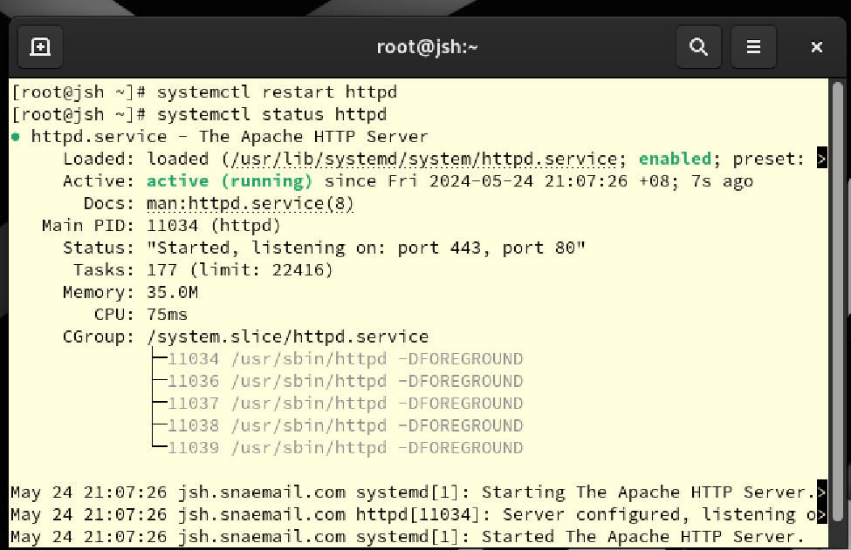

Restart http to apply change and use status to show its state. It is working well as shown.

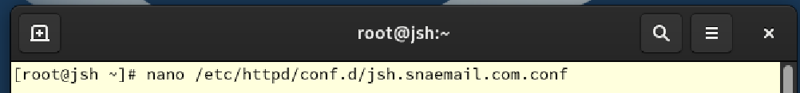

Open jsh.snaeamil.conf to change setting with nano.

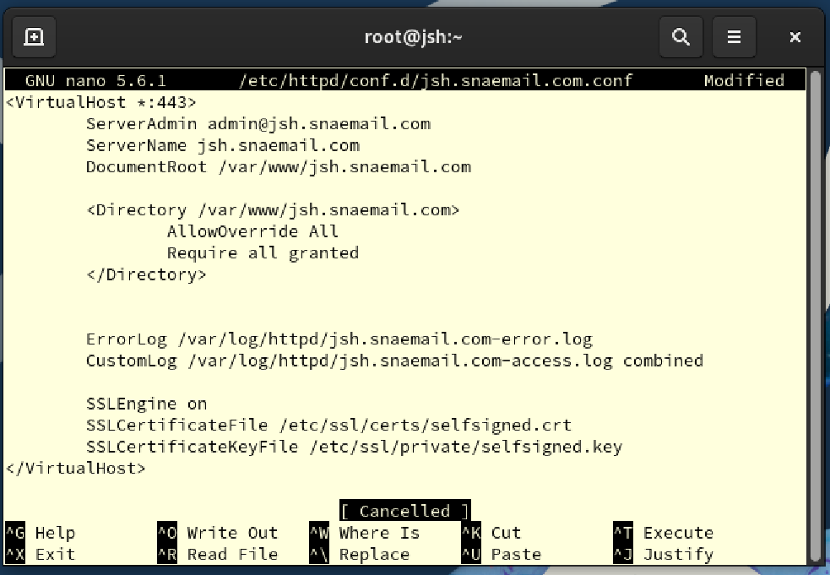

Add SSLEngine on, SSLCertificatefile, and SSLCertificatekeyfile line to set SSL to web server. Save and exit.

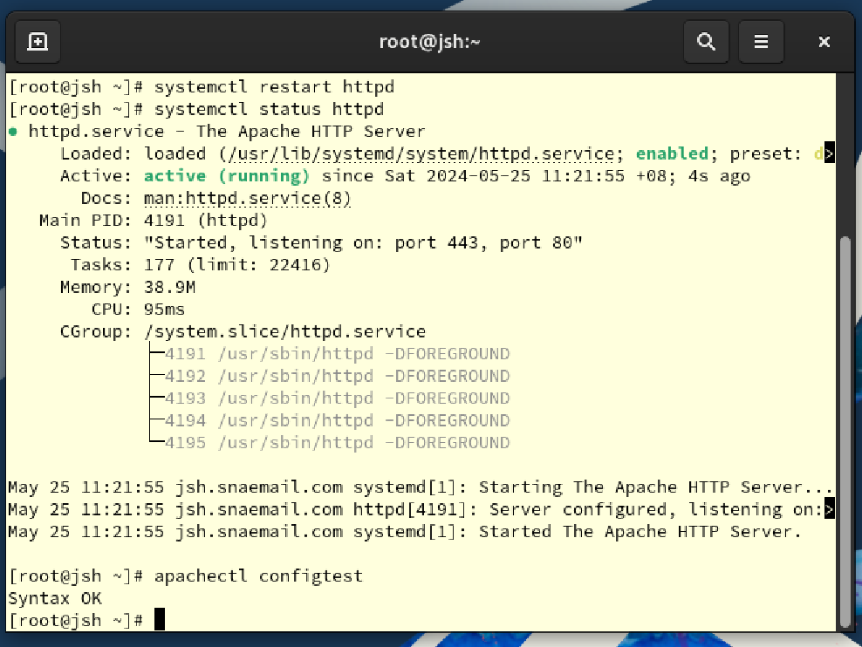

Restart httpd and show status using restart and status. It is working well as shown.



Open httpd.conf file using nano.

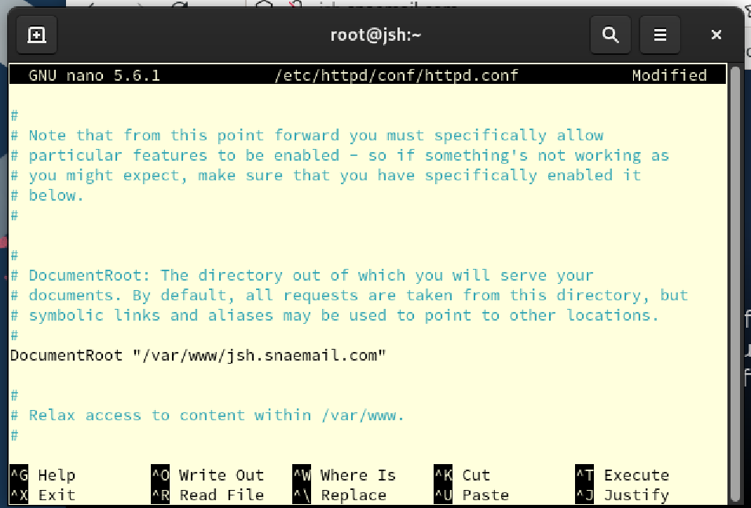

Add DocumentRoot "/var/www/jsh.snaemail.com" Line. This setting specifies the document root of the Apache web server as /var/www/jsh.snaemail.com. This path is the default location where the web server will look for website files, and when a request comes in to the web server, it will serve a web page based on the files in this directory.

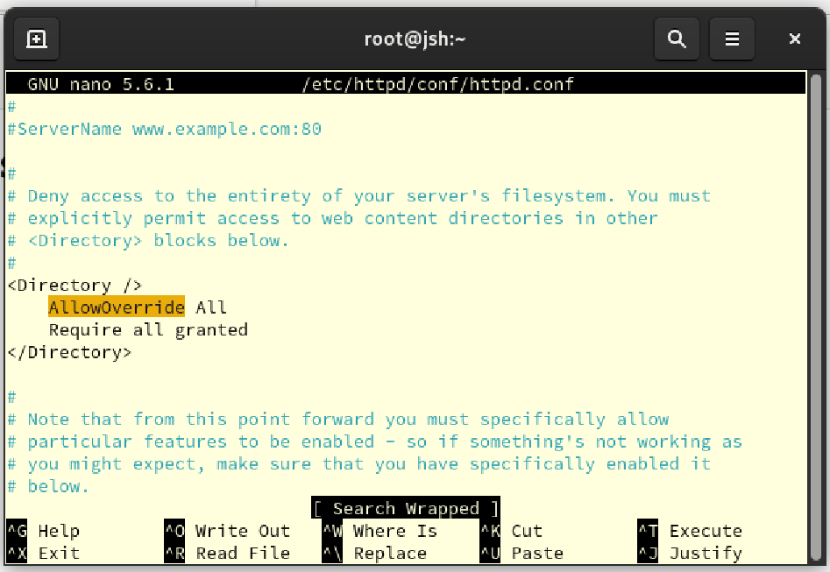

Add line AllowOverride All which to override (override) various configuration options via an .htaccess file in any directory on the server, and line Require all granted which grants all users access to all directories on the server.

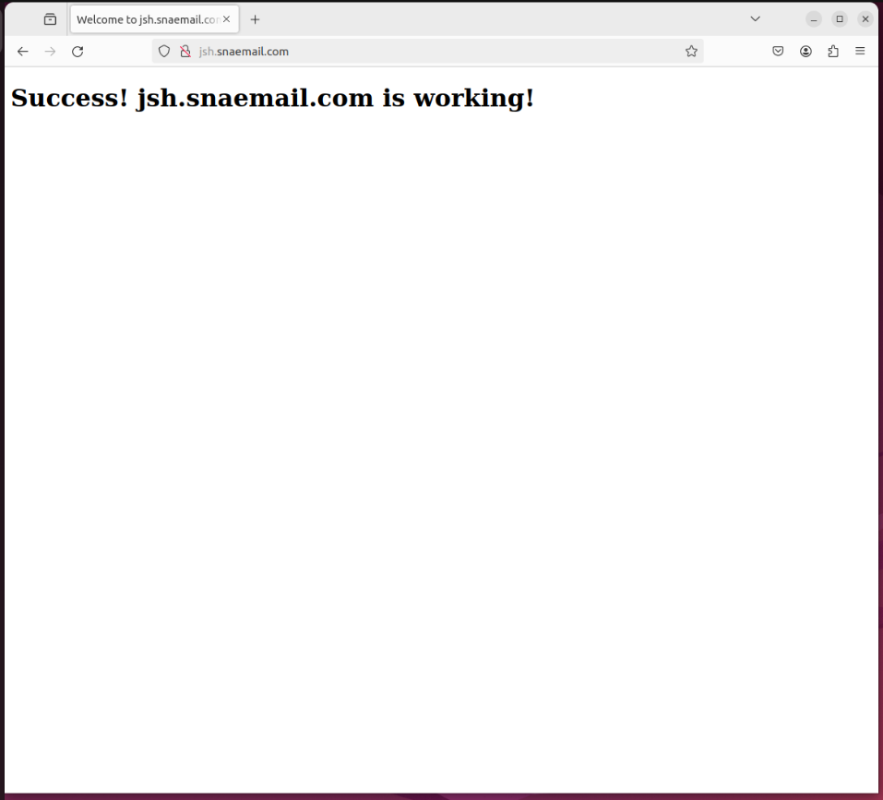

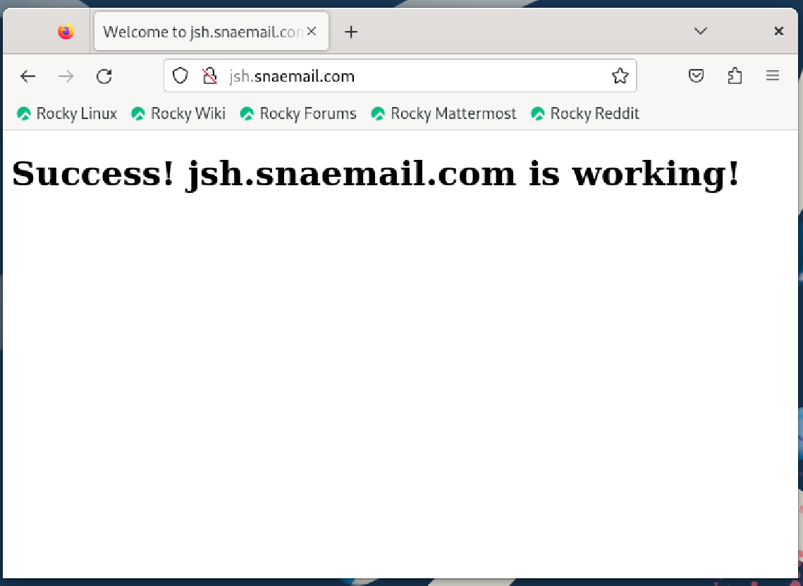

Now for Both rocky and ubuntu the web server is accessible.

## **6.2 Obstacles encountered, obstacles overcome/ Any Outstanding/Unresolved Issues**

As stated, I was not able to make SSL/TLS setting for email server to work. Although I tried other methods than openssl, I failed to make it work. Even though I did not stated, I tried importing the certificate to ubuntu and allowing as exception by thunderbird itself, but failed. Although I failed to fix it, I wanted to show the method I tried.

For web server, I forgot to change httpd.conf, so I got the same blank page as before. Thankfully for this time, applying the solution worked.

# **7. Test the system to ensure that all services are working correctly on the virtual machine. Verify that clients can access the website, send, and receive email.**

## **7.1 Testing**





For the web server, it is reachable as stated in previous question.



Also, without SSL/TLS, email server is accessible, able to send and receive email. However, as stated above, with SSL/TLS, it does not work.

## **7.2 Obstacles encountered, obstacles overcome**

As testing was done for every step of questions, no further obstacles were there. However, still the email server with SSL/TLS function is not working.

# **8. Document the system configuration**

## **8.1 Documenting**

### **8.1.1 Documenting for Rocky**

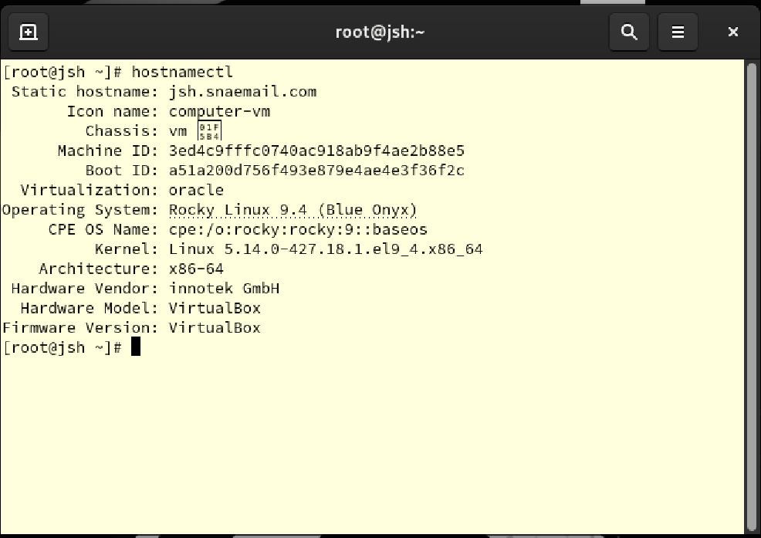

This is the system configuration of rocky server. Here, hostname is noticeable.

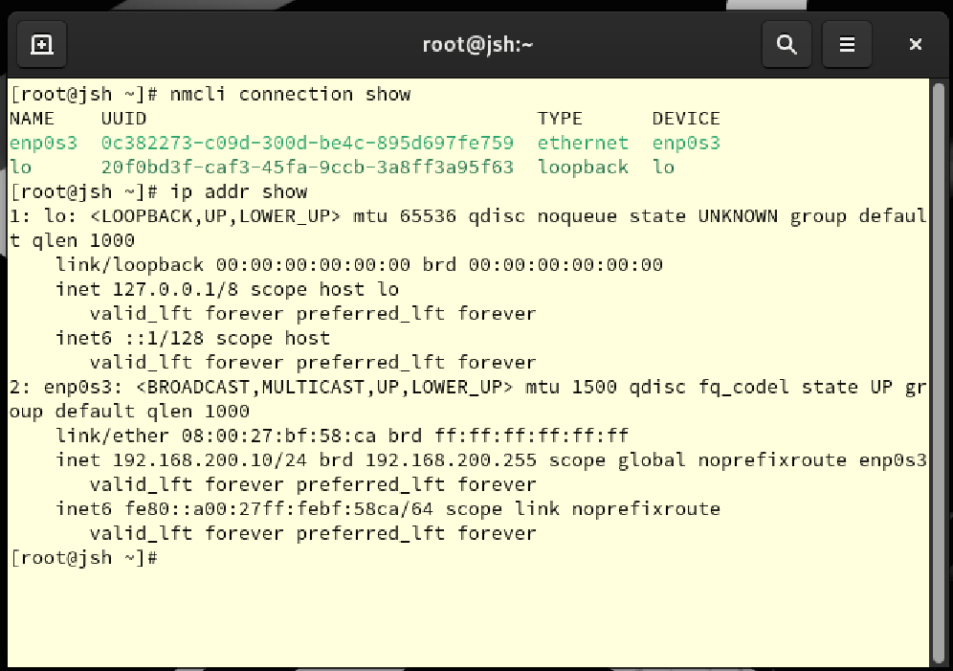

This is the network configuration and ip address of rocky server. There are two network connections, lo and enp0s3. Lo is local network, having ip address of 127.0.0.1, while enp0s3 has ip address of 192.168.200.10. ip address was changed from basic 192.168.200.4 to give changes.

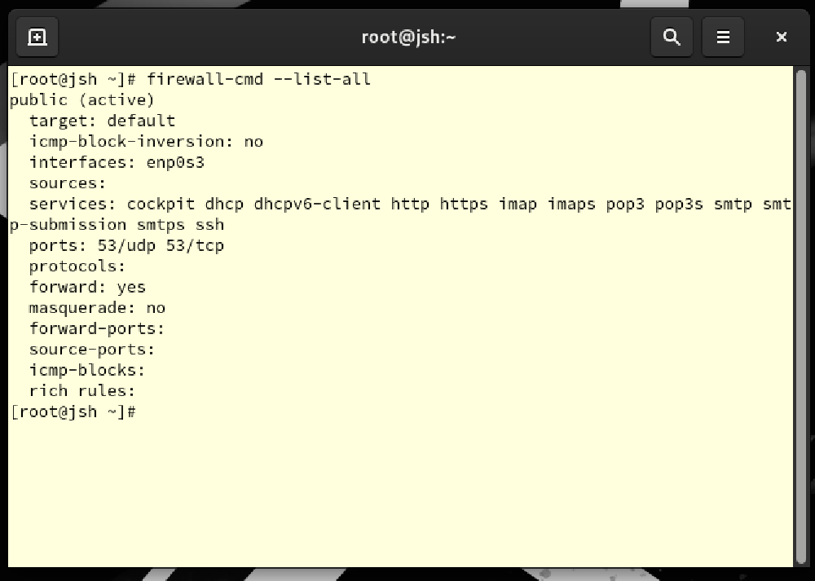

This is the firewall configuration of rocky server. As there were dhcp, http, and email services add, line of service is noticeable.

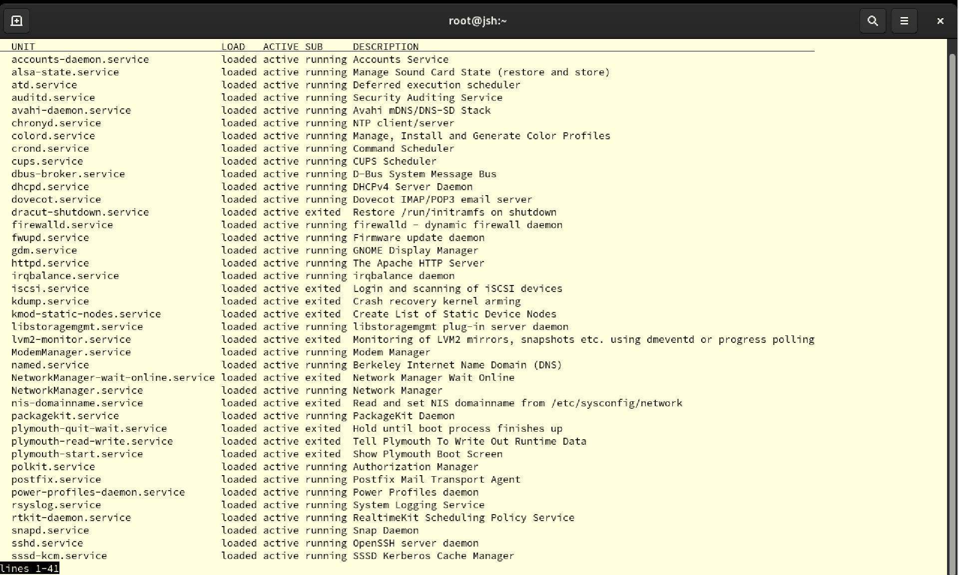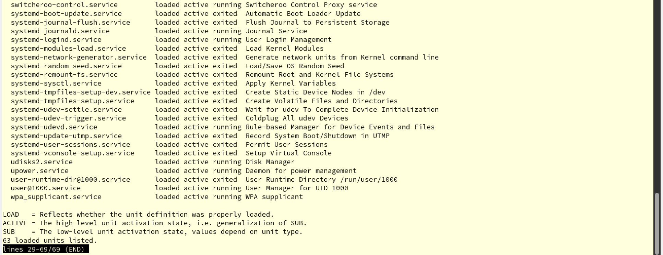

This is the every service working in rocky server.

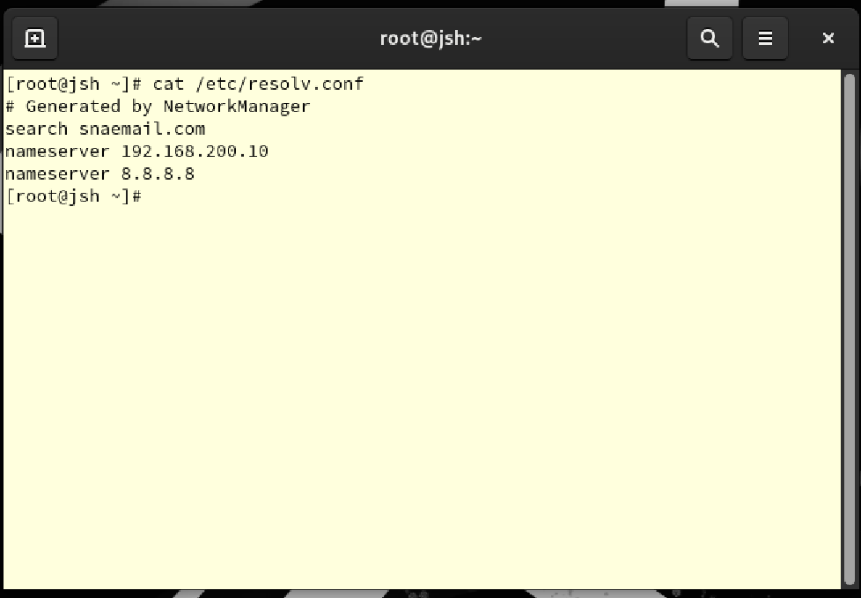

This is the DNS configuration of rocky server. As modified, dns connects to 192.168.200.10 at first, and try 8.8.8.8.

### **8.1.2 Documenting for Ubuntu**

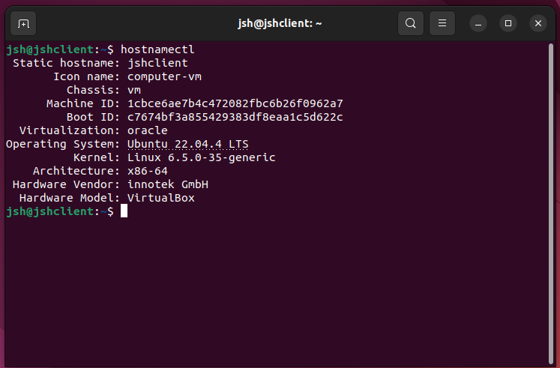

This is the system configuration of ubuntu client. Here, hostname is noticeable.

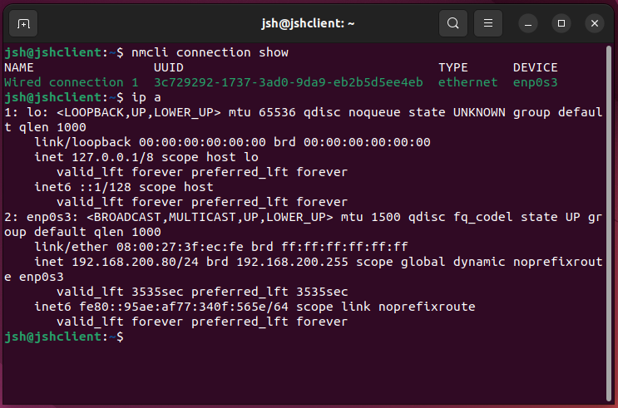

This is the network configuration and ip address of ubuntu client. Only wired connection 1 is shown, but local ip address is same as that of server by 127.0.0.1, and ip address for enp0s3 connection is 192.168.200.11. This ip address was also modified for the same reason as rocky.

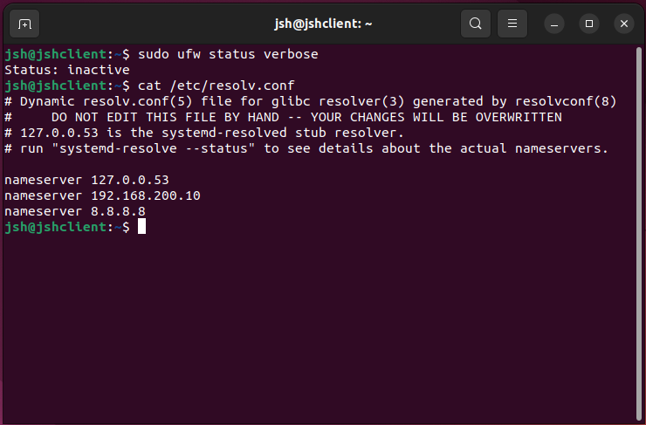

This shows that the firewall for ubuntu is inactive, and dns server of rocky. It tries 127.0.0.53 at first, 192.168.200.10 which is the host at next, and 8.8.8.8 for the last.

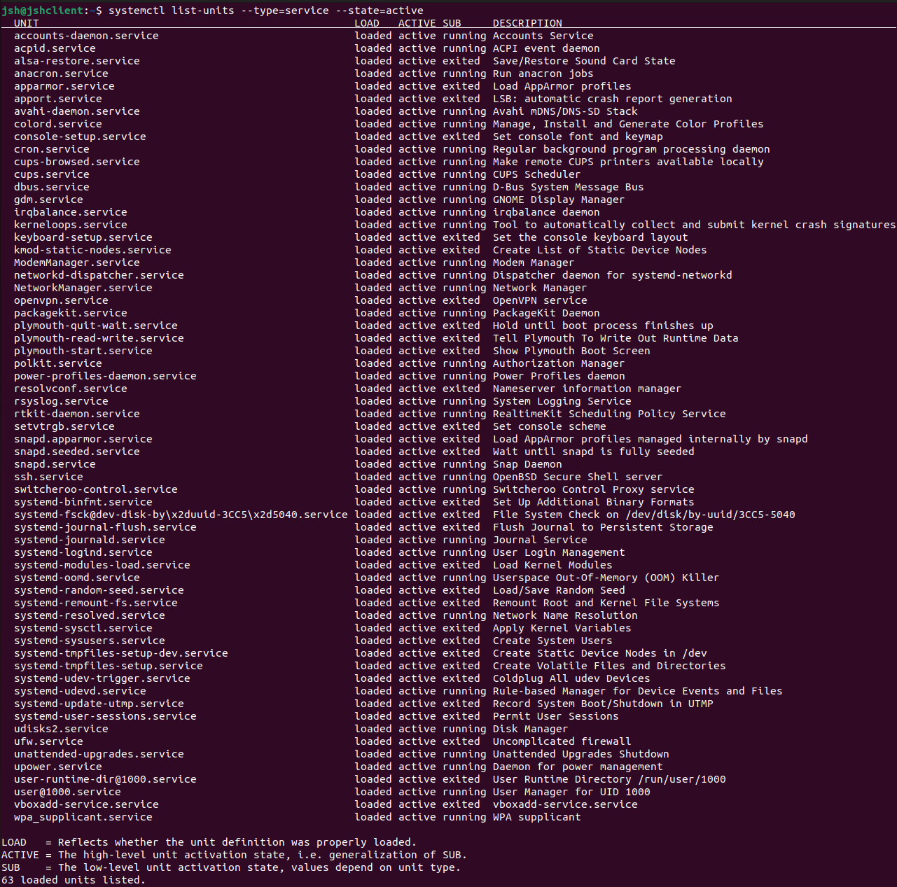

This is the list of every active services in ubuntu.

## **8.2 Obstacles encountered, obstacles overcome**

For this part, there was no obstacles that I encountered. However, I do not know every service that is active for rocky and ubuntu, so I was only able to check the list of them.

# **Conclusion**

Throughout this project, I deepened my understanding of Linux's diverse functionalities. This experience not only improved my problem-solving skills but also bolstered my ability to work independently. Moreover, it sparked a renewed interest in Linux, opening new avenues in system administration and software development.

As I navigated through configuring and managing a Rocky Linux server and an Ubuntu client, I gained valuable practical insights into network management, server configuration, and security protocols. These competencies are essential in the tech environment and are highly valued within the IT industry, promising a viable path for career development.

The challenges faced during the setup process encouraged me to delve deeper into the command line and scripting within Linux, which are critical for automating tasks and optimizing system operations. This has inspired me to further explore open-source technologies and consider Linux as a powerful tool for my future projects.

This assignment highlighted the importance of continuous learning and keeping abreast of the latest technological advancements. The ever-evolving nature of Linux and its applications encourages a lifelong commitment to education and skill enhancement.

In conclusion, this project was a pivotal experience in my academic and professional journey. It reinforced my passion for technology and set the stage for future endeavors in the IT field. The practical experience, combined with a proactive approach to learning and curiosity, has led to substantial personal and professional growth.

# **References**

Server world:  
https://www.server-world.info/en/